An unexplored remarkable Poly(N-isopropylacrylamide)-osmolyte interaction study
Payal Narang and Pannuru Venkatesu*
Department of Chemistry, University of Delhi, Delhi – 110007, India

Abstract (300 word limit)

We investigate the aggregation and hydrophobic collapse of water soluble amphiphilic polymer, poly(N-isopropylacrylamide) (PNIPAM), in aqueous solution containing various additives such as trehalose, sucrose, sorbitol, urea, TMAO and their mixtures in varying ratios. The effect of these osmolytes on the coil to globular transition of the PNIPAM is studied by the use of comprehensive biophysical techniques like UV-visible and flourescence spectroscopy, dynamic light scattering (DLS) and Fourier transform infrared spectroscopy (FTIR). The polarization induced by these additives makes the collapse of PNIPAM much faster as compared to PNIPAM in aqueous solution. The decrease in lower critical solution temperature (LCST) of the polymer with increase in the concentration of osmolyte is due to the significant changes in the interactions among polymer, osmolyte and water. The driving force for concomitant sharp configurational transition has been attributed to rupture of hydrogen bonds between water and polymer and to hydrophobic association of polymer. The results of the present study can be used in the bioresponsive smart PNIPAM-based devices. This tuning of LCST may help in various scientific areas to explore target specific applications of intelligent PNIPAM. The modified collapsed state in PNIPAM may provide sites for efficient drug encapsulation and their controlled release.

Image
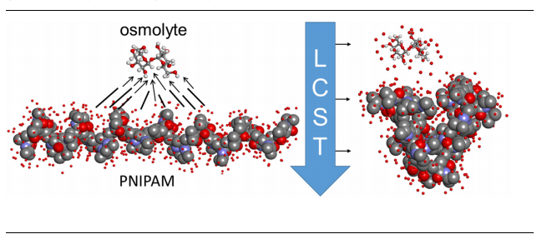
Recent Publications (minimum 5)
- A. Halperin, M. Kröger, F.M. Winnik, Poly(N-isopropylacrylamide) Phase Diagrams: Five years of research, Angew. Chem. Int. Ed. 54 (2015) 15342-15367.
- Y. Zhang, P.S. Cremer, Chemistry of Hofmeister Anions and Osmolytes, Annu. Rev. Phys. Chem. 61 (2010) 63–83.
- P.M. Reddy, M. Taha, P. Venkatesu, A. Kumar, M.J. Lee, Destruction of hydrogen bonds of poly(N-isopropylacrylamide) aqueous solution by trimethylamine N-oxide, J. Chem. Phys.136 (2012) 234904-1-10.
- R. Umapathi, P.M. Reddy, A. Kumar, P. Venkatesu, The biological stimuli for governing the phase transition temperature of the “smart” polymer PNIPAM in water, Colloids and Surf., B: Biointerfaces 135 (2015) 588-595.
- P.H. Yancey, M.E. Clark, S.C. Hand, R.D. Bowlus, G.N. Somers, Living with water stress: evolution of osmolyte systems, Science 217 (1982) 1214-1222.

Biography (150 word limit)
Payal Narang, is a Ph.D student in Department of Chemistry, University of Delhi. Her reaserch work focus on the behaviour of thermo-reponsive polymers in presence of various additives and furthur exploring their promising applications in the field of pharmaceutical industries and many more fields of biomedical research. She can create new pathways for comsumption of improved or more efficient polymers in various areas of science. She has represented this model of work after two years of experience in reaseach that includes experimental design, observations and analysis. She cleared University Grant commission (UGC)-National Eligibility Test (NET) with 18th rank which is providing her fellowship for Ph.D. She also got one Young Scientist Award and two Best Oral presentation awards in conferences/seminars during her two years of Ph.D.
Email: narangpayal1992@gmail.com

