Synthesis of Nylon6/Maghnite nanocomposites by direct in-situ polymerization
Djamal E Kherroub, RN PhD, University of Oran 1 Ahmed Ben bella, Algeria
Mohammed Belbachir, Pr, University of Oran 1 Ahmed Ben bella, Algeria

Abstract

The purpose of this study was to obtain Nylon6 nanocomposites with Algerian organically modified clay (12-Maghnite). The formation of nylon6 was confirmed by infrared spectroscopy (IR); the prepared nanocomposites were characterized by X-ray diffraction (XRD), transmission electron microscopy (TEM) and thermogravimetric analysis (TGA).

The evolution of mechanical properties was also studied. The obtained results confirm the intercalation of molecules of salt in the clay layers, and a good interaction with the polymer, showing the formation of intercalated and/or exfoliated structures.

The nanocomposites showed higher thermal stability compared to pure polymer, and the mechanical properties presented interesting and promising results.
Image
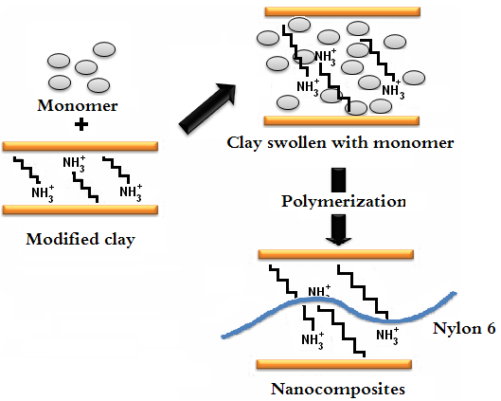
Recent Publications
1. Liu Y, Yang G (2010) Non-isothermal crystallization kinetics of polyamide-6/graphite oxide nanocomposites. Thermochimica Acta 500:13–20.
2. Kalpana SK, Debashis S, Dinesh RK, Pijush G, Devendra V (2006) Molecular interactions in intercalated organically modified clay and clay–polycaprolactam nanocomposites: Experiments and modeling, Polymer 47:403–414.
3. Jiang T, Wang Y, Yeh J, Fan Z (2005) Study on solvent permeation resistance properties of nylon6/clay nanocomposite. European Polymer Journal 41:459–466.
4. Araujo EM, Leite AMD, da Paz RA, Medeiros VN, de Melo TGA, Lira HL (2011) Polyamide 6 Nanocomposites with Inorganic Particles Modified with Three Quaternary Ammonium Salts. Materials 4: 1956–1966.
5. Chen G, Shen D, Feng M, Yang M (2004) An Attenuated Total Reflection FT-IR Spectroscopic Study of Polyamide 6/Clay Nanocomposite Fibers, Macromolecular Rapid Communication 25: 1121-1124.

Biography
Djamal Eddine Kherroub, Doctor of Science in Polymer Chemistry, Member researcher of Laboratory of Polymer Chemistry, University of Oran 1. Ahmed Ben Bella, Algeria. He received his degree of Magister in applied chemistry in 2012, at the military polytechnic school (EMP), Algeria, his doctor of science degree in 2016 at the University of Oran 1. Recent occupation: Supervision of Master Students in Green Chemistry and chemical engineering.
Email: djamaleddine.kherroub@yahoo.com
Biography
Mohammed Belbachir, PhD; Full Senior Professor, Founding Member of Algerian Academy of Sciences and Technology (AAST). Head of Laboratory of Polymer Chemistry, University of Oran 1, Algeria. He has received his PhD degree at National High School of Chemistry-Montpellier, France in 1978. He conducts research in the field of Green Chemistry. He was Head of Post-Graduation: Polymer Chemistry 1990-2010 and Head Formation ‘’Master: Green Chemistry since 2011.
Email: legenial@yahoo.fr

Notes/Comments:

