Preparation of bio-compatible and UV-curable elastic materials with
HEMA as a diluent

Ji eun Jang, Master's course, KITECH, the Republic of KOREA,
Jung soo Kim, Doctor’s course, KITECH, the Republic of KOREA
Min sung Kim, Master's course, KITECH, the Republic of KOREA,
Seok ju Hong, Master's course, KITECH, the Republic of KOREA,
Hansoo Park, Ph.D, Chungang University, the Republic of KOREA
and Dong hyun Kim, Ph.D, KITECH, the Republic of KOREA

Abstract

The biocompatible photocurable elastic materials were synthesized with urethane acrylate oligomer, 2-hydroxyethyl methacrylate (HEMA), and polyethylene glycol diacrylate (PEGDA) using 2-Hydroxy-4′-(2-hydroxyethoxy)-2-methylpropiophenone (Irgacure 2959 as an initiator. We could obtain elastic materials with different properties such as softness, tensile strength, and elasticity by changing the input molar ratio of HEMA, urethane acrylate with PEGDA. Generally, urethane oligomer with a higher PEGDA ratio has higher elasticity and higher viscosity properties. On the other hand, as the content ratio of HEMA increases in urethane oligomer, the viscosity and physical properties decrease.
We studied various properties such as tensile properties, hardness, biocompatible properties, and viscosity to find the critical point of higher elasticity and lower viscosity according to HEMA/PEGDA ratio. Also, the chemical structures of the synthesized polymers were characterized using Fourier Transform Infrared spectroscopy (FT-IR) and nuclear magnetic resonance (NMR

Image

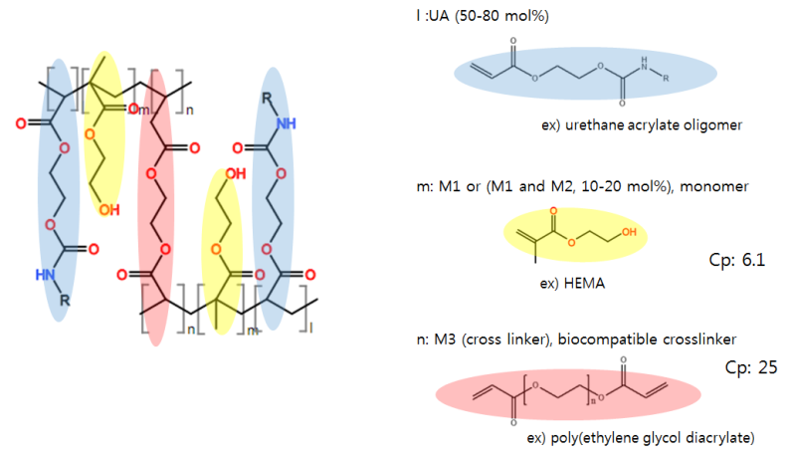
Recent Publications
- Zhang, C., Zhang, N., & Wen, X. (2006). Improving the elasticity and cytophilicity of biodegradable polyurethane by changing chain extender. Journal of Biomedical Materials Research Part B: Applied Biomaterials, 79(2), 335-344.
- Xu, G., & Shi, W. (2005). Synthesis and characterization of hyperbranched polyurethane acrylates used as UV curable oligomers for coatings. Progress in Organic Coatings, 52(2), 110-117.
- Deka, H., Karak, N., Kalita, R. D., & Buragohain, A. K. (2010). Biocompatible hyperbranched polyurethane/multi-walled carbon nanotube composites as shape memory materials. Carbon, 48(7), 2013-2022.
- Lin, Y. H., Liao, K. H., Chou, N. K., Wang, S. S., Chu, S. H., & Hsieh, K. H. (2008). UV-curable low-surface-energy fluorinated poly (urethane-acrylate) s for biomedical applications. European Polymer Journal, 44(9), 2927-2937.
- Chen, Q., Mangadlao, J. D., Wallat, J., De Leon, A., Pokorski, J. K., & Advincula, R. C. (2017). 3D printing biocompatible polyurethane/poly (lactic acid)/graphene oxide nanocomposites: anisotropic properties. ACS applied materials & interfaces, 9(4), 4015-4023.

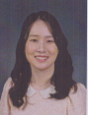Biography (150 word limit)
Ji Eun Jang is currently a graduate student in Chungang University and a researcher in Korea Institute of Industrial Technology (KITECH) at the same time. Her major is integrative engineering and she is consistently learning how to do experiments and manage novell materials. She is currently researching biocompatible materials applied for 3D printing. In KITECH, she held experiments regarding superabsorbent polymers and 3D printing resins. This study aimed for innovative experimental results such as biocompatibility and high elasticity for the application of 3D printing materials.
Email: Jejang@kitech.re.kr

Notes/Comments:

