The properties of superabsorbent polymers synthesized with acrylate based crosslinking agents

Yoo Jin Kim, Master’s course, KITECH, the Republic of KOREA,
Jung Soo Kim, Doctor’s course, KITECH, the Republic of KOREA,
Byeong Kwan Kang, Master’s course, KITECH, the Republic of KOREA,
Hae Chan Kim, Master’s course, KITECH, the Republic of KOREA,
Woo Seung Shin, Master’s course, KITECH, the Republic of KOREA,
Jin Woong Kim, Ph.D, Hanyang University, the Republic of KOREA,
and Dong Hyun Kim, Ph.D, KITECH, the Republic of KOREA

Abstract
Super absorbent polymer (SAP) is a cross-linked hydrophilic polymer. It can absorb, swell, and retain aqueous solutions up to hundred times of its own dry weight. We synthesized copolymers consisting of carboxylized vinyl monomer and vinyl sulfonic acid using various crosslinking agent. Crosslinking agent is needed to synthesize SAP and it has a direct effect on the crosslinking density of the SAPs. As the amount of added crosslinking agent increases, the cross-linking density of the SAPs increases. This is related to absorbency. We synthesized the SAPs using four types of acrylate based crosslinking agents to compare absorption properties. As a result, only two of them succeeded in synthesis and the rest did not proceed. Each monomer was neutralized with sodium hydroxide to prepare carboxylate ions. Polymerization was initiated by ammonium persulfate added after the crosslinking agent addition. The structures of the prepared polymers were confirmed by FT-IR. We have measured SAP’s properties such as centrifuge retention capacity (CRC) and absorbency under load (AUL) in 0.9 wt.% saline solution depending on the reaction time, reaction temperature or the amount of the crosslinking agent. We studied the effect of each crosslinking agent on the SAP absorption properties.

Image
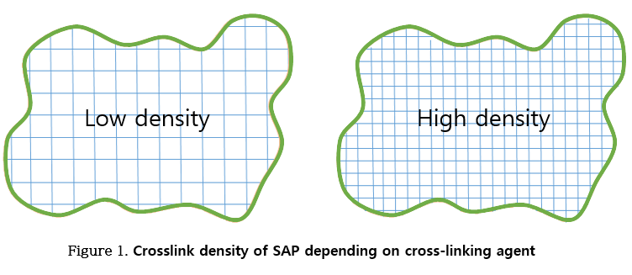
Recent Publications
- Nádia S.V. Capanema (2018) Superabsorbent crosslinked carboxymethyl cellulose-PEG hydrogels for potential wound dressing applications. International Journal of Biological Macromolecules 106:1218-1234.
- Ajaman Adair (2017) Superabsorbent materials derived from hydroxyethyl cellulose and bentonite: Preparation, characterization and swelling capacities. Polymer Testing 64:321-329.
- Kyong Ku Yun (2017) Hygral behavior of superabsorbent polymers with various particle sizes and cross-linking densities. Polymers 9:600.
- Guanghua He (2017) Preparation and properties of quaternary ammonium chitosan-g-poly (acrylic acid-co-acrylamide) superabsorbent hydrogels. Reactive and Functional Polymers 111:14-21.
- Hyun Jae Kim (2017) Synthesis of super absorbent polymer using citric acid as a bio-based monomer. Polymer degradation and stability 144:128-136.

 Biography
Yoojin Kim graduated from Myongji University is in a master’s course of Hanyang University. Her bachelor's major was chemistry and the master's one is bio-nano science. She is also currently working in Korea Institute of Industrial Technology (KITECH) as a student researcher. She is researching the superabsorbent polymer (SAP) using bio-degradable materials. This research aims of the SAPs are to reduce wastes and enhance their absorption properties.
Email: kyj@kitech.re.kr

Notes/Comments

