Silica dispersion in the Si-SBR composites: Synthesis of poly(glycidyl methacrylate-co-styrene) as a reactive dispersant by emulsion copolymerization.
Hae Chan Kim, Master’s course, KITECH, the Republic of Korea,
Min Seong Kim, Master’s course, KITECH, the Republic of Korea,
Seok Ju Hong, Master’s course, KITECH, the Republic of Korea,
Woo Seung Shin, Master’s course, KITECH, the Republic of Korea,
Yoo Jin Kim, Master’s course, KITECH, the Republic of Korea,
Jong Ho Kim, Ph.D, Hanyang University the Republic of Korea,
And Dong Hyun Kim, Ph.D, KITECH, the Republic of Korea

Abstract
To disperse silica in SBR matrix, a need for adequate dispersant is long- standing. Proper interactions between SBR and silica are important for improving silica dispersibility between SBR and silica in medium. We prepared poly(glycidyl methacrylate-co-styrene) copolymer as a reactive dispersant by emulsion copolymerization using the sodium persulfate/iron sulfate redox system. The structure of poly (GMA-co-styrene) is an amphipathic copolymer composed of phenyl group and epoxy group. The glycidyl group of GMA and silanol one of Si formed a covalent bond resulting in improving the dispersion of silica in Si-SBR composites. We suggested a possible reaction mechanism for our system. We confirmed the structure of poly(GMA-co-styrene) copolymer using FT-IR spectroscopy. Also, we investigated dispersion effects in Si-SBR composites according to the input molar ratio of monomer in copolymer and content of initiator.

Image
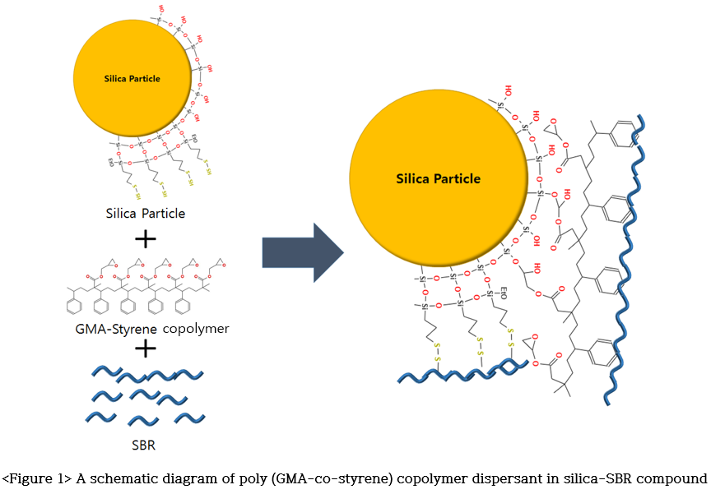
Recent Publications
- Mei-Chun Li, Xin Ge, and Ur Ryong Cho (2013) Emulsion Grafting Vinyl Monomers onto Starch for Reinforcement of Styrene-Butadiene Rubber, Macromolecular Research, 21(5), 519-528.
- Yan Gui, Junchi Zheng, Xin Ye, Dongli Han, Meimei Xi, Liqun Zhang (2016). Preparation and performance of silica/SBR masterbatches with high silica loading by latex compounding method. Composites Part B: Engineering 85, 130-139.
- Shuting.W, Lan.C, Qihao.W. (2015). Maleated glycidyl 3-pentadecenyl phenyl ether with styrene: synthesis and application as compatibilizer in SBR/silica composite. Polym. Adv. Technol, 26(8), 953-959.
- SEO, Byeongho, et al. Characterization of AN-SBR/Silica compound with acrylonitrile as a polar group in SBR. Macromolecular research, 2013, 21.7: 738-746.
- XIA, Lin, et al. Preparation of epoxidized Eucommia ulmoides gum and its application in styrene‐butadiene rubber (SBR)/silica composites. Polymers for Advanced Technologies, 2017, 28.1: 94-01.

Biography
He has a passion for developing new materials using polymer synthesis. He is focusing on developing various materials with a sense of purpose in creating high value-added products through the development of new materials. He is currently working for the Korea Institute of Industrial Technology (KITECH) in the Republic of Korea and is in master's course in Hanyang University.
Email: coolskawk@kitech.re.kr

Notes/Comments

