The silica dispersing effects of poly(styrene-co-allyl alcohol) and poly(styrene-co-methyl methacrylate) in Si-SBR composites
ByeongKwan Kang, Master’s course, KITECH, KOREA,
MinSeong Kim, Master’s course, KITECH, KOREA,
Seokju Hong, Master’s course, KITECH, KOREA
YooJin Kim, Master’s course, KITECH, KOREA
Youngwook Chang, Ph.D, Hanyang University, KOREA
Donghyun Kim, Ph.D, KITECH, KOREA

Abstract
The high silica content in the tire-tread rubber can maximize the efficiency of the vehicle. However, silica does not mix well with other mixtures, including tire-tread rubber. This phenomenon deteriorates the various properties of the tire-tread rubber. Therefore, we have tried to improve the dispersity of silica in Si-SBR composites using dispersants. The dispersity of silica in the Si-SBR composites is one of the importantfactors determining their mechanical properties. We prepared dispersants to reduce silica loss ratio and enhance silica dispersity in Si-SBR composites. Poly(styrene-co-allyl alcohol) and poly(styrene-co-methyl methacrylate) are amphipathic copolymers composed of hydrophobic group and a hydrophilic group. The content of silica in the composites was measured by thermal gravimetric analysis (TGA) according to the types of dispersants.Also, we studied the payne effect with Rubber Process Analyzer (RPA) instrument and dynamic viscoelasticity with Dynamic Mechanical Analysis (DMA) instrument.We measured the mechanical properties of Si-SBR composites. We found that there are optimal types and content of dispersants for the Si-SBR composites.

Image
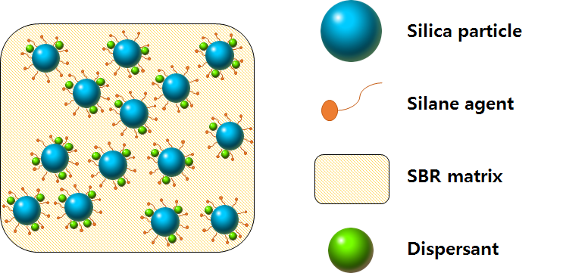
Recent Publications
- GUI, Yan, et al. Preparation and performance of silica/SBR masterbatches with high silica loading by latex compounding method. Composites Part B: Engineering, 2016, 85: 130-139.
- SEO, Byeongho, et al. Characterization of AN-SBR/Silica compound with acrylonitrile as a polar group in SBR. Macromolecular research, 2013, 21.7: 738-746.
- CHOI, Sung‐Seen; NAH, Changwoon; JO, Byung‐Wook. Properties of natural rubber composites reinforced with silica or carbon black: influence of cure accelerator content and filler dispersion. Polymer international, 2003, 52.8: 1382-1389.
- CHOI, Sung‐Seen; PARK, Byung‐Ho; SONG, Hanjong. Influence of filler type and content on properties of styrene‐butadiene rubber (SBR) compound reinforced with carbon black or silica. Polymers for Advanced Technologies, 2004, 15.3: 122-127.
- XIA, Lin, et al. Preparation of epoxidizedEucommiaulmoides gum and its application in styrene‐butadiene rubber (SBR)/silica composites. Polymers for Advanced Technologies, 2017, 28.1: 94-101.


He is in master’s course and his major is Chemical engineering in Hanyang University. Also, he is a member of Research Institute ofIndustrial Technology Convergencein Korea Institute of Industrial Technology (KITECH). His Research Institute leads industrialconvergence technology and explores future growth engines to drive the Republic of Korea’s economy by developing and commercializing intelligent robots, high-tech medical fibers, ultra-precision nanotechnology, wellness systems, and packaging technology. He is especially interested in polymer chemistry such as hydrogel.
Email: 90kbk@kitech.re.kr

Notes/Comments:

