The silica dispersing effects of silica-SBR composites with dispersing agent : poly(styrene-allyl alcohol) and poly(styrene-methyl methacrylate)
B.K Kang, Master’s course, KITECH, KOREA,
M.S Kim, Master’s course, KITECH, KOREA,
J.S Kim, Doctor’s course, KITECH, KOREA,
Y.W Chang, Ph.D, Hanyang University, KOREA,
And D.H Kim, Ph.D, KITECH, KOREA

Abstract (300 word limit)
The higher silica content in the tire-tread rubber can maximize the efficiency of the vehicle. However, silica does not mix well with other mixtures, including the tire-tread rubber. This phenomenon deteriorates the various properties of the tire-tread rubber. Therefore, We have tried to improve the dispersity of silica in tire-tread rubber by using dispersant. The dispersion of silica in tire-tread Styrene-Butadiene Rubber (SBR) is one of important factors in the mechanical properties of it. We prepared dispersants to enhance silica content and dispersity in SBR using Wet master batch (WMB) system. The dispersants were prepared by copolymerization of styrene with allyl alcohol or methyl methacrylate. The synthetic conditions of dispersants were changed to improve the silica loading content and dispersity in WMB system for the preparation of silica-SBR composites. The WMB system was consisted of the steps involving dispersants synthesis, silica modification, dispersion of modified silica in SBR emulsion latex, and coagulation of silica-SBR composites. We confirmed the structure of the dispersants using FT-IR. The content of silica in the composites was measured by thermal gravimetric analysis (TGA) according to the types of dispersants. Also we study the payne effect with Rubber Process Analyzer (RPA) instrument and dynamic viscoelasticity with Dynamic Mechanical Analysis (DMA) instrument. We measured the mechanical properties of them such as tensile strength and modulus of M300. We found that the optimal types and content of dispersants for silica-SBR composites.

Image
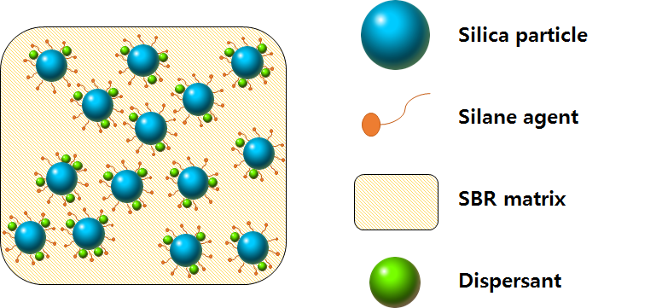
Recent Publications (minimum 5)
- BOURGEAT-LAMI, E.; ESPIARD, Ph; GUYOT, A. Poly (ethyl acrylate) latexes encapsulating nanoparticles of silica: 1. Functionalization and dispersion of silica. Polymer, 1995, 36.23: 4385-4389.
- CHOI, Sung‐Seen; PARK, Byung‐Ho; SONG, Hanjong. Influence of filler type and content on properties of styrene‐butadiene rubber (SBR) compound reinforced with carbon black or silica. Polymers for Advanced Technologies, 2004, 15.3: 122-127.
- CHOI, Sung‐Seen; NAH, Changwoon; JO, Byung‐Wook. Properties of natural rubber composites reinforced with silica or carbon black: influence of cure accelerator content and filler dispersion. Polymer international, 2003, 52.8: 1382-1389.
- Yan Gui, Junchi Zheng, Xin Ye, Dongli Han, Meimei Xi, Liqun Zhang (2016). Preparation and performance of silica/SBR masterbatches with high silica loading by latex compounding method. Composites Part B: Engineering 85, 130-139
- Byeongho Seo, Heejeong Kim, Hyun-jong Paik, Gwang-hoon Kwag, and Wonho Kim (2013) Characterization of AN-SBR/Silica Compound with Acrylonitrile as a Polar Group in SBR, Macromolecular Research, 21(7), 738-746

 Biography (150 word limit)
I am studying Chemical engineering in Haynyang University as master’s degree. Also I am working at Korea Institute of Industrial Technology (KITECH). Our company research Institute of Industrial Technology Convergence leads Industry Convergence Technology and explores future growth engines to drive the economy by developing and commercializing intelligent robots, high-tech medical fibers, ultra-precision nanotechnology, wellness systems, and packaging technology. I am interested in polymer chemistry such as hydrogel.
Email: 90kbk@kitech.re.kr

Notes/Comments:

