Characterization of Poly(lactic Acid) Foams produced by extrusion with different chemical blowing agents
Akos Kmetty^{1,2,} Katalin Litauszki¹
¹Department of Polymer Engineering, Faculty of Mechanical Engineering, Budapest University of Technology and Economics, Muegyetem rkp. 3., H-1111 Budapest, Hungary. ²MTA–BME Research Group for Composite Science and Technology, Muegyetem rkp. 3., H-1111 Budapest, Hungary

Abstract

Nowadays the number and amount of polymers produced from renewable resources are increasing considerably. Global market forecasts predict a fourfold increase until 2019 (7.8 million ton/year). Polymer foams nowadays are mostly produced from petroleum-based petrochemical materials. Foamed products, such as packaging and insulating materials, are made by physical, chemical and bead foaming techniques. A great disadvantage of materials and products made from them is that they are difficult and costly to recycle, cannot be decomposed biologically, and are a considerable load on the environment after they lose their function. Renewable resource-based and biodegradable polymers offer an environmentally friendly alternative. Of all biopolymers, poly(lactic acid) (PLA) receives the most attention nowadays. It is a thermoplastic polyester which can be produced entirely from agricultural sources, e.g. sugarcane, and is biodegradable by composting. PLA in itself is rigid (Young’s modulus: ~2500 MPa), breaks easily (Charpy impact strength: ~4 kJ/m²) and has low strain at break (~3%). Its D-lactide content and functional additives can greatly influence its properties. The comprehensive characterization of its chemical foaming and the bio-foam produced this way is a new direction of research. PLA can be used to develop biopolymer foam products that can be a viable alternative to single-use non-biodegradable foam products, such as food industry trays and padding foams. The lecture presents the effects of various kinds (e.g. exothermic) of chemical foaming agents on the morphological and mechanical properties of PLA foam. We used PLAs with different D-lactide contents. The PLA foams were manufactured with a twin-screw extruder. We produced rod-shaped foam specimens. The chemical foaming agents and the PLA foams made with them were tested morphologically (e.g. Differential Scanning Calorimetry) and mechanically (e.g. foam strength). The cell structure was characterized by scanning electron microscopy.

Image
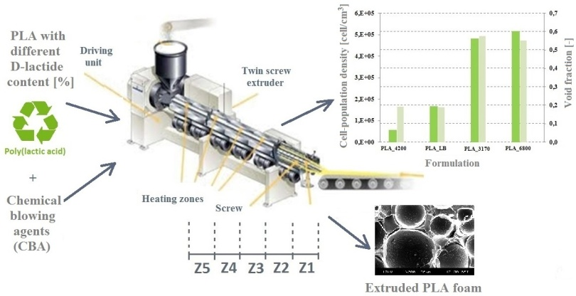
Acknowledgement
Supported by the ÚNKP-17-4-III New National Excellence Program of the Ministry of Human Capacities. This research was also supported by The National Research, Development and Innovation Office (NVKP_16-1-2016-0012).
Recent Publications
- Nova Institute: Bio-based Building Blocks and Polymers in the World. www. bio-based.eu
- Auras R, Lim L-T, Selke E M S, Tsuji H (2010) Poly(lactic acid). Synthesis, structures, properties, processing and application. Wiley, Hoboken, New Jersey.
- Julien J M, Quantin J C, Bénézet J C, Bergeret A, Lacrampe M F, Krawczak P (2015) Chemical foaming extrusion of poly(lactic acid) with chain-extenders: Physical and morphological characterizations. European Polymer Journal 67:40–49.
- Zimmermann VG M, Paola da Silva M, J Zattera J A, Santana MC R (2017) Poly(lactic acid) foams reinforced with cellulose micro and nanofibers and foamed by chemical blowing agents. Journal of Cellural Plastics
- Göttermann S, Weinmann S, Bonten C, Standau T, Altstadt V (2016) Modified standard polylactic acid (PLA) for extrusion foaming. AIP Conference Proceedings 1779.

Biography
Akos Kmetty’s research interests are development of self-reinforced petroleum-based and bio-based polymer composites and the analysis of renewable resource-based polymer materials and composites. He works as assistant professor at the Budapest University of Technology and Economics, Faculty of Mechanical Engineering, Department of Polymer Engineering. In 2012 he joined the MTA–BME Research Group for Composite Science and Technology as research fellow. Now he focuses on the production and characterization of bio-polyester-based foams produced by extrusion techniques via chemical and physical blowing methods. His research activities include the analysis of the morphological and mechanical properties of bio-polymer foams and he is examining the relationships between the manufacturing parameters and material properties.
Email: kmetty@pt.bme.hu

