Study of coumarin incorporation in therapeutic polymers
M. José Carrero, Ana M. Borreguero, Juan F. Rodríguez, and María J. Ramos*
Institute of Chemical and Environmental Technology (ITQUIMA), Department of Chemical Engineering, University of Castilla-La Mancha, Avda. Camilo José Cela 1A 13004 Ciudad Real, Spain.

Abstract

Poly(ethylene oxide)-poly(propylene oxide) (PEO-PPO) block copolymers stand out among amphiphilic molecules due to the possibility of modifying their hydrophilic/hydrophobic character easily, just varying the proportion between the PEO and PPO molecules respectively. This property together with their biocompatibility and biodegradability make them, and their derivatives, suitable for products formulation in industries ranging from agriculture to pharmaceuticals and controlled release of drugs. Thus, these copolymers are able to form thermodynamically stable micelles in aqueous solution above a certain copolymer concentration, CMC (critical micelle concentration) that can improve the poor solubility of the drugs. Moreover, the introduction of glycidyl propargyl ether (GPE), which contains triple bonds, in the copolymer chain allows to obtain functionalized terminal alkynyl-polyethers suitable for future click attachment, with the objective of enlarge the drug lifetime in the body. The ultimate purpose of this work is to obtain a tailor-made polymeric drug carrier able to incorporate the coumarin (anticancer agent) which will provide the two aforementioned benefits.

First, PEO-PPO-GPE triblock copolymers were synthesized through nucleophilic ring-opening polymerization, maintaining the mass ratio between hydrophilic/hydrophobic segments (50/50) in all cases, but changing the ratio for the hydrophobic monomers (PPO and GPE) to increase the GPE mass percentages in the final copolymer from 0 to 15 percent. Subsequently, on the one hand, the coumarin was loaded in polymeric micelles with different percentages of GPE using direct dissolution method. Based on the DLS results, the micelles size was in the suitable range (10-200 nm) to enable its absorbability by the target cells and this size increased when coumarin was added, confirming its incorporation. On the other hand, the click reaction based on the use of Cu (II) as catalyst, between the PEO-PPO-GPE copolymers and azide-coumarin was successfully carried out according to FTIR and NMR analysis.

Image
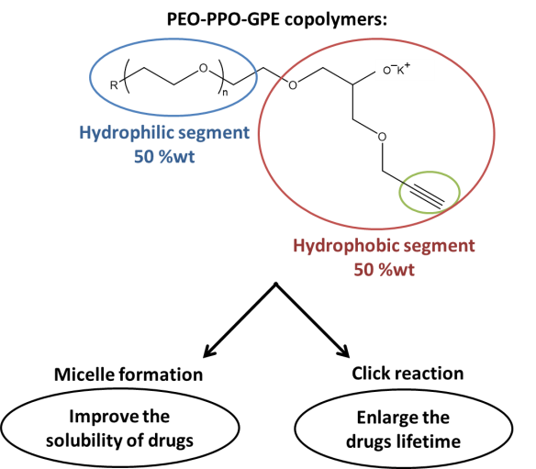
Figure 1: PEO-PPO-GPE copolymers structure and their possibilities of drugs incorporation

Recent Publications
- Gracia E, García MT, Borreguero AM, De Lucas A, Gracia I, Rodríguez JF (2017) Functionalization and optimization of PLA with coumarin via click chemistry in supercritical CO2. Journal of CO2 Utilization 20: 20-26.
- De Haro JC, Rodríguez JF, Pérez Á, Carmona M (2016) Incorporation of azide groups into bio-polyols. Journal of Cleaner Production 138: 77-82.
- Borreguero AM, Muñoz M, De Haro JC, Carmona M, Rodríguez JF (2016) Zidovudine insertion in tailor-made propylene and ethylene oxide copolymers. Reactive and Functional Polymers 101: 1-8.
- Cabezas LI, Gracia I, Garcia MT, de Lucas A, Rodriguez JF (2013) Production of biodegradable porous scaffolds impregnated with 5-fluorouracil in supercritical CO2. Journal of Supercritical Fluids 80: 1-8.
- Velencoso MM, Gonzalez ASB, García-Martínez JC, Ramos MJ, De Lucas A, Rodriguez JF (2013) Click-ligation of coumarin to polyether polyols for polyurethane foams. Polymer International 62: 783-790.

Biography
M. José Carrero is PhD student at the University of Castilla-La Mancha (UCLM). Her research focuses on the synthesis of polymer-drug conjugates to controlled delivery of drugs, and currently she has participated in one congress obtaining the best presentation award in 2017.
Ana M. Borreguero is lecturer at UCLM. She has published 27 papers in high impact journals indexed in the JCR and she has contributed in more than 45 congresses of recognized prestige. Moreover, she has participated in several research projects.
Juan F. Rodríguez is lecturer at UCLM and Director of the Institute of Chemical and Environmental Technologies (ITQUIMA). He has published more than 170 papers, 30 book chapters and he has participated in more than 170 national and international congresses.
María J. Ramos is lecturer at UCLM. She has published more than 45 papers in reputed journals and she has participated in several research projects with private and public economical financial support.
Email:MariaJesus.Ramos@uclm.es

Notes/Comments:

