Tannic acid reduced GO and electrochemical properties of PANI/TA-rGO composite
Xueyan Zhao, PhD student, Leibniz Institute of Polymer Research, Dresden, Germany
Jürgen Pionteck, Doctor, Leibniz Institute of Polymer Research, Dresden, Germany

Abstract
Supercapacitor, which can be divided into electrochemical double layer supercapacitor (EDLC) and pseudocapacitor, is an attractive environment-friendly energy supplier. And composition is a promising way to combine the high power density of carbon-based EDLC and high energy density of pseudocapacitors based on conductive polymers or transition metal oxidant. Among the composites for the use of supercapacitor electrode, reduced graphite oxide-based polyaniline composite (PANI/rGO) is cost-efficient, easy to synthesize and suitable for large-scale manufacture. However, there are two main obstacles for the development of PANI/rGO composite. Firstly, commonly used reducers, such as hydrazine hydrate (HH) and sodium borohydride, are toxic. Secondly, rGO tend to restack after reduction, resulting in a non-uniform dispersion inside the PANI. In this study, we used an environment friendly tannic acid (TA) as reducer, and the electrochemical properties of PANI/TA-rGO composites were investigated. Additionaly, TA is expected to interact with rGO and develop the dispersion of rGO, therefore additionally surface modification or addition of dispersant can be avoided.
X-ray diffraction and Raman spectra indicate that, the reducing efficiency of TA could be enhanced by extending the reduction time. Compared with HH, TA presents a less reducing efficiency, but the rGO-TA shows better dispersion in the water than the rGO-HH. Therefore, the PANI/rGO-TA composites own much higher specific surface area and higher rate capability than the PANI/rGO-HH composite. The specific capacitance of PANI/rGO composite relies not only on the specific surface area, but also on the conductivity. PANI/rGO-TA-24h, in which the rGO was prepared by using TA as reduced for 24 h, shows the highest specific capacitance in this study. Moreover, the morphology of PANI could be influenced by the surface functionality of rGO.

Image
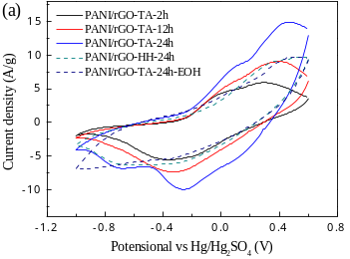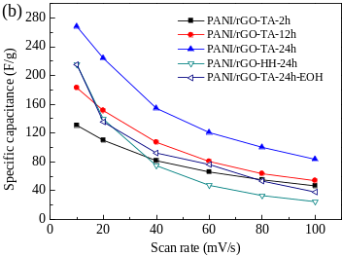
Figure 1 (a) Cyclic voltammograms under a scan rate of 20 mV/s and (b) the specific capacitance of PANI/rGO-TA (1:0.1) and PANI/rGO-HH (1:0.1) composites.

Recent Publications
- Abad, B., et al., Improved power factor of polyaniline nanocomposites with exfoliated graphene nanoplatelets (GNPs). Journal of Materials Chemistry A 2013, 1 (35), 10450-10457.
- Eftekhari, A., et al., Polyaniline supercapacitors. Journal of Power Sources 2017, 347, 86.
- Cho, S., et al., Fabrication of water-dispersible and highly conductive PSS-doped PANI/graphene nanocomposites using a high-molecular weight PSS dopant and their application in H₂S detection. Nanoscale, 2014. 6(24): 15181-15195.
- Lei, Y., et al., Hydrolysable tannin as environmentally friendly reducer and stabilizer for graphene oxide. Green chemistry, 2011. 13(7): 1655-1658.
- Luo, J., et al., Tannic acid induced self-assembly of three-dimensional graphene with good adsorption and antibacterial properties. ACS Sustainable Chemistry & Engineering, 2016. 4(3): 1404-1413.

Biography
Xueyan Zhao is a PhD student at Dresden University of Technology (TU Dresden) majoring in chemistry. She is belonging to the Functional Nanocomposites and Blends department of Leibniz Institute of Polymer Research. Her present research work is mainly on developing supercapacitor electrode material based on polyaniline/carbon composites. She got the master degree of Material Engineering at the Polymer science and Engineering College of Sichuan University in 2012. Then she received the Scholarship from the China Scholarship Council and further study as a PhD student in TU Dresden Germany.
Email: zhao-xueyan@ipfdd.de

