Determination of semicarbazide in fish by molecularly imprinted stir bar sorptive extraction coupled with high performance liquid chromatography
Qin Hu, PhD, Nanjing Medical University, Nanjing, China

Abstract
A novel molecularly imprinted stir bar (MI-SB) for sorptive extraction of semicarbazide (SEM) was fabricated in present paper. The coating of the stir bar was characterized by scanning electron microscopy, Fourier-transform infrared spectroscopy, dynamic adsorption and static adsorption tests. In order to optimize the MI-SB extraction operating conditions for the analysis of SEM, extraction and desorption solvents affecting the extraction performance of MI-SB, the extraction and desorption time of MI-SB for SEM were optimized. Under the optimized conditions, the saturated adsorption of MI-SB was about 4 times over that of non-imprinted stir bar (NI-SB). Urea, DMAC, cysteine and NFZ were used to verify the selectivity of MI-SB. The recoveries of the MI-SB for SEM kept almost no changed, and all above 95% when urea, DMAC, cysteine and NFZ were added into SEM solution. The result showed that these analogues of SEM did not affect the adsorption of MI-SB to SEM. The different batches of MI-SBs to adsorb SEM had no significance difference. Moreover, after three extractions for a single MI-SB, the recovery of SEM was 86% with RSD of 4.78% (n=3). The results of experiment revealed that the MI-SB was reproducible and could be used for three times at least. A method to determine SEM was established by coupling MI-SB sorptive extraction with HPLC-UV. The liner range was 1-100 ng/mL for SEM with a correlation coefficient of 0.9985. The limit of detection was about 0.59 ng/mL, which was below the minimum required performance limit of SEM in meat products regulated by European Union. The method was applied to the determination of SEM in fish sample with satisfactory results.

Recent Publications
- Cooper K.M., Samsonova J.V., Plumpton L., Elliott C.T., Kennedy D.G. (2007) Enzyme immunoassay for semicarbazide-The nitrofuran metabolite and food contaminant, Anal. Chim. Acta 592: 64-71.
- Gomez-Caballero A., Diaz-Diaz G., Bengoetxea O., Quintela A., Unceta N., Goicolea M.A., Barrio R.J. (2016) Water compatible stir-bar devices imprinted with underivatised glyphosate for selective sample clean-up, J. Chromatogr. A 1451: 23-32.
- Balbão M.S., Bertucci C., Bergamaschi M.M., Queiroz R.H., MalfaráW.R., Dreossi P.M.L, De S.A., Queiroz M.E. (2010) Rifampicin determination in plasma by stir bar-sorptive extraction and liquid chromatography, J. Pharmaceut. Biomed. 51: 1078-1083.
- Díaz-Álvarez M., Turiel E., Martín-Esteban A. (2016) Molecularly imprinted polymer monolith containing magnetic nanoparticles for the stir-bar sorptive extraction of triazines from environmental soil samples, J. Chromatogr. A 1469: 1-7.
- Ling Z., Xu G., Wei F., Jing Y., Qin H. (2015) Determination of melamine in powdered milk by molecularly imprinted stir bar

sorptive extraction coupled with HPLC, J. Colloid Interf. Sci. 454: 8-13.
- Lei Y., Xu G., Wei F., Yang J., Hu Q. (2014) Preparation of a stir bar coated with molecularly imprinted polymer and its application in analysis of dopamine in urine, J. Pharmaceut. Biomed. 94: 118-124.
Image
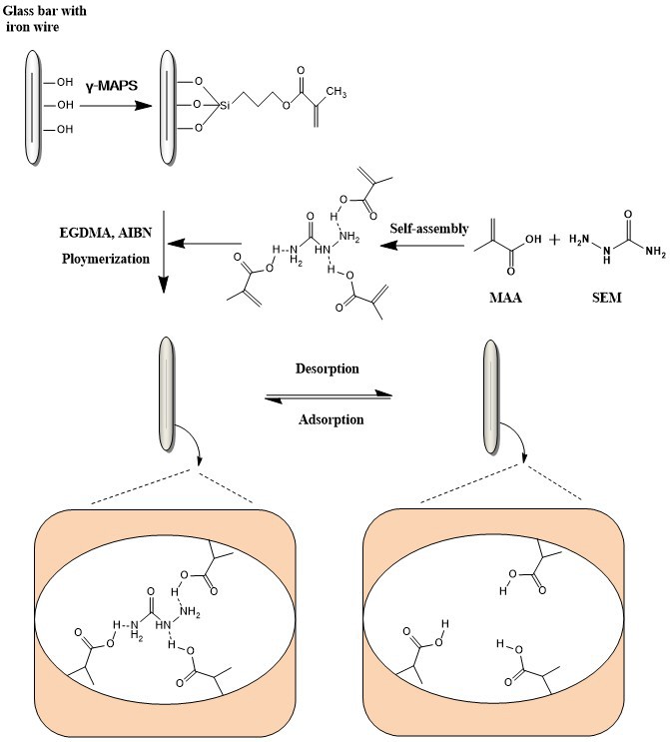
Scheme 1 Schematic representation of the preparation of MIP-SB.

 Biography
Qin Hu has her expertise in preparation of molecularly imprinted polymers, nano carbon dots and quantum dots，and their application to the detection of micro materials in life system.

Email: huqin@njmu.edu.cn

