Dynamic polymer networks based on reversible aromatic disulfide bond: From self-healing to processability, recyclability and more
Alaitz Rekondo, PhD, CIDETEC Foundation, SPAIN

Abstract (300 word limit)
Thermoset materials are those having a crosslinked network fixed by irreversible covalent bonds. These polymers exhibit excellent mechanical strength, solvent resistance and thermal stability. The above mentioned properties make thermoset materials suitable for numerous applications, such as, biomedical materials, adhesives, coatings and structural applications. Due to their thermosetting nature, one of the major drawbacks of classical thermosets is the impossibility to be melted after their curing step. This makes their reprocessing and recycling impossible limiting their use in some applications. This limitation has been overcome by means of the polymeric networks containing dynamic covalent bonds that have found applications in reprocessable/recyclable thermosets and self-healing polymers¹⁻³. The idea underneath is to introduce exchangeable bonds in a polymer network, which can rearrange thermally (or under another stimulus), while keeping the network integrity. This enables unprecedented functionalities to such polymer networks, such as self-healing capacity, thermoforming, repairing, reprocessing or recycling.
CIDETEC has developed an interesting range of innovative dynamic thermoset materials by using as a crosslinking agent a commercially available hardener containing reversible aromatic disulfide bonds⁴⁻⁶. The introduction of dynamic aromatic disulfide moieties in different polymer matrixes has enabled the development of i) novel polyurethane elastomers with complete self-healing capacity at room temperature or ii) reprocessable, repairable and recyclable epoxy resin based thermoset composites. Such systems constitutes a step forward towards the implementation of advanced polymeric materials in industrial applications, and offers the possibility of obtaining a new generation of fiber-reinforced composite structures with enhanced functional properties.

Image
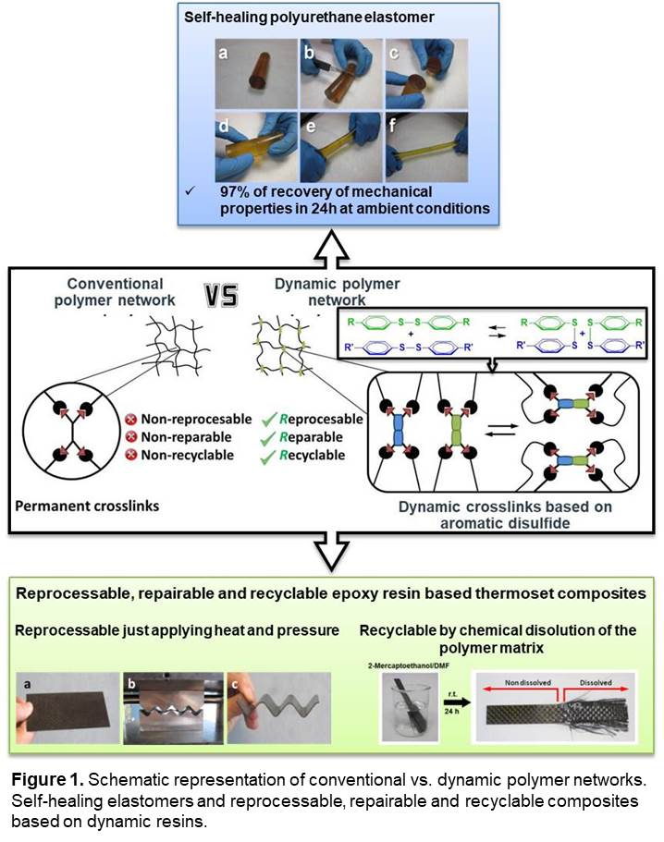
Recent Publications (minimum 5)
- Y. Jin, C. Yu, R. J. Denman, W. Zhang, Chem. Soc. Rev. 2013, 42, 6634.
- N. Roy, B. Bruchmann, J.-M. Lehn, Chem. Soc. Rev. 2015, 261, 155.
- C. J. Kloxin, C. N. Bowman, Chem. Soc. Rev. 2013, 42, 7161.
- A. Rekondo, R. Martin, A. Ruiz de Luzuriaga, G. Cabanero, H. J. Grande, I. Odriozola, Mater. Horiz. 2014, 1, 237.
- R. Martin, A. Rekondo, A. Ruiz de Luzuriaga, G. Cabanero, H. J. Grande, I. Odriozola, J. Mater. Chem. A. 2014, 2, 5710.
- A. Ruiz de Luzuriaga, R. Martin, N. Markaide, A. Rekondo, G. Cabanero, J. Rodriguez and I. Odriozola, Mater. Horiz. 2016, 3, 241.

Biography (150 word limit)
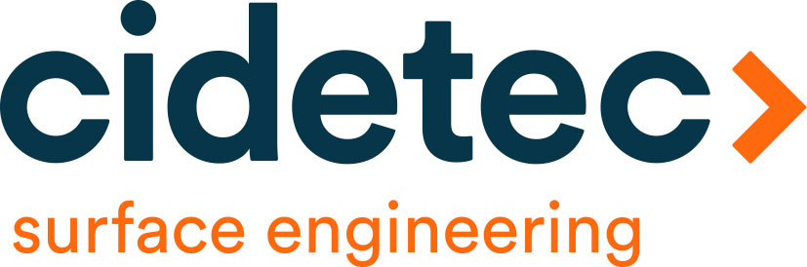
Dr. Rekondo has been developing her research in the field of elastomeric PUU materials since 2003. Before joining CIDETEC she was working for 6 years in the R&D department of an industrial company focused on the field of adhesives and sealants, where she developed and coordinated several research projects. She has been Head of the Laboratory of Sealants and Adhesives for a year in the same company, leading projects aimed to new product development. She currently is the head of the Polymers & Composites Unit of CIDETEC, where her main research activities focus on the development of new families of dynamic materials (composites, elastomers, adhesives and coatings) based on reversible chemical bonds.
Email: arekondo@cidetec.es

Notes/Comments:

Presenting author details
Full name: Alaitz Rekondo
Contact number: +34 943 309 022
Mail id: arekondo@cidetec.es
Category: Oral presentation

