New Drug-Loaded Phosphorus Dendrimers: Synthesis, Characterization and Biological Evaluation

Nabil .El Brahmi, Euromed Research Institute, Euromed University of Fes (UEMF), Route de Meknes, 30000, Fès, Morocco.

Abstract

Dendrimers are monodisperse nanosized polymeric molecules composed of a large number of perfectly branched monomers. The versatile chemical composition of dendrimers strongly offers a variety of applications in different areas such as for instance: chemistry, catalysis, and medicine. Currently, the potential of using dendrimers as nano-carriers for drug delivery is revolutionizing medicine by improving the efficiency and reducing the toxicity of various treatments [1].
Dendrimers can form either covalent or non-covalent (encapsulation) bonds with bioactive molecules. In the case of covalent bond, drug can be directly attached to dendrimer or via a linker – cleavable or not - and the resulting drug-loaded dendrimer can act as a nano-vehicle for drug transport and controlled release.
We will present the synthesis and characterization of original functionalised phosphorus dendrimers [2] (generations G1 to G3) containing various functional groups on their peripheries such as arene-copper (II) and ethacrynic acid moieties. Also, we will report the studies of the very interesting cytotoxicity activities against different solid and liquid cancer cell lines of these new dendrimers.

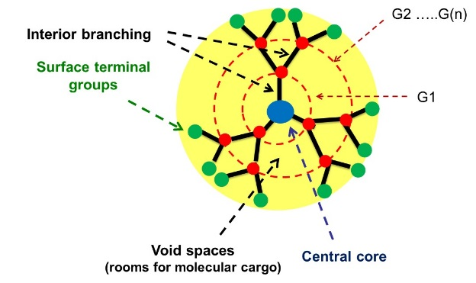

Figure 1. 2D structural units of dendrimers for medicinal chemistry (G: Generation of dendrimers)

Recent Publications
- a) R. K. Tekade, P. V. Kumar, N. K. Jain, Chem. Rev. 109, 2009, 49. b) S. H. Medina, M. E. H. El-Sayed, Chem. Rev. 109, 2009, 3141. c) D. Astruc, E. Boisselier, C. Ornelas, Chem. Rev. 109, 2010, 1857. d) S. El Kazzouli, N. El Brahmi, S. Mignani, M. Bousmina, M. Zablocka, J-P. Majoral, Current Med. Chem. 2012, under press. e) S. El Kazzouli, S. Mignani, M. Bousmina, J-P. Majoral, New J. Chem. 2012, 36, 227.
- a) S. Mignani, N. El Brahmi, L. Eloy, J. Poupon, V. Nicolas, A. Steinmetz, S. El Kazzouli, M. Bousmina, M. Blanchard-Desce, A. M. Caminade, J. P. Majoral, T. Cresteil. European Journal of Medicinal Chemistry, 2017, 132, 142-156. b) N. El Brahmi, S. El Kazzouli, S. Mignani, R. Laurent, S. Ladeira, A. M. Caminade, M. Bousmina, J. P. Majoral. Tetrahedron, 2017, 73, 1331-1341. c) S. Mignani, N. El Brahmi, S. El Kazzouli, L. Eloy, D. Courillaud, J. Caron, M. M. Bousmina, A.M. Caminade, T. Cresteil, J.P. Majoral. European Journal of Medicinal Chemistry, 2016, 122, 21, 656-673. d) N. El Brahmi, S. El Kazzouli, S. Mignani, E. M. Essassi, G. Aubert, R. Laurent, A. M. Caminade, M. Bousmina, T. Cresteil, J-P. Majoral. Mol. Pharmaceutics. 2013, 10, 1459-1464. e) M. Hayder, M. Poupot, M. Baron, D. Nigon, C. O. Turrin, A. M. Caminade, J. P. Majoral, A. R. Eisenberg, J. J. Fournie, A. Cantagrel, Science Translational Medicine, 3(81), 2011, 81ra35



Nabil El Brahmi was born in Taounate (Morocco). He obtained in 2007 his M.Sc. in pharmaceutical chemistry from the University Mohamed V (Rabat, Morocco). In 2013, he received his Ph.D in organic chemistry from the same University in collaboration with the Laboratoire de Chimie de Coordination (LCC) at CNRS of Toulouse (France). From May 2013 to January 2014, he worked as a postdoctoral fellow at the Euro-Mediterranean University of Fes, Morocco (UEMF) in collaboration with the LCC. In 2014 he was appointed Assistant Professor at the UEMF. His current research interests are the synthesis of bioactive molecules and drug delivery.

Email: n.elbrahmi@ueuromed.org

