Synthesis and thermal properties of new Nano-star shaped block copolymers

Hadi S. Al-Lami Baqer A. Al-Mayyahi, Athir M. Haddad
Department of Chemistry, College of Science, University of Basrah, Basrah-Iraq

Abstract

Over the recent few years, Controlled “Living” Radical Polymerization (CRP) has undergone notable development and has become one of the most capable and vigorous synthetic methods in modern polymer chemistry. CRP is interesting from both scientiﬁc and industrial viewpoints, as the discovery of these reactions opened up a whole new world of possibilities regarding the design of novel polymeric architectures and compositions. CRP may be deﬁned as a polymerization reaction, where no unwanted side reactions such as transfer or termination take place, and where all polymer chains are initiated simultaneously. Thus, the growing ends of the polymer chains are active indeﬁnitely and an ideally living system should yield polymers with predetermined molecular weight and narrow molecular weight distribution (PDI = M_{w}/M_{n}) close to unity. Among the developed, controlled radical polymerization processes, one approach was the most successful. Control via a reversible redox reaction between alkyl halides and transition metal complexes, this process called Atom Transfer Radical Polymerization (ATRP).
Herein, the work is demonstrating a synthesis of well-defined star-shaped block copolymers having eight arm poly(POSS lactide-b-N- hydroxyethyl acrylamide) inorganic/organic polymers prepared by atom-transfer radical polymerization with the increasing of N-hydroxyethyl acrylamides (HEA). Thus, we believe that increasing the number HEA polymer chains of arms will reflect positively on the thermal stabilities of the copolymers and to improve their different application efficiencies since they appear to have nanofiber structures.

Their syntheses were confirmed by Fourier transform infrared spectroscopy (FTIR), nuclear magnetic resonance (1H NMR and 13CNMR), gel permeation chromatography (GPC). The characterization of the copolymers was verified the expected structure and composition with the presence of nanofibre structure as examined by scanning electron microscope, and it was found that their size decreased with increasing L-lactide monomer chain length. This was positively reflected on their thermal stabilities determined from TGA micrographs like decomposition temperature at 50% loss of the sample weight, decomposition rate, and the char content, etc.

Image

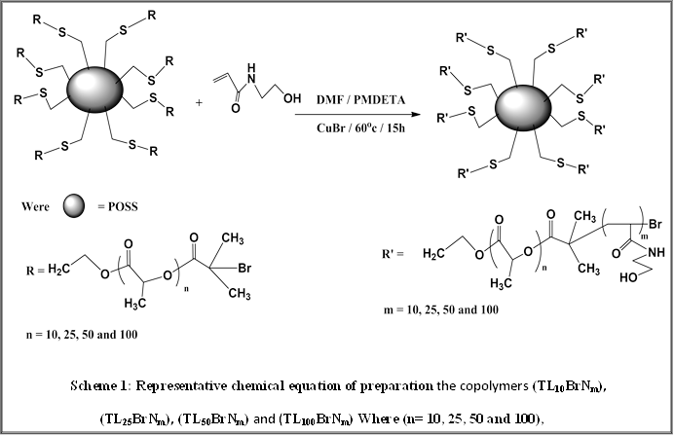

Recent Publications
- Al-Mayyahi BA, Haddad AM, Al-Lami HS (2017) Karbala International Journal of Modern Science Characterization and thermal stability of nano eight arm copolymers synthesized by atom transfer radical polymerization, 3:83-92.
- Al-Mayyahi BA, Al-Lami HS, Haddad AM (2016) Synthesis, characterization and thermal properties of the nano four arms poly(pentaerythritollactide‐b‐N,N‐dimethylaminoethyl methacrylate) derivatives, European Journal of Chemistry, 7 (4) 405‐409.
- Al-Mayyahi BA, Al-Lami HS, Haddad AM (2016) Synthesis, Characterization of Nano Four Arms Poly (Lactide-b-N-hydroxy ethyl acrylamide) via ATRP, Research Journal of Pharmaceutical, Biological and Chemical Sciences, 6(6):1269-1273.
- Sweah ZJ, Al-Lami HS, Haddad AM (2016) Preparation and Swelling Behavior of L-Lactide Interpenetrating Networks, Open Journal of Organic Polymer Materials, 6:119-133.
- Al-Mayyahi BA, Haddad AM, Al-Lami HS, Synthesis, Characterization and Thermal Behavior of Four Arms Poly(L-lactide) via Ring Opening Polymerization (2015) Chemistry and Materials Research 7(9):54-62.


Biography

Hadi Salman Al-Lami is working as Professor of polymer chemistry and In addition teaches courses in advance polymer chemistry, inorganic polymers, and biomaterial chemistry and supervising many M.Sc. and Ph.D. postgraduate students. He has published about 100 peer-reviewed papers and three books, beside 10 Iraqi Patents
Email: hadisalman54@yahool.com:

Notes/Comments:

