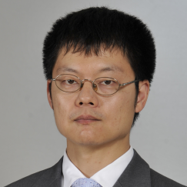

Title of the Abstract: Effective anionic UV curing for a thermally dismantlable photoadhesive having disulfide bonds
Author Name: Masahiro Furutani
Affiliation: Department of Pure and Applied Chemistry
University: Tokyo University of Science
Country: Japan

Abstract:
A thermally dismantlable photoadhesive system has been proposed. The photoadhesion is achieved via an effective anionic UV curing reaction of an epoxy resin, with a photobase generator and a base amplifier (BA) that is decomposed autocatalytically into a diamine. Both the diamine and resin have disulfide bonds in their molecular structures. Then, cross-linked networks having disulfide bonds with high density are fabricated. This curing system is applied to adhesion of two stainless substrates, where UV irradiation of 10000 mJ cm⁻² at a wavelength of 365 nm is carried out, followed by postbaking at 160 degree C for 30 min. The adhesive sample is dismantled with gentle heating (100 degree C) and a shear force, probably due to exchange reactions between disulfide bonds.

Biography:

Masahiro Furutani has completed his PhD in Engineering from The University of Tokyo in 2013. He is now a research associate of Pure and applied chemistry in Tokyo University of Science, working under Professor Koji Arimitsu in the area of UV curing systems of kinds of resins for the applications of coatings and adhesives.

Research Interests:
Organic material chemistry
References:
M. Furutani, A. Kakinuma, K. Arimitsu, J. Polym. Sci. A 2018, 56, 237.
M. Furutani, H. Kobayashi, T. Gunji, Y. Abe, K. Arimitsu, J. Polym. Sci. A 2015, 53, 1205.
Mail Id:
furutani@rs.tus.ac.jp
Contact Number:
+81-4-7124-1501

