A micro-rheological model to predict the morphology development in immiscible blends of polyolefins
BOUJELBENE.C.I.^{1.2}, CARROT.C.¹, MAJESTE.J.C.¹, LHOST.O²

¹ UMR CNRS 5223 Polymer Materials Engineering (University of Saint-Etienne, EU)
²Total Research Center Feluy-Belgique / TOTAL Normandy Refinery

Recently, the control of the evolution of polymer blend morphology during processing has received attention because of its great impact on the mechanical, barrier or electrical properties. In general polymer blend morphologies can be divided into two groups: dispersed and co-continuous. In the literature, several papers illustrate that the blend morphology depends on the composition, the rheological behavior of each component, the mixing conditions and the interfacial tension. The models proposed by Veenstra and Yu were used to understand the evolution of co-continuous morphology.
In this study, a prediction model of dispersed and co-continuous morphology has been established. Blends of HDPE/sPP, LDPE/iPP, at various PE to PP weight ratios (90:10, 80:20, 70:30, 60:40, 50:50, 40:60, 30:70, 20:80 and 10:90) prepared by twin-screw extruder were characterized. The interfacial tension was measured by the Palierne model [3]. The shear rate in the extruder was determined using the Ludovic software. Rheological studies were conducted in an Ares rheometer using parallel plate geometry. The experimental results onthe various blends show a good correlation between the interfacial area and the melt elasticity measured at low frequency. The PE/PP blends were observed by scanning electron microscopy (SEM) using staining agent to enhance electron density contrast. The characteristic dimension of dispersed (R) and co-continuous morphology (lc) were measured from SEM observations to obtain the interface areas as a function of the composition. The results were compared to the interface areas obtained using the predictive model. The model was partially validated and showed that the breakup mechanism was dominated by Rayleigh disturbances.

Keywords: Polymer, Blends, Morphology, Microrheology, Co-continuity
Professional Biography
Ilhem BOUJELBENE CHARFEDDINE obtained her engineering degree at the national school of engineers of sfax, Tunisia specialty engineering materials. She is currently in her third year of her PhD in Chemistry and Materials Science at Saint-Etienne University. She has CIFRE scholarship with Total company (CIFRE PhDs). So she is situated at the intersection of the industrial and academic worlds.

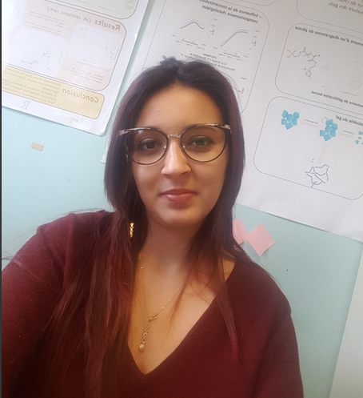
Email Id: ilhem-charfeddine@univ-st-etienne.fr

