Chin augmentation with cervical flaps associated with rhytidoplasty
Dr Márcio Manoel Ferreira da Cunha
Ferreira Segantini – Cirurgia Plástica
Uberlândia / MG / Brazil

Abstract

Introduction: The lack of chin projection in the lower third of the face is sometimes responsible for the breaking of the facial contour harmony. Alloplastic implants, fillers, and osseous advancements have been used to correct these deformities.

In this study, we propose a new maneuver to increase chin projection by using a cervical flap associated with rhytidoplasty.

Methods: We assessed 19 patients who underwent operations using the cervical flap for chin projection between January 2017 and July 2018. The inclusion criteria were only patients who desired chin augmentation without the use of prosthetics, fillers, or osseous approaches, and those who would undergo rhytidoplasty.

Results: A cephalometric analysis revealed improvements in chin projection and cervical contour, and no complications in the immediate or late postoperative period.

Conclusion: In addition to presenting satisfactory results and acceptance, the cervical flap used for chin augmentation eliminated the use of synthetic materials, reduced surgical costs, and improved safety and durability, achieving a more refined mandibular contour and natural chin projection.

Keywords: Mentoplasty; Rhytidoplasty; Chin augmentation; Cervicoplasty; Chin.



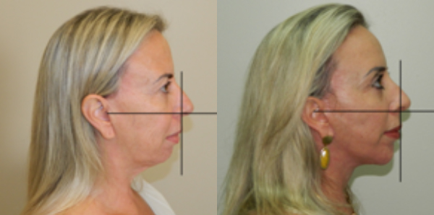

Recent Publications
Cunha M. (2020) - Chin augmentation with cervical flaps associated with rhytidoplasty. Brazilian Journal of Plastic Surgery - Ideas and Innovation - Year2020 - Volume35 - Issue 1
HIPERLINK


Biography

Dr.Márcio Manoel Ferreira da Cunha, full member of the Brazilian Society of Plastic Surgery and international member of the American Society of Plastic Surgeon, is a specialist in Face Surgery and, with more than 1,500 complete complete face surgeries, has been coordinating the service for 18 years of Plastic Surgery at Ferreira Segantini.
Email: marcio@ferreirasegantini.com.br

Notes/Comments:

