Abstract Template
Abstract Title: The Cervicofacial lift under Pure local anaesthesia diminishes the incidence of postoperative haematoma
Authors: Vivien MORIS1, Pierre BENSA1, Brice GERENTON1, Philippe RIZZI1, Sarah
CRISTOFARI2, Narcisse ZWETYENGA1, David GUILIER1

¹ Plastic surgery department in Dijon (University of Bourgogne, FR)
² Plastic surgery department in Tenon, Paris (University of Paris, FR)

Abstract (not more than 300 words)

INTRODUCTION :
The cervicofacial lift is a frequently performed procedure in plastic surgery. It is the reference technique for facial rejuvenation and restoration of the oval form of the face and it is essential to treat excess skin. One of the most frequent complications of this procedure is the formation of haematomas. The aim of this article is to analyze the incidence of bleeding in the standard cervicofacial lift carried out under pure local anaesthesia.

MATERIEL AND METHODS:
The entire operation, including liposuction and tightening of the SMAS, can be done under local anaesthesia. A total of 1500 patients, who have undergone cervicofacial lift under pure local anaesthesia between November 1995 and January 2016, were included in the study.

RESULTS:
The incidence of early bleeding (in the first 15 days following the operation) was recorded and analyzed. Pre- intra and postoperative monitoring of the arterial blood pressure revealed stable pressure in the peri-operative period. The mean difference in blood pressure when comparing the intraoperative to the postoperative periods was 7 mmHg for the systolic BP [range from 3 - 25] and 4 mmHg [range from 2 - 12] for the diastolic BP, with lower mean values in the postoperative period. We identified nine bleeding events in 1500 patients (0.6%).

DISCUSSION:
The cervicofacial lift under pure local anaesthesia does not radically modify the surgical technique. It allows better control of arterial blood pressure of patients throughout the surgical procedure and avoids fluctuations in blood pressure, which is one of the main causes of bleeding and haematoma formation. The infiltration of xylocaine adrenaline combined with the absence of hypotensive general anaesthesia diminishes the incidence of haematoma and ensures an early return home for the patients.

:

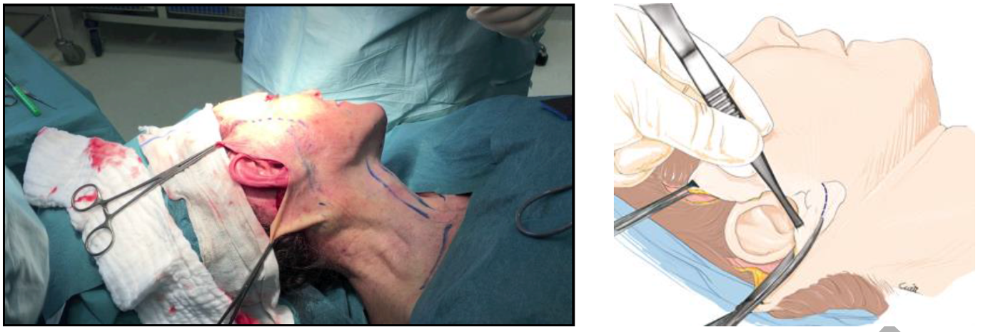

Keywords—FaceLift, SMAS dissection, Local anesthesia, lidocaine, aesthetic surgery

Professional Biography (100-150 words)

Dr Vivien Moris has completed his PhD at the age of 32 years from Paris Descartes University, his surgical school in the University of Burgundy and his medical school in the University of Strasbourg. He is the director of the plastic, aesthetic and reconstructive department in the University Hospital of Dijon. He has published more than 24 papers in reputed journals and has been serving as an editorial board member of repute. He presents innovative work all around the world in different conferences.

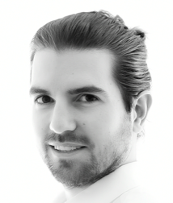
Paste your Photograph here

Email Id: morisvivien@gmail.com

Any Comments:
Note: To submit your abstract go through the following link: https://bit.ly/2GdI9Rn

