5th International Plastic Surgery Week
Primary umbilical endometriosis: excision and neo-omphaloplasty

Roberto Luiz Sodré
Plastic Surgeon – Hospital Maternity Leonor Mendes de Barros, São Paulo, Brazil

Abstract
Umbilical primary endometriosis is a rare condition that affects women of childbearing age. Spontaneous umbilical endometriosis presents lump in the navel, cyclic pain, discreet local bleeding during menstruation, with no history of previous surgery. The treatment is block excision of the lesion and umbilical cord with edges margin to avoid recurrence and immediate umbilical reconstruction in one stage.
The possibility of umbilical endometriosis should be considered when the presence of nodules and umbilical bleeding, even without previous surgery. The surgical technique provides total remission of the lesion and an umbilical natural scar.

Keywords – Endometriosis; Umbilicus; Rare diseases; Reconstructive surgical procedures.

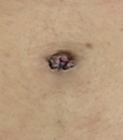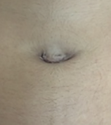
Umbilical endometriosis Posoperative (10 months)

Professional

Medical Residency: General e Plastic Surgery at the Hospital do Servidor Publico Municipal de São Paulo, 1992-1996.
Title: Full Member of the Brazilian Society of Plastic Surgery, 2004
Honorable Mention: Georges Arie Award - Scientific Work: "Mastoplasty Chiari in L: Changes Tactics" in the Brazilian Society of Plastic Surgery, 2007



