Abstract Template
Abstract Title: Fluorescent indocyanine green angiography: Preliminary results in microsurgery monitoring.
Moris V¹, Cristofari S², Stivala A¹, Lehre B¹, Gengler C¹, Rabuel V¹, Srouji A¹, Zwetyenga N¹, Guilier D¹.

¹ Plastic surgery department in Dijon (University of Bourgogne, FR)
² Plastic surgery department in Tenon, Paris (University of Paris, FR)

Abstract (not more than 300 words)

INTRODUCTION :
Pedicled flaps and free-tissue transfer flaps are used routinely to reconstruct hard and soft tissue defects in head and neck, limb, hand, thoracic and abdominopelvic reconstructive surgery. Indocyanine green (ICG), a fluorescent dye is a suitable tracer for vessel perfusion. The objective of this study is to evaluate the fluorescent indocyanine green angiography (FA ICG) in free flaps procedures.

MATERIEL AND METHODS:
Patients who had microsurgical flap reconstruction were included during the study period in a single center. The FA ICG was used at specific times. Intra-veinous injections of 0.1mg/kg of INFRACYANINE® (concentration 2.5mg/mL) were done intraoperatively. The Fluobeam® device programmed on sensitivity and mapping to interpret the data, was used. These different injections allowed to checked skin paddle perforators vessels, osseous perforators vessels, arterial and venous patency after anastomosis and the cutaneous, muscular and osseous perfusion.

RESULTS:
A total of 12 patients enrolled were 10 males and 1 female. Their mean age was 54.5 years (range 25-75 years). Of the 12 flaps, 8 were free flaps with 4 fibular flaps (3 for mandibular reconstruction and one for femur reconstruction); 2 radial forearm flaps for maxillary reconstruction; one latissimus free flap for tibia skin coverage and one retroauricular fasciocutaneous free flap for thumb skin coverage. We got to modify specific steps during surgery with 8 patients by using the FA ICG to anticipate potential complications: modifying the draw of the skin paddle, recut of this paddle, modifying the osteotomies, re-doing the anastomosis or modifying the position of the pivot point.

DISCUSSION:
The successful of salvage rate is linked to the delay between the onset of ischemia and its clinical assessment. FA ICG could be a reliable method for monitoring free-tissue transfers. This technique is objective, non invasive and facilitate a complex reconstructive procedure to augment is liability.

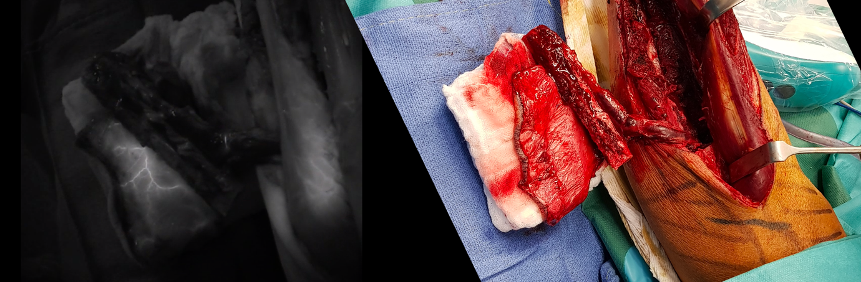

Keywords—Fluorescent indocyanine green angiography; Free flap; Head and neck reconstruction; Monitoring; Non invasive; Pedagogical tool

Professional Biography (100-150 words)

Dr Vivien Moris has completed his PhD at the age of 32 years from Paris Descartes University, his surgical school in the University of Burgundy and his medical school in the University of Strasbourg. He is the director of the plastic, aesthetic and reconstructive department in the University Hospital of Dijon. He has published more than 24 papers in reputed journals and has been serving as an editorial board member of repute. He presents innovative work all around the world in different conferences.


Paste your Photograph here

Email Id: morisvivien@gmail.com

Any Comments:
Note: To submit your abstract go through the following link: https://bit.ly/2GdI9Rn

