Septal Extension Graft: clinical experience and literature review
Guilherme C. P. Sella, M.D., Ph.D.¹
¹ Clínica Avançada de Otorrinolaringologia de Maringá, Brazil

Abstract (not more than 300 words)

Rhinoplasty in modern times basically consists of two essential steps: well-executed dorsum reconstruction (both reduction and increase of the dorsum) and the Septal Extension Graft (SEG) well positioned to provide projection, support and stability for the nasal tip, in addition to the format most desired. When it was first described approximately 20 years ago, SEG would not know that it would take such an important proportion. It is more than proven that grafts that are not anchored in the septum (such as columellar strut) present reasonable and unpredictable long-term results. Nowadays, there has been a difficult rhinoplasty with long-lasting and consistent results that does not use a graft in the septum that projects the lower cartilages to support the tip and better definition.
Thus, we will show our clinical experience associated with what is described in the literature about SEG, in addition to videos and illustrations, and clinical cases that were and were not used SEG with results in the short and long term. We will discuss the technique of how to perform SEG, complications (such as postoperative position change, loss of nasal projection, nasal tip lateralization) and unwanted effects (nasal tip stiffness, septum thickening, reduction of the nasal valve area), as well as how they can be approached to reduce these effects.

Keywords— Nasal tip location, Rhinoplasty, Septal Extension Graft, Tip projection

Professional Biography (100-150 words)

Guilherme Constante Preis Sella has medical residency in Otorhinolaryngology, and by the age of 31 has completed his PhD in Morphology of Facial Structures in the Department of Ophthalmology, Otorhinolaryngology and Head and Neck Surgery, Ribeirão Preto Medical School, University of São Paulo (FMRP-USP).
He currently works at his private clinic (Clínica Avançada de Otorrinolaringologia) in the city of Maringá (Brazil) and is a full professor in the chair of otolaryngology at UniCesumar Medical School, in addition to being responsible for the Academic League of Ophthalmology and Otorhinolaryngology of Maringá (LAOOM). He is a full member of the Brazilian Association of Otorhinolaryngology and Cervical-Facial Surgery (ABORL-CCF) and is also member of the Brazilian Academy of Facial Plastic Surgery (ABCPF). He has already held several courses and conferences focused on functional and aesthetic nasal surgery (rhinoplasty), and has some articles published and papers presented at conferences.

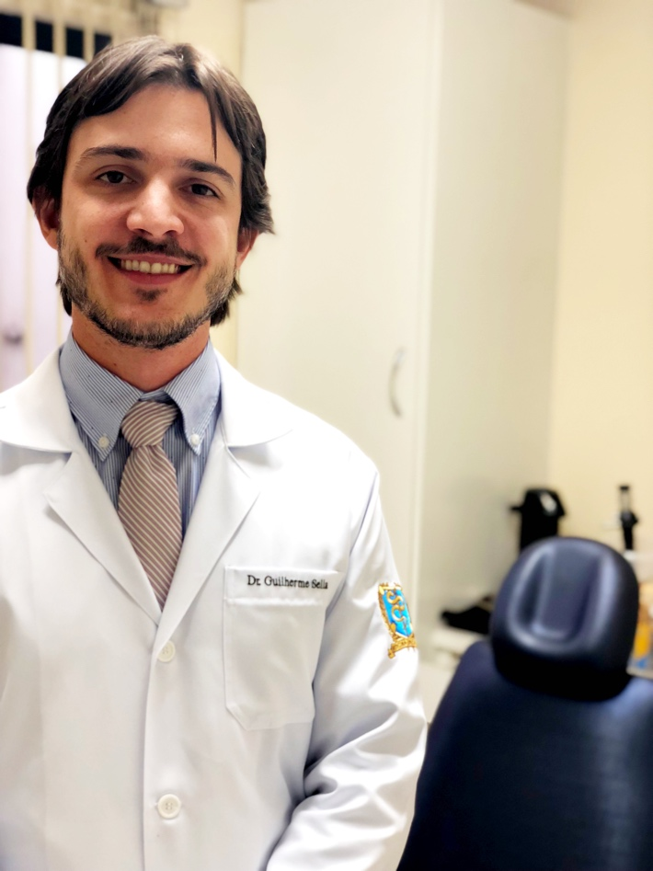

Email Id: guilherme_sella@yahoo.com.br

Any Comments: Address to complete CV: http://lattes.cnpq.br/2316412619285426
Note: To submit your abstract go through the following link: https://bit.ly/2GdI9Rn

