Abstract Template
Abstract Title: Eyebrow management adjunctive to blepharoplasty
Author: Alexander Martinez Rua

Author Affiliation (University of Antioquia, Colombia)

Abstract

Introduction: Superior blepharoplasty is one of the most frequent aesthetic procedures performed in the world. When performing the surgical plan, the position of the eyebrow should be evaluated because the postoperative result can be affected by eyebrow ptosis not corrected in the same surgical act.

Objective: To present the use of eyebrow elevation techniques that can be combined with blepharoplasty and the indications of these.

Conclusion: The identification and management of the eyebrow ptosis adjunct to the upper blepharoplasty improves the postoperative results

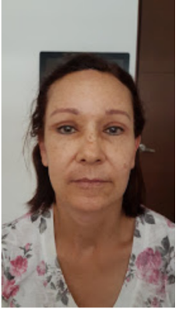

Keywords—Blepharoplasty, Eyebrow, Frontoplasty,

Professional Biography

Alexander Martinez Rua completed his specialty of ophthalmology at the age of 28 at the University of Antioquia. He trained in oculoplastica, orbit and lacrimal in the National Ophthalmology Unit of the Roosevelt Hospital in Guatemala City - Guatemala, and finished the Master in Telehealth with the University of Antioquia (Medellin) and Telemedicine with the Open University of Catalonia (Spain). He practices at the Clofan Clinic and the CEO Clinic in the city of Medellin. Participates in the training of ophthalmology residents of the University of Antioquia. He has published some articles in the journal of the Colombian Society of Ophthalmology



Email Id: amr327@hotmail.com

