Abstract Template
Abstract Title:
Management of eyelid ptosis in children

Author, Alexander Martinez Rua

Author Affiliation (University of Antioquia, Colombia), Clofan Ophtalmic Clinic Medellin – Colombia, CEO Ophthalmic Clinic Medellin - Colombia

Abstract

Introduction: The upper eyelid ptosis in children is a frequent reason for consultation in the area of ​​ophthamicplastic, sometimes considered priority procedures because of the risk of amblyopia associated with it. The techniques used for its correction vary according to the severity of this and the function of the levator muscle, and can be via conjunvital, anterior via with surgeries in the levator muscle and suspensions to the frontal muscle.
Objective: To present the use of two surgical techniques such as conjunctomyomullectomy and supramaximal resection of the levator in the correction of congenital ptosis, its indications and the technique of realization. In addition to the results obtained and post-surgical management of these.

Conclusion: Conjunctivomullectomy and levator resection (supramaxim) are two
surgical alternatives used in the correction of congenital ptosis with adequate post-surgical results, few adverse effects, and a rapid learning curve.

Keywords— Congenital ptosis, Conjunctivomyllerectomy, Levator Muscle Resection

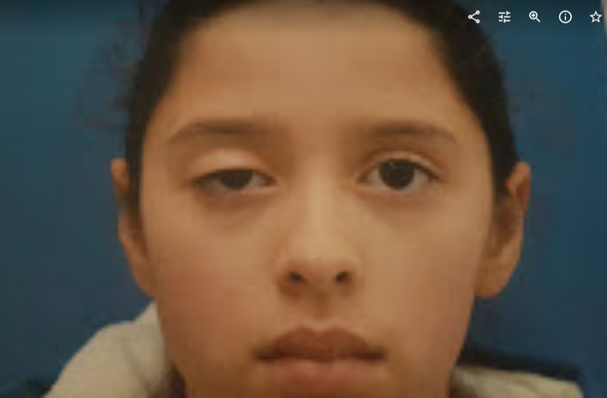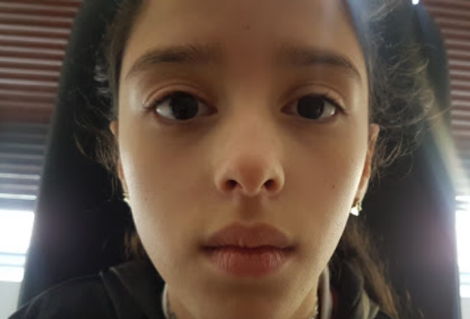
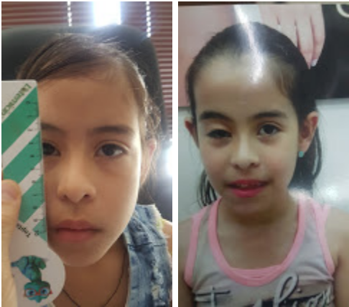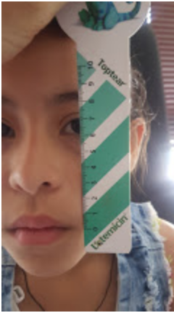

Professional Biography

Alexander Martinez Rua completed his specialty of ophthalmology at the age of 28 at the University of Antioquia. He trained in oculoplastica, orbit and lacrimal in the National Ophthalmology Unit of the Roosevelt Hospital in Guatemala City - Guatemala, and finished the Master in Telehealth with the University of Antioquia (Medellin) and Telemedicine with the Open University of Catalonia (Spain). He practices at the Clofan Clinic and the CEO Clinic in the city of Medellin. Participates in the training of ophthalmology residents of the University of Antioquia. He has published some articles in the journal of the Colombian Society of Ophthalmology

Email Id: amr327@hotmail.com
