Abstract Template
Abstract Title: Lower Body Contouring After Massive Weight Loss
Neves, P.M.A.

¹ Private Clinic, Rj

Abstract (not more than 300 words)

As the incidence of obesity increases in Western societies, ever greater numbers of patients undergo bariatric surgery. However, one consequence of such surgery is rapid, massive weight loss associated with functional and aesthetic sequelae, such as skin excess and poor skin tone, attributable to metabolic and nutritional disorders.
Truncal skin redundancy can be corrected by abdominoplasty. However, excess skin and fat on the flanks, thighs, hips, buttocks, and gluteal ptosis cannot be thus corrected.
Indeed, the circular skin deformation caused by massive weight loss can be fully corrected only by means of a circular technique, termed a lower circumferential body lift.
Flank, trochanteric and dorsal liposdistrofy are deformities usually associated in these patients, and the best technique to correct them is an associated lipossuction. As for gluteal lipodistrofy, the main author consider subcutaneous lipofilling the best approach, considering complications and bad aesthetic results related to subcutaneous flap and silicone gluteal implants.

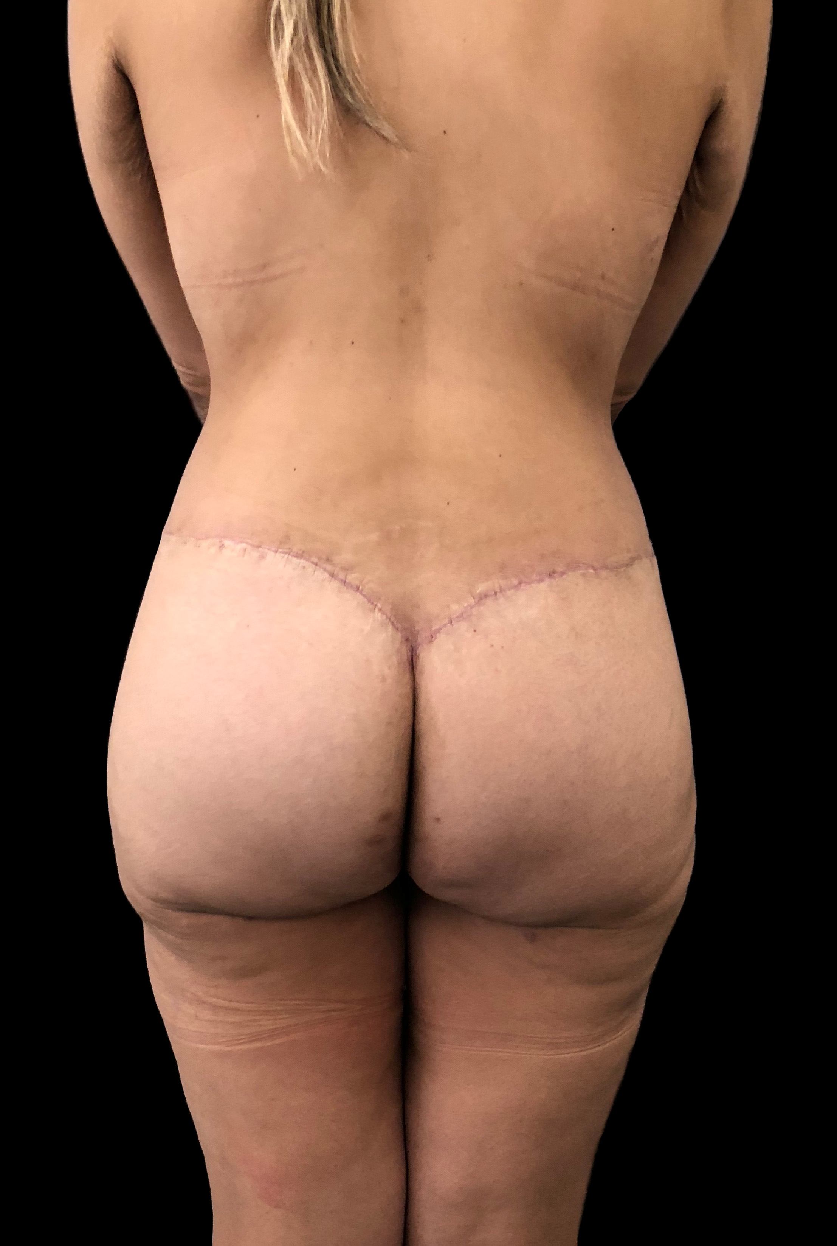
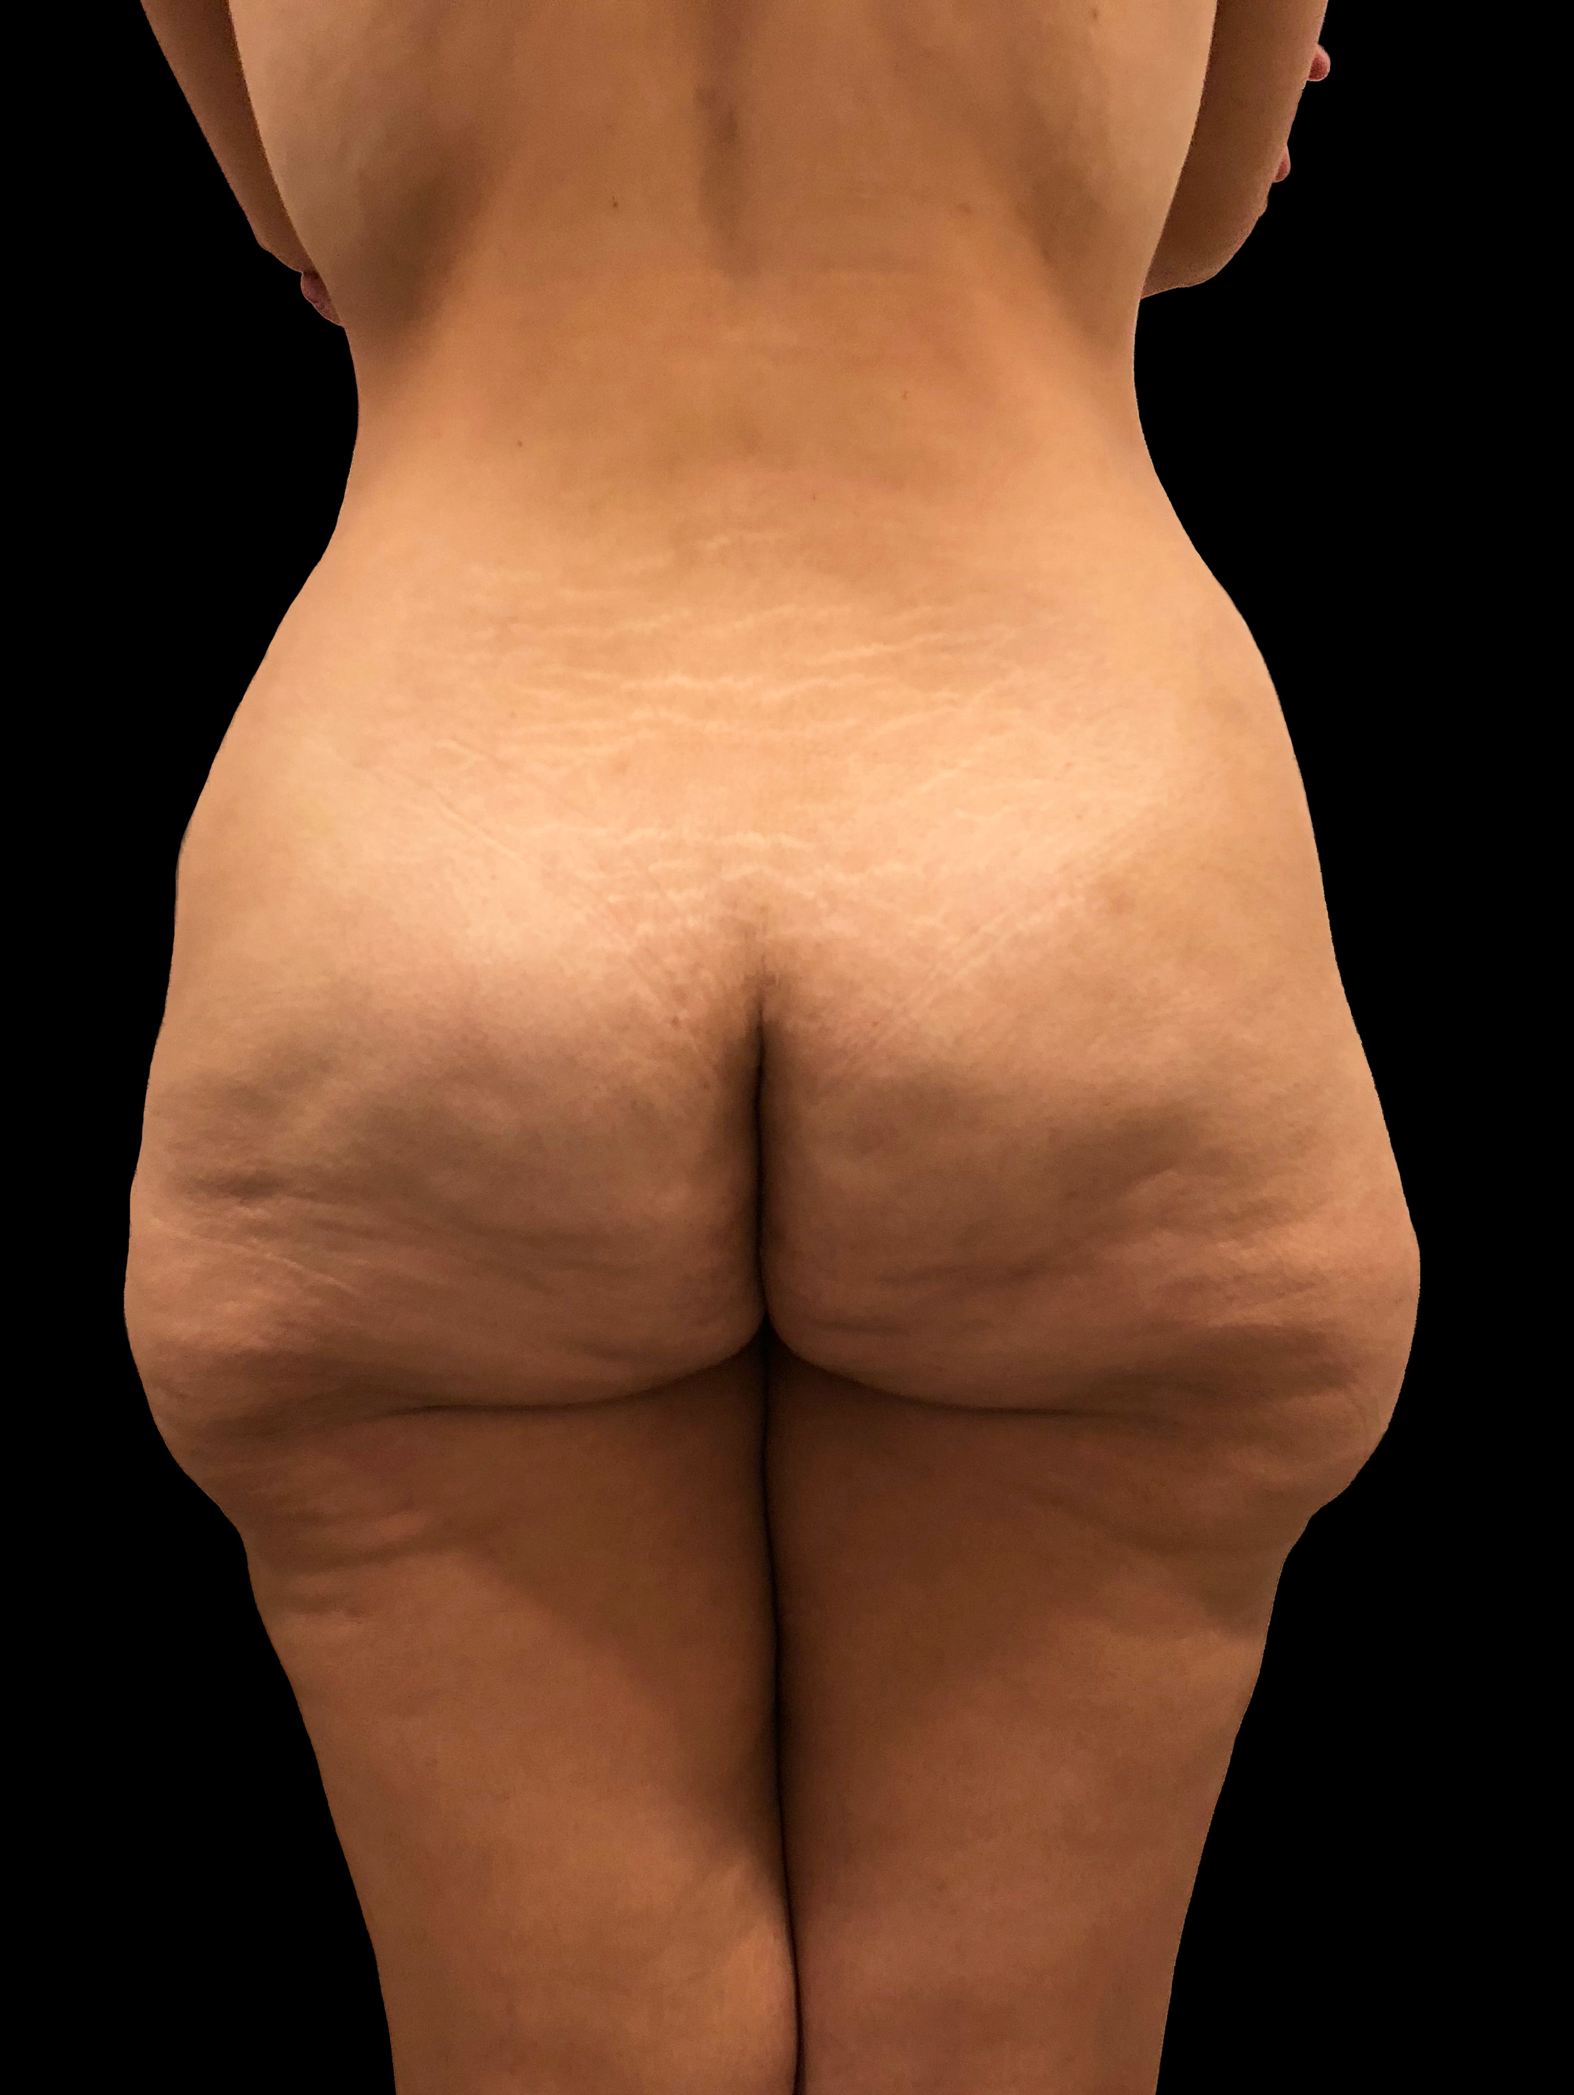
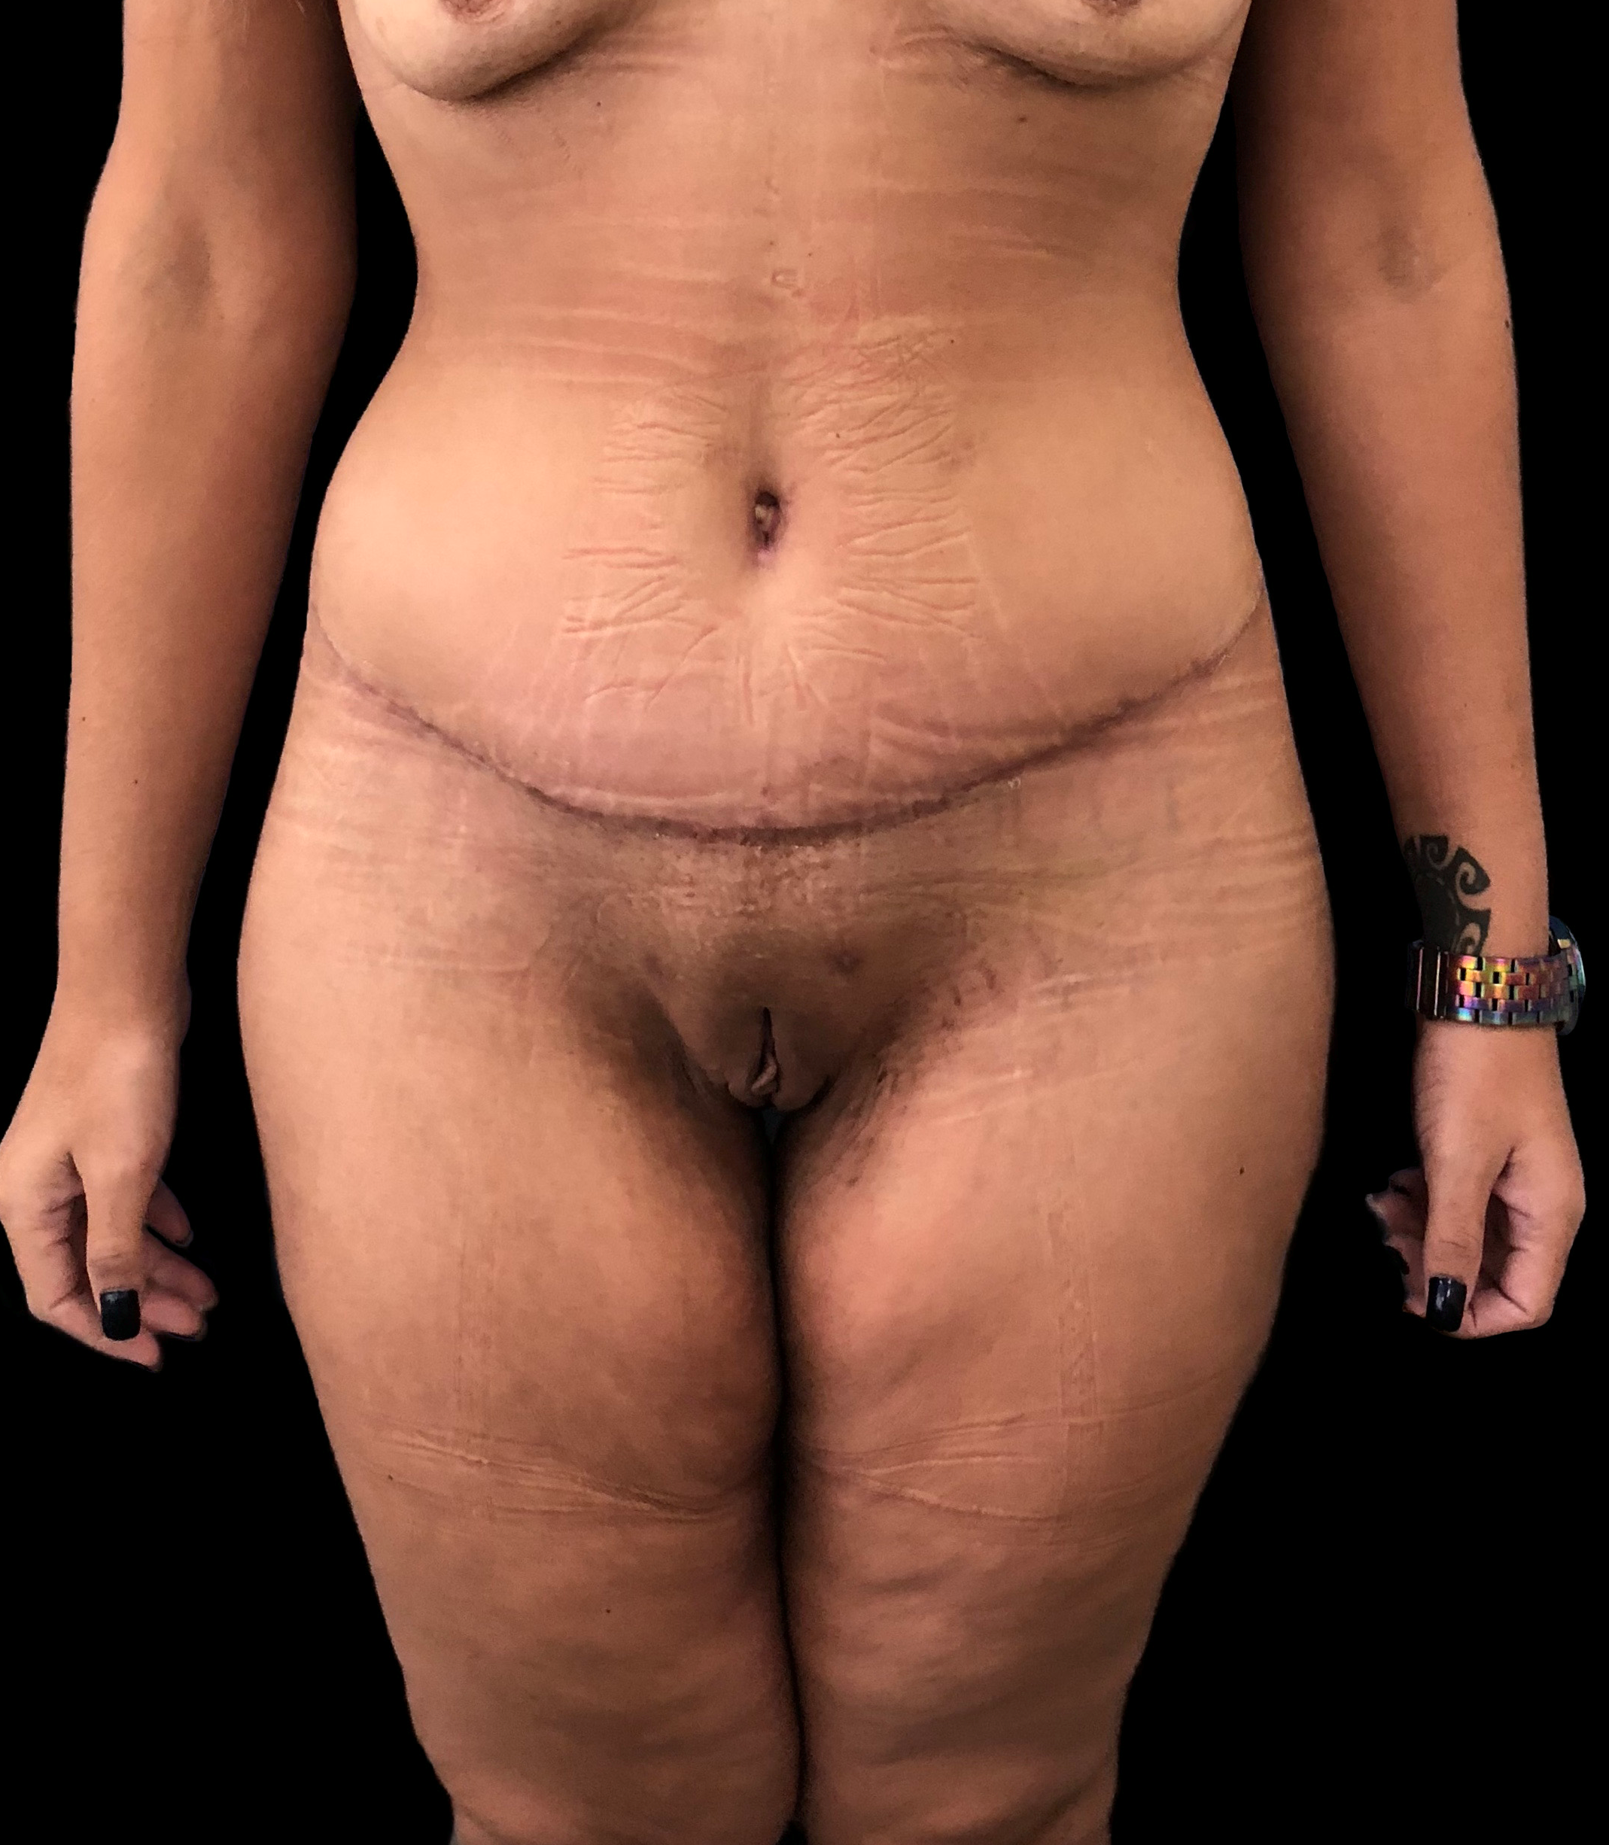
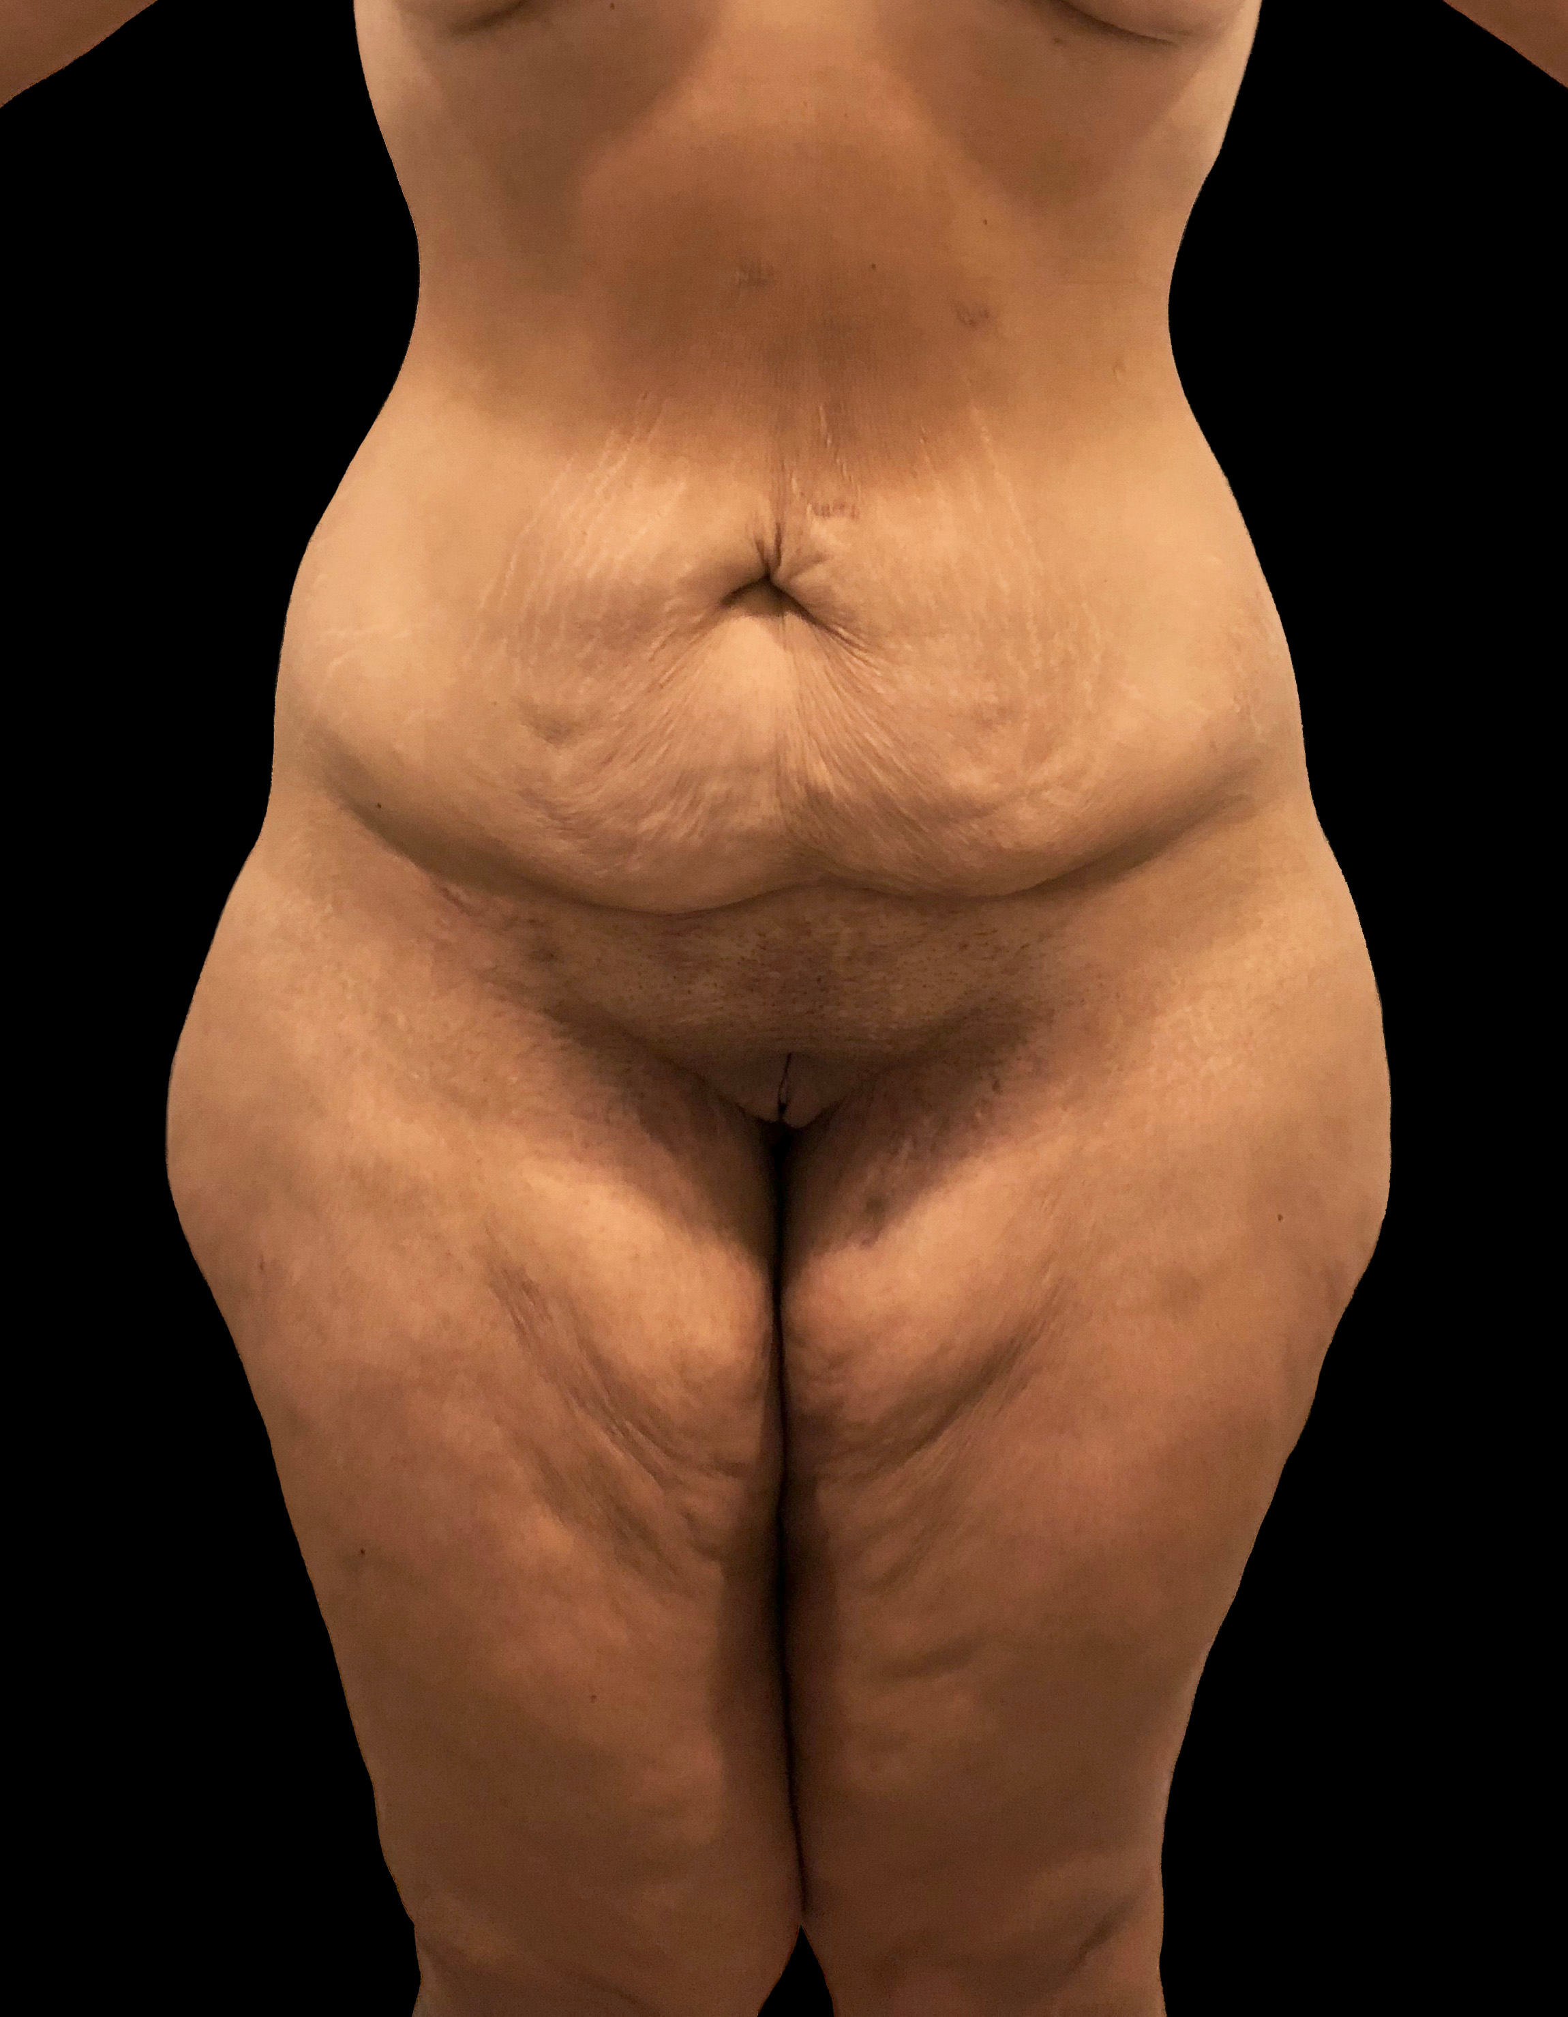
Keywords — Abdominoplasty, Lipodistrofy, Post-bariatric, Torsoplasty

Professional Biography (100-150 words)


Patrícia Neves, M.D. completed her residency in plastic surgery at the age of 29 years in Hospital Federal dos Servidores do Estado do Rio de Janeiro. Has worked as Plastic Surgeon in private clinic in Rio de Janeiro since 2014 and in Hospital Federal da Lagoa since 2015. Has worked as reviewer both in Plastic and Reconstructive Surgery Journal and Plastic and Reconstructive Surgery Global Open since 2017. Since the beggining of her medical career, she has presented more than 25 works both in brazilian and international meetings.

Email Id: drpatricianeves@gmail.com

Any Comments: Oral Presentation
Note: To submit your abstract go through the following link: https://bit.ly/2GdI9Rn

