Abstract Template
Abstract Title: Semi-open Rhinoplasty
Pitombo, V. A., Neves, P.M.A.

¹ Private Clinic, Centro de Cirurgia Plastica de Botafogo, RJ
² Hospital Federal da Lagoa, RJ

Abstract (not more than 300 words)

First rhinoplasty surgeries were performed using closed techniques. Thereafter, with better understanding of the nasal anatomy and poor anatomic results achieved using closed techniques, mainly in difficult and secondary cases, open nasal surgery was developed and fastly reproduced. However, owing to its prolongued operative time and the disruption of nasal support mechanism, the authors believe that the semi-open technique, also called ”bucket-handle”, should be the elected procedure to approach most of the nose tips in primary rhinoplasty.
The semi-open technique is a closed endonasal technique which delivers the tip cartilages, providing a wide exposition of the nasal tip, and allows an accurate anatomic diagnosis under direct vision. This technique is elected because it is less invasive, faster to perform (time-saving) and still avoids some other disadvantages of the open technique, including columella scar and the weakening of the tip foundation.

In order to correct the shape deformities, Pitombo Tip Classification, a three-type tip classification, has been developed based on the strength of tip support:

Type 1: strong cartilage support.

Type 2: weak cartilage support.

Type 3: complex tip (usually secondary nose or grossly deformed tip).

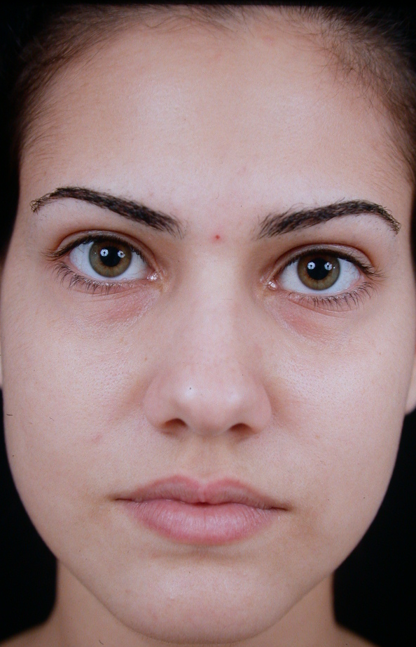
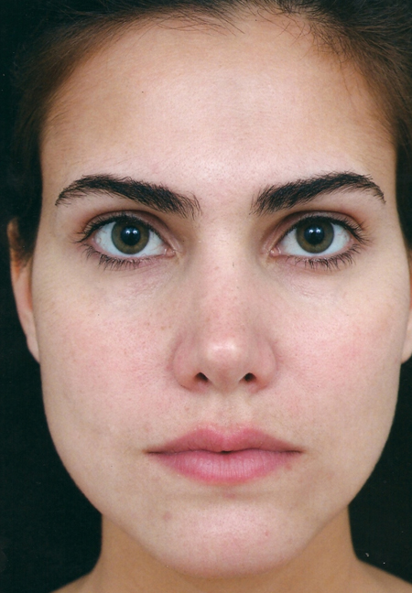
Pitombo tip classification is a helpful tool to assist the surgeons in choosing the right approach and decide whether cartilage graft is required or not. Types I and II are treated with semi-open technique, whereas type III noses are treated using open technique.

Bucket-handle, Nose, Rhinoplasty, Semi-open.

Professional Biography (100-150 words)

Patrícia Neves, M.D. completed her residency in plastic surgery at the age of 29 years in Hospital Federal dos Servidores do Estado do Rio de Janeiro. Has worked as Plastic Surgeon in private clinic in Rio de Janeiro since 2014 and in Hospital Federal da Lagoa since 2015. Has worked as reviewer both in Plastic and Reconstructive Surgery Journal and Plastic and Reconstructive Surgery Global Open since 2017. Since the beggining of her medical career, she has presented more than 25 works both in brazilian and international meetings.

Email Id: drpatricianeves@gmail.com

Any Comments: Poster presentation
Note: To submit your abstract go through the following link: https://bit.ly/2GdI9Rn

