Facial Fat Volumization With Adipose Tissue
Neves, P.M.A.

¹ Private Clinic, Hospital Federal da Lagoa, Rj

Abstract

Successful surgical rejuvenation requires comprehension of the process of face aging. Among its related aspects such as collagen depletion, skin sagging and bone reabsorption, lipoatrophy is highlighted. In fact, much of facial aging can be attributed to volume deflation. The introduction of lipossuction techniques by Illouz in the 80's and fat grafting by Coleman in the 90's has made an excellent contribution to the improvement in the treatment of facial volumetric depletion.
Facial fat compartments have previously been described by Rohrich et al, and it is also fundamental to understand its physiology when restoring volume with adipose tissue. Areas of apparent adipose deposits and areas of fat atrophy are explained by the fact that these compartments do not suffer atrophy as a confluent mass, but isolatedly.
It is known that there are some treatment options for facial volumization, such as the use of hyaluronic acid or alloplastic materials. However, autologous facial fat grafting is a worldwide procedure, with low complication rates and overall optimal results. Its advantages are uncountable - low cost, offers minimal morbidity and no chances of rejection. May be executed in association with other procedures such as blepharoplasty and facelifting, associated with other aesthetic treatments such as toxins and chemical peels, but can also be executed as single procedure. This study was used to describe techniques used to revolumize facial fat compartments that were age-related atrophic, such as harvesting, processing and injecting techniques, as well as possible facial areas to be treated (periobrital, temporal, zygomatic, naso labial and labial mental grooves. Future researchs promisse to explore the regenerative capacity of the adipose tissue.

Keywords — Face, Fat Grafting, Lipofilling, Rejuvenation,

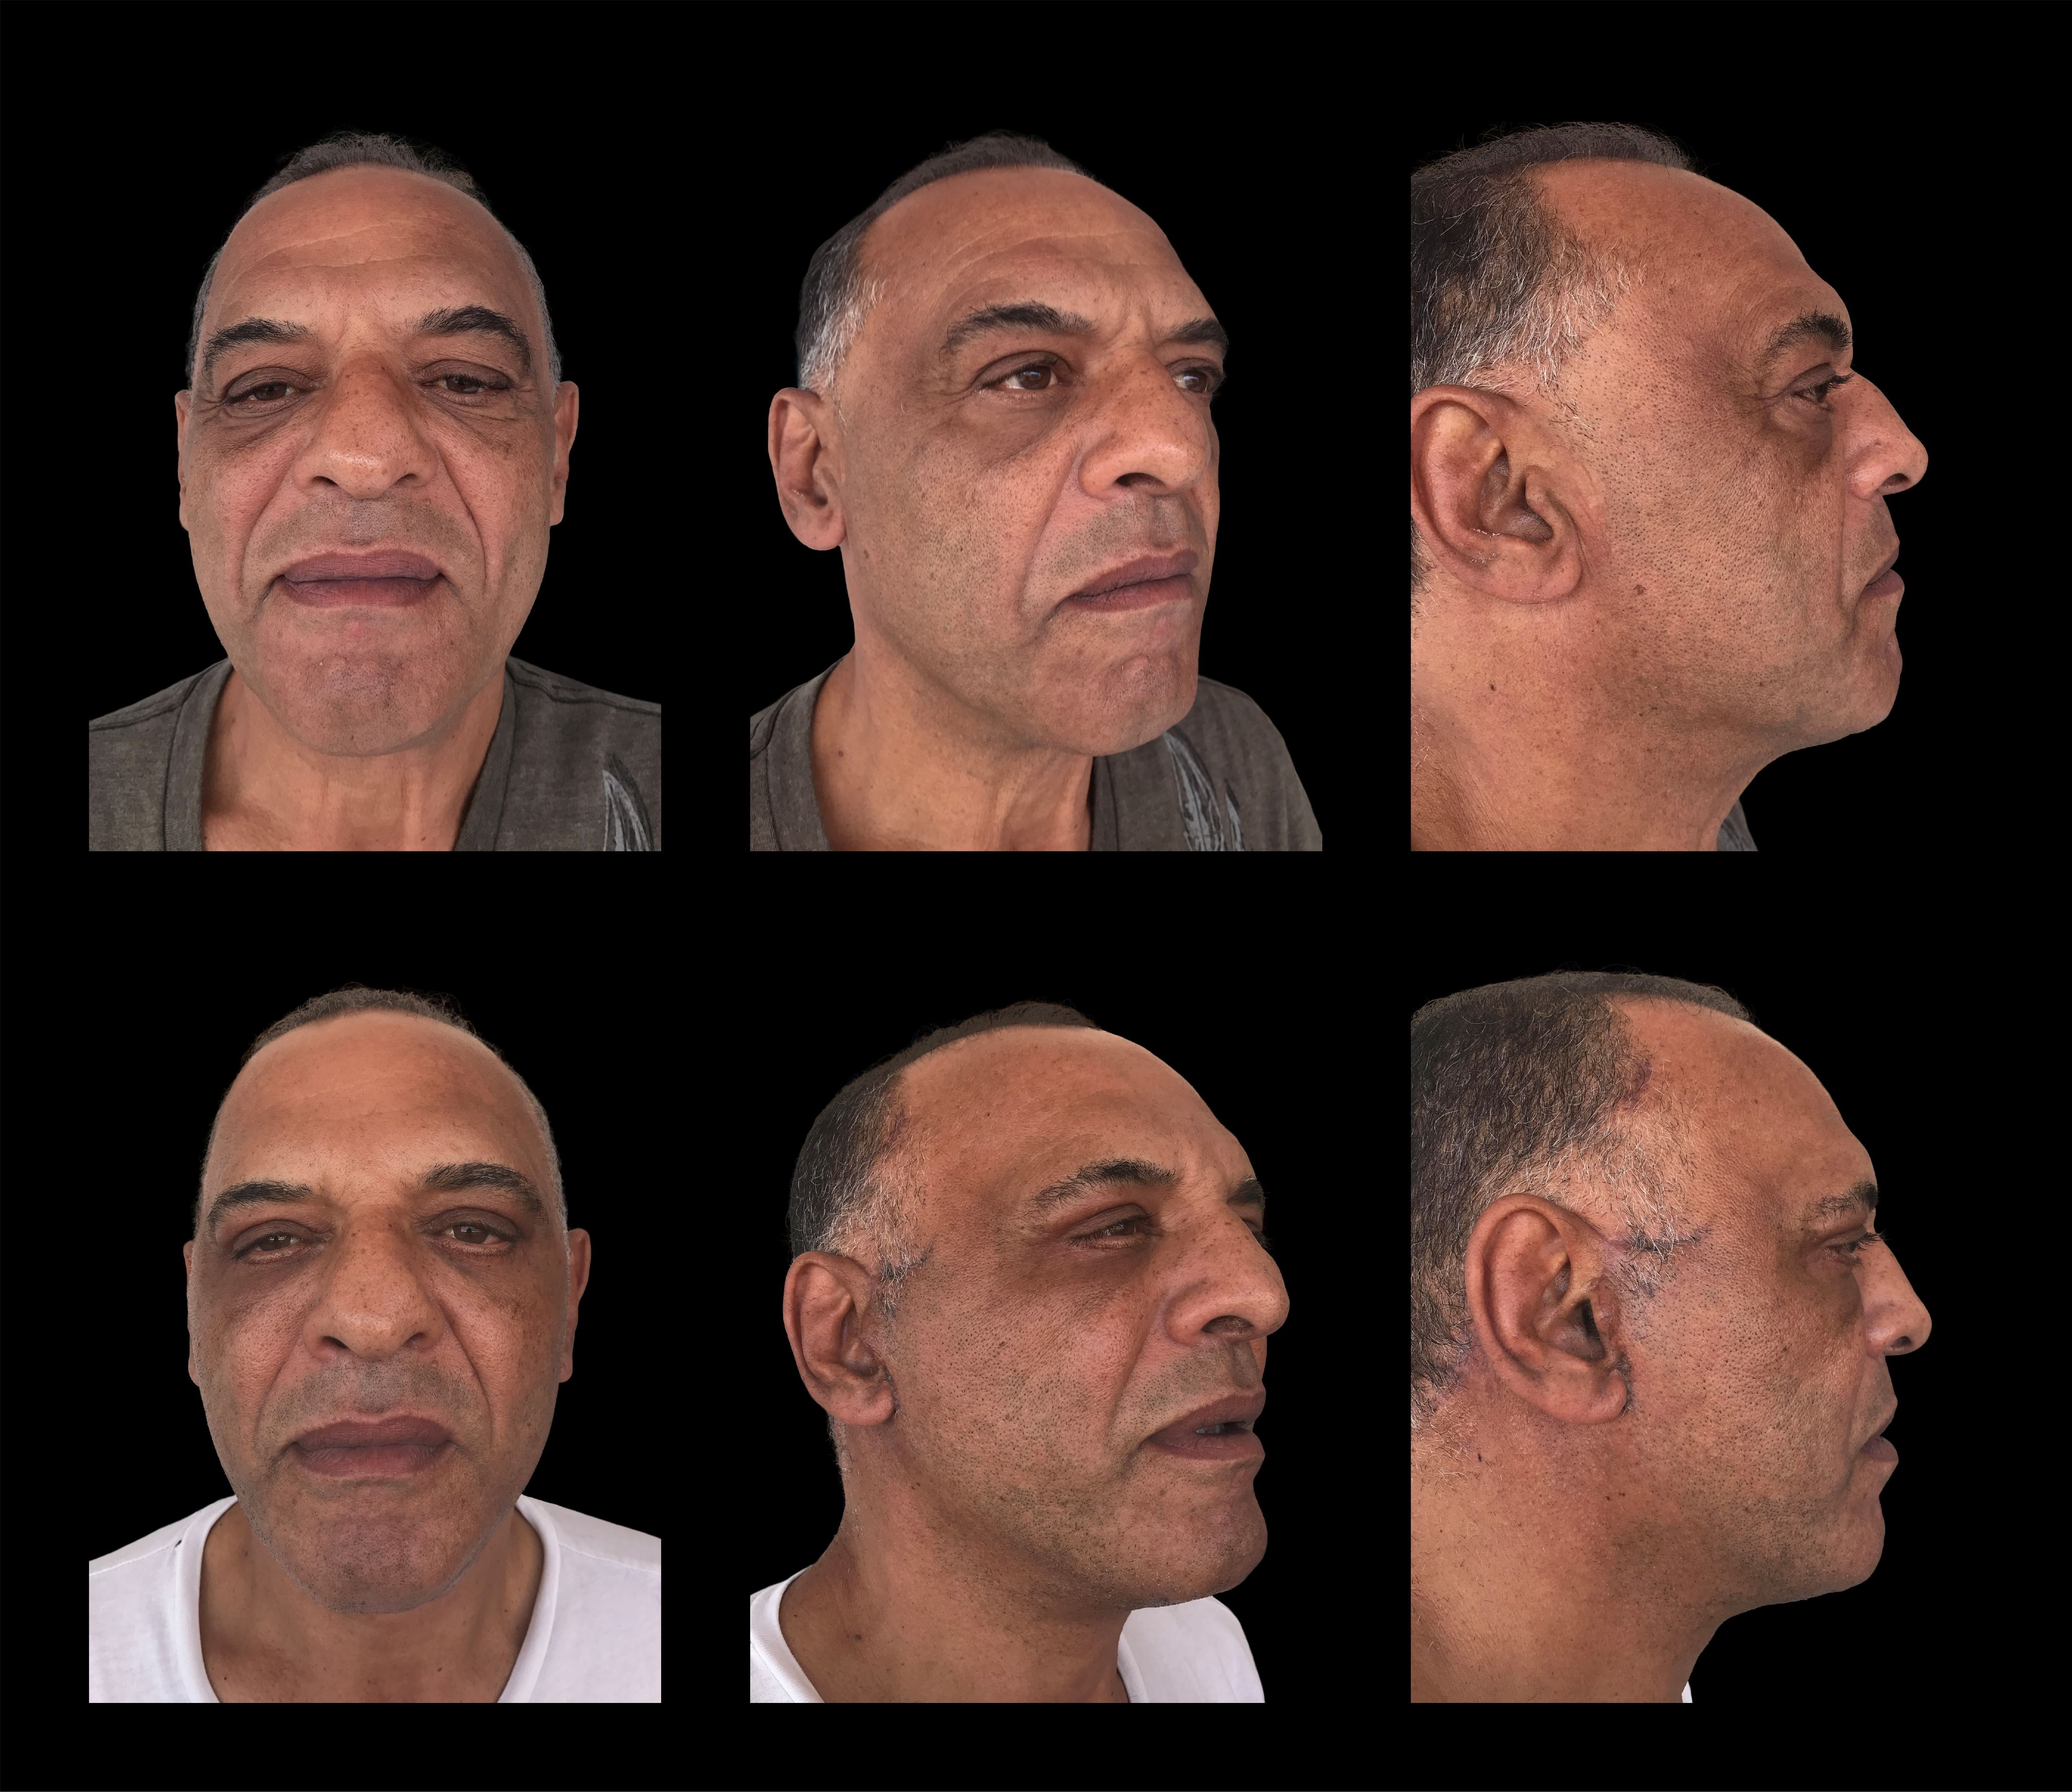

Professional Biography (100-150 words)


Patrícia Neves, M.D. completed her residency in plastic surgery at the age of 29 years in Hospital Federal dos Servidores do Estado do Rio de Janeiro. Has worked as Plastic Surgeon in private clinic in Rio de Janeiro since 2014 and in Hospital Federal da Lagoa since 2015. Has worked as reviewer both in Plastic and Reconstructive Surgery Journal and Plastic and Reconstructive Surgery Global Open since 2017. Since the beggining of her medical career, she has presented more than 25 works both in brazilian and international meetings.

Email Id: drpatricianeves@gmail.com

Any Comments: Oral Presentation
Note: To submit your abstract go through the following link: https://bit.ly/2GdI9Rn

