Extreme juvenile gigantomastia with bilateral excision of 16.5 kg (27% of body weight) in a 15year-old adolescent: a case report
Dr Hailouma Ismail

Abstract

Juvenile gigantomastia is a rare condition characterized by excessive and rapid breast enlargement during puberty, leading to significant functional and psychological impairment. Extreme forms requiring massive surgical resection are exceptional and pose important therapeutic challenges.

We report the case of a 15-year-old girl presenting with progressive bilateral gigantomastia over two years, with a body mass index of 24.2 kg/m². The patient experienced severe functional limitation, chronic back pain, postural disturbance, and marked psychological distress. Clinical examination revealed massive bilateral breast hypertrophy with severe ptosis and a sternal notch–to–nipple distance exceeding 45 cm.
Bilateral reduction mammoplasty using the Thorek technique with free nipple–areola complex grafting was performed.

A total of 16.5 kg of breast tissue (27% of body weight) was resected. The procedure was complicated by postoperative hypovolemic shock requiring blood transfusion and intensive care monitoring. Partial nipple–areola complex necrosis occurred and was managed by delayed reconstruction using a full-thickness inguinal skin graft.
At 8-month follow-up, the patient demonstrated complete resolution of pain, improved mobility, and significant psychological improvement, with satisfactory aesthetic outcomes.

Extreme juvenile gigantomastia represents a challenging clinical entity requiring individualized surgical management. The Thorek technique provides a safe and effective approach in cases of massive breast hypertrophy, although staged reconstruction may be necessary. Early multidisciplinary management is essential to optimize functional and psychological outcomes.

Image
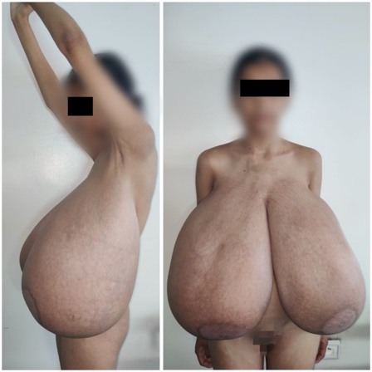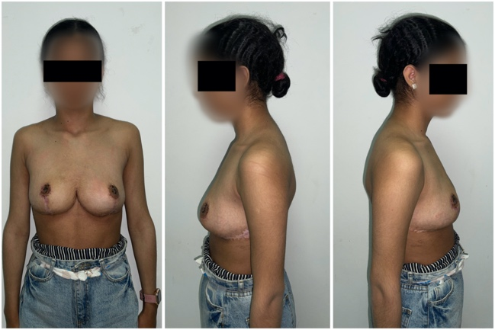
Recent Publications (minimum 5)
- Ozdemir A. Modified Thorek mammoplasty for the treatment of idiopathic gigantomastia. ACH Med J. 2025;4(2):63-69. doi:10.5505/achmedj.2025.70298.
- Baker SB, Burkey BA, Thornton P, LaRossa D. Juvenile gigantomastia: presentation of four cases and review of the literature. Ann Plast Surg. 2001;46:517–526.
- Mojallal A, Comparin JP, Voulliaume D, et al. The role of upper pedicle breast reduction in cases of gigantomastia. Ann Chir Plast Esthet. 2005;50(2):118–126.
- Loury J, Piquet M, Letertre P, Pauchot J, Tropet Y. Retrospective study of complications and imperfections: a report on 100 cases of upper pedicle breast reduction. Ann Chir Plast Esthet. doi:10.1016/j.anplas.2009.06.011.
- Dancey A, Khan M, Dawson J, Peart F. Gigantomastia—a classification and review of the literature. J Plast Reconstr Aesthet Surg. 2008;61(5):493–502. doi:10.1016/j.bjps.2007.10.041

Photograph

Biography
Dr. Ismail Hailouma is a resident in Plastic, Reconstructive and Aesthetic Surgery at Mohammed VI University Hospital in Oujda, Morocco. His clinical and research interests focus on reconstructive surgery, breast surgery, and complex soft tissue reconstruction. He is actively involved in the management of challenging surgical cases, including burn sequelae and rare breast pathologies. Dr. Hailouma has contributed to several clinical case reports and is committed to advancing surgical practice through research and academic collaboration.
Email: ismail.ahfir1@gmail.com

Notes/Comments:

This case represents an exceptionally rare and severe presentation of juvenile gigantomastia, with a total resection of 16.5 kg (27% of body weight) in an adolescent patient. The case highlights significant surgical challenges, perioperative complications, and the need for staged reconstruction. Due to its rarity and strong clinical and visual impact, this case may be of particular interest for oral presentation.

