Abstract Template
Rhinoplasty in elderly
Paulo Manzano, General Hospital of Fortaleza, BR

Abstract (not more than 300 words)

People need to have the best quality of life is possible as they get old. It is estimated 2 billion, 20 percent of humanity will be more than 60 years old in 2050’s. We must be prepared to treat aged patients because they will be more often in our daily schedule. Rhinoplasty in elderly patients requires special skills from the surgeon due to anatomic, structures, psychologic and clinical aspects in these patients. Bones becomes thin, weak and osteotomies should be possible avoid. The resorption of nasal spine and areolar area, the enlargement of pyriform aperture added to a heavy thick skin on the tip , conjuntive and skin disordes , lost of support by the cartilages results in a ptotic tip ,reduction of nasolabial angle, columelar retraction and collapses of the lateral wall. The superior cartilages falls down inferiorly and medially, with reduction of the nasal airway, resulting in external and internal valves disfunctions and nasal obstruction. Basically, the technical approaches results in open rhinoplasty , structured grafts, septal extension grafts, lateral structural grafts, batten grafts, alar rim grafts, and support sutures some that this presentation intend to show.
The psicologic aspects shows that sometimes elderly pacients are looking for rejuvenation but they do not expect different changes or just functional breathing and quality of life . Interrupt antiplatelet agents fifteen days before surgery or other clinical evaluation are necessary.
Conclusion : Aging pacients is an increasing reality in our daily schedule due to the success of human survival. Adequate nasal functional maybe essencial to live in elderly patient or just a way to have more quality of life and satisfaction. This presentation intend to show the morphological and structures changes of the elderly nose and special surgical approaches with a functional and cosmetic rhinoplasty.

Keywords—approaches-elderly-grafts-rhinoplasty-

Professional Biography (100-150 words)

Paulo Augusto de Moraes Manzano has completed his PhD at the age of 24 years from Pontifícia Catolica Univesity, São Paulo, Brasil and postdoctoral studies from Beneficência Portuguesa Hospital, São Paulo and Fellowship in Facial Plastic Surgery in Medical School of University of São Paulo. Actualy, ENT Coordinate of Otoclínica Hospital , Fortaleza , Group of Facial Plastic Surgery of Otos Clinic, Fortaleza and Preceptor of Facial Plastic Surgery of ENT Department of General Hospital of Fortaleza, BR, Titular Member of Facial Plastic Surgery Brasilian Academy - International Federation of Facial Plastic Surgery Societies (IFFPSS)

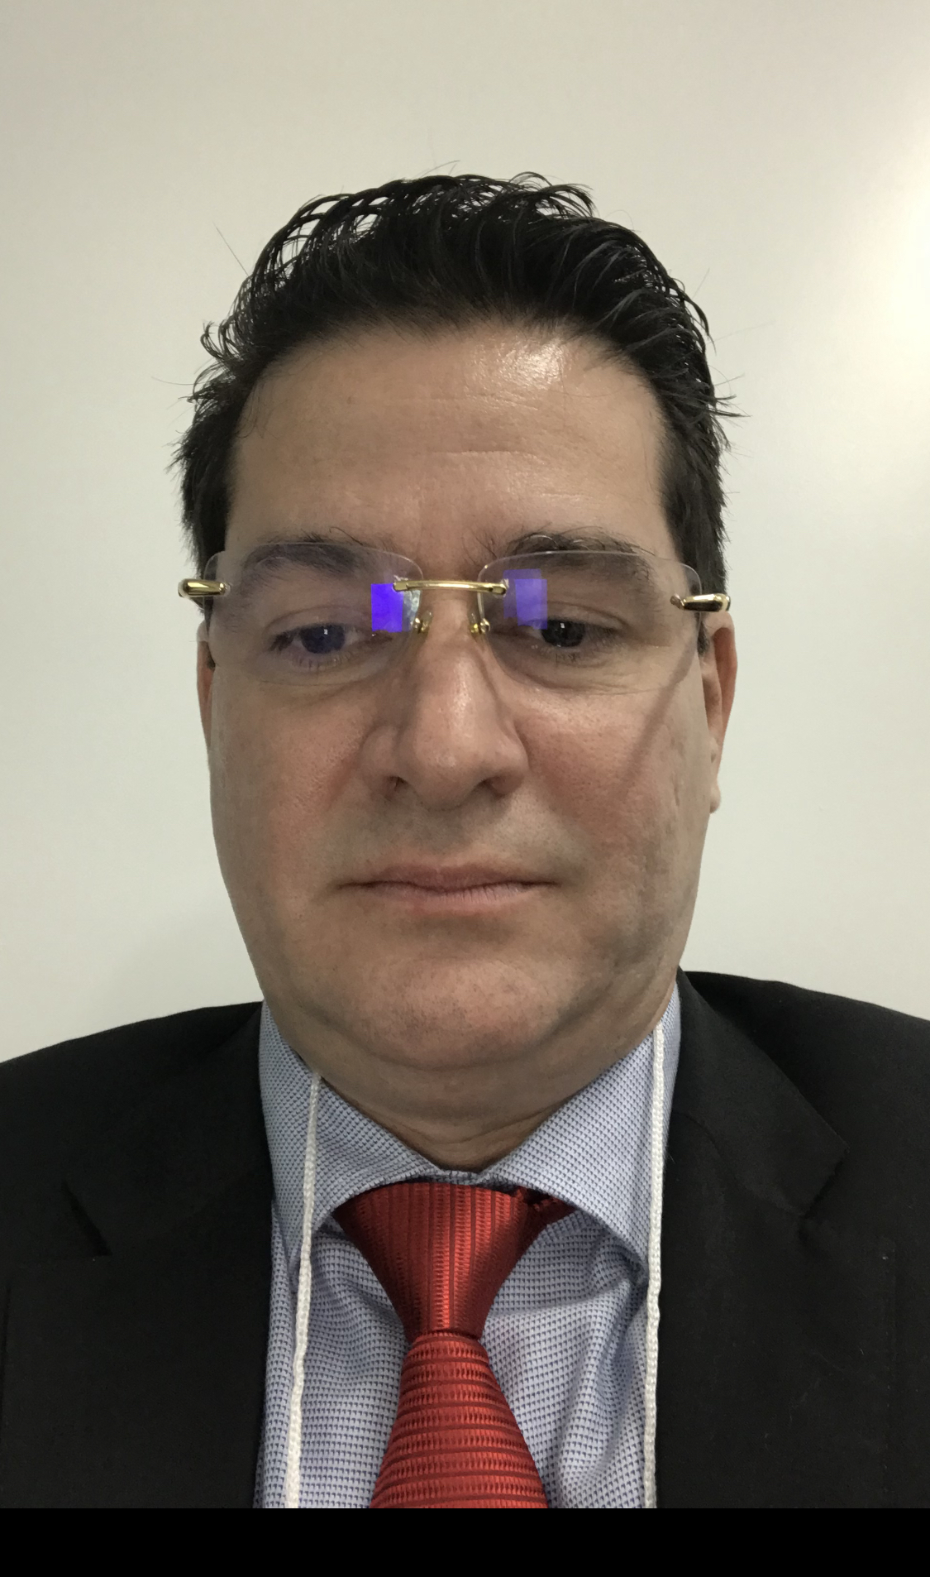
Paste your Photograph here

Email Id: plasticafacial.manzano@gmail.com

