Abstract Title: Successful cover of exposed Tibia by liquid regenerative matrix – A new concept in tissue bridging. Case Report and Proof of concept
Mohan Rangaswamy

Chief of Surgery, American Academy of Cosmetic Surgery Hospital, Dubai, UAE

Abstract (not more than 300 words)

A new principle of using a trilaminar matrix of platelet rich fibrin matrix, condensed autologous lipoaspirated fat and collagen sheet to cover exposed bone in a bad case of tissue loss is presented as proof of a new concept in tissue coverage.
Case report: A 10 year old boy sustained 4th iatrogenic burn of the leg following an image guided radiofrequency needle ablation of a bony tumor in tibia. There was invasive infection. The bony cortex and marrow below it, although physically intact, were non-viable as shown by bone scan. debridement, antibiotics and negative pressure wound therapy were used to eliminate infection. The soft tissue defect was 7x5 cm and the exposed bone measured 4x2 cm.
At a second debridement, lack of vascularity of bone and marrow was also confirmed directly at surgery. The defect was covered with a trilaminar matrix of autologous platelet rich fibrin matrix gel, autologous condensed fat graft and collagen dressing. NPWT was applied the next day for 5 days. A well-vascularized soft tissue bridge covered the bone, this was skin grafted successfully. The results are stable at one year.
Discussion: Significant soft tissue defects greater than 2 cm with exposure of cortical bone usually require a flap cover, skin grafts do not survive on bare bone. Locoregional flaps are normally used. This case illustrates a new principle: that simple fat graft with platelet rich fibrin matrix can get vascularized by formation of a vascular network in situ, sufficiently robust to support a skin graft. This is a low cost procedure. The role of each component in this matrix, the mechanisms of vascularization and other basic science details need to be worked out.

Keywords—Fat graft, platelet rich fibrin matrix, radiofrequency ablation, exposed bone

Professional Biography (100-150 words)

Dr. Mohan Rangaswamy is a consultant Plastic surgeon in Dubai. He is currently the HOD of surgical services at the American Academy of cosmetic surgery hospital.
In the aesthetic field, has special interests in lipoabdominoplasty, body contouring, rhinoplasty, aesthetic gynecology and in post Bariatric body corrections. In the reconstructive field, he is active in wound healing, hand surgery, general and,orthopedic reconstructions and post burn deformities. He has been using fat grafts and adipose derived stem cells in a variety of applications, both aesthetic and reconstructive. An innovator in many ways, he likes to indulge in lateral thinking when faced with difficult clinical problems to make unique plans consistent with patient safety. He is a member of ISAPS, ASPS, APSI, IAAPS and ISSH.

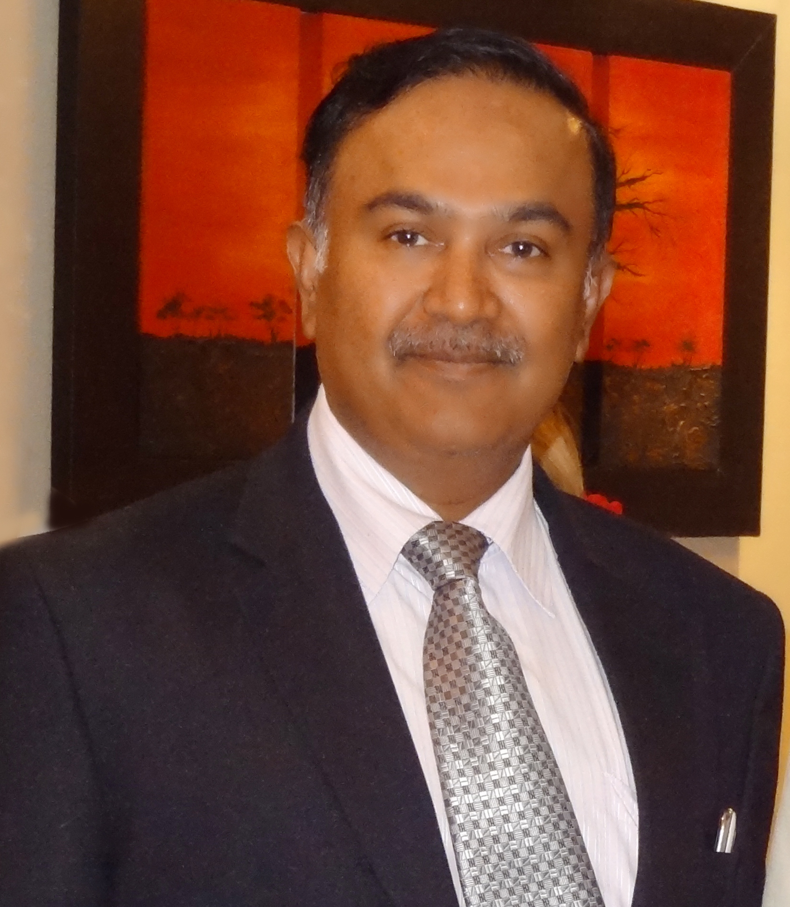

Email Id: drmohan@plasticsurgeryworks.com

