ABSTRACT: (FT) FACE TRANSPLANT
Dr. ENOC CHAMBI VENERO M.D.
Prof. Plastic Regenerative Surgery and Research
UPEU Medical University
Director of California C.V Surgery Center

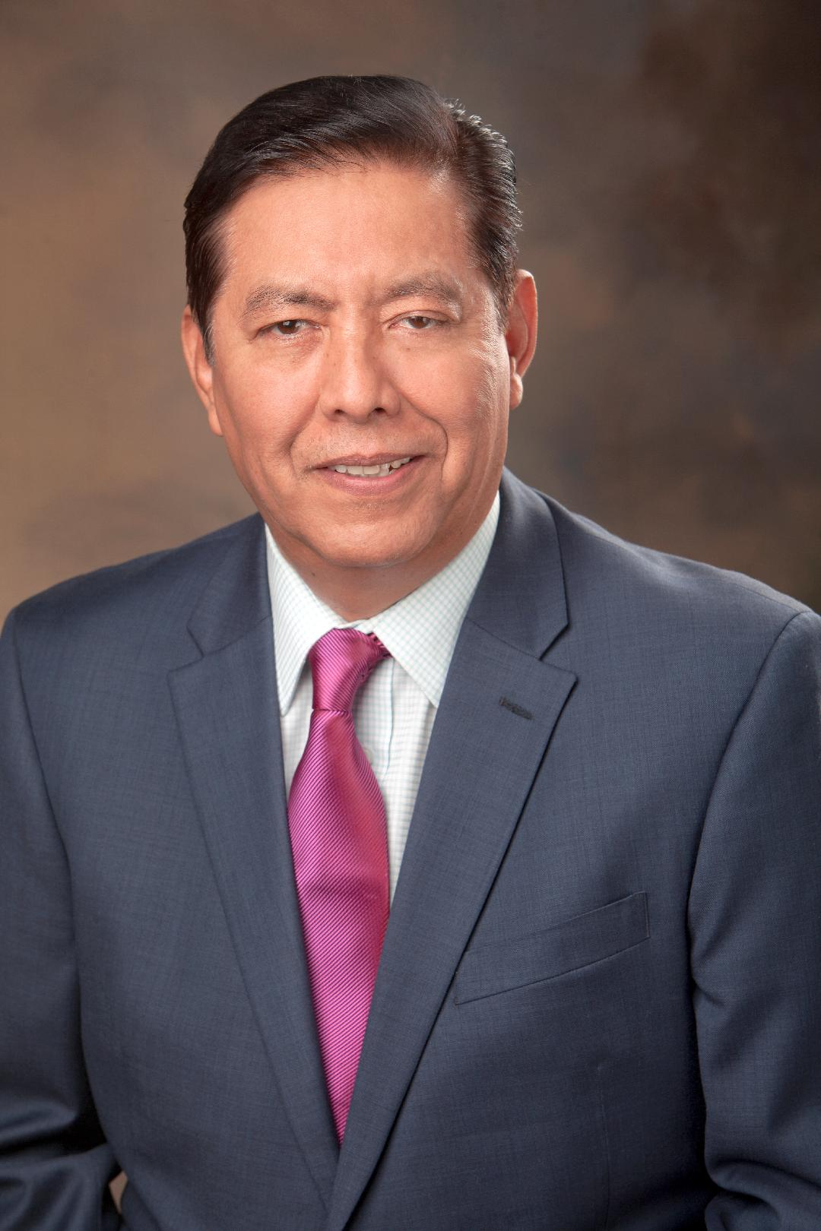
MATRIX OF IDENTITY AND FACE TRANSPLANT: It is a presentation about the face as one of the vital organs and as the matrix of the human identity.
Face transplant (FT) has evolved enormously in the last 10 years
We will show this procedure that has become a new reconstructive option for complex facial deformities to restore the anatomy of patients with severely disfigured faces and for Facial Plastic Surgeon will help to undertand better
the Face.
The presentation will describe the main surgical procedure evolved thanks to the new approach of medical, immunological and ethical technology in microsurgical techniques, computer-assisted surgical planning and preoperative planning.
Although it is still considered an experimental procedure in which we have much to learn to define its true role in current reconstructive surgery and solve the main technical, medical and ethical problems related to FT.
We will show the limitations of the FT and the anatomy and physiology will learn to understand facial aging and human identity, as well as the inability to simultaneously restore the morphological identity, the aesthetic appearance and the expressive function dedicated to the human face.
The future of face transplant can evolve with the use of more advanced technology and development, such as the use of the Extracellular Matrix (ECM). Since 2005, the first successful facial transplant was applied to the highly complex three-dimensional (3D) structure of the face, based on vascularized composite tissue allograft (VCA).
Although the ethical concerns in FT have been overcome by the outstanding superiority of the clinical results, this presentation describes the production of matrix from human cadavers and VCA.
Face grafts and the decellularized protocol with segmental success, maintaining its morphology, maintaining a vascular bed perfusion, and allowing cell grafting in facial areas.
This presentation will show why the face is a very unique anatomical and functional organ, which consists of a very complex association of different tissues, which should be treated uniformly and be well known in the practice of plastic and reconstructive surgery of the Face.

