Abstract Title: Radial forearm free flap for reconstruction of ankle and foot defect
Khan M A, Kalam M A, Khan N

¹ Mostafa Amin Khan, Specialist, Plastic Surgery (Dhaka National Medical Institute Hospital, Dhaka, Bangladesh)
²Md. Abul Kalam , Professor (Department of Plastic Surgery, Dhaka Medical College Hospital, Dhaka, Bangladeshl)
³Noazesh Khan, Professor (Department of Plastic Surgery, Dhaka Medical College Hospital, Dhaka, Bangladeshl)

Abstract

Background: Microvascular free tissue transfer is the established method of reconstructive procedure in most of the countries of the world. With changing patterns of trauma, the limb become so badly injured that single local or regional flap fails to provide adequate tissue coverage, particularly in the distal third of lower limb, specially in ankle and foot soft tissue damage. Sometimes cancer and burn area need coverage by free flaps where pedicle flaps from surrounding area is not suitable. Microvascular free flap can cover with single vascular anastomosis and can be applied to any area of body where suitable vessel for anastomosis is available. Radial forearm free flap meets most of the anatomic prerequisites for the ideal foot flap. It facilitates the restoration of normal foot contour by replacing "like-with-like," allowing patients to use normal shoes without the need for debulking, it provides a durable and stable weight-bearing plantar surface during ambulation; it achieves excellent aesthetic results without the dryness or cracking of the hypertrophied skin-grafted muscle. Besides, it has very few limitations like needs of speciality centre, high performance surgical team, donor site skin grafting.
Objective: To evaluate the clinical outcome of radial forearm free flap are a good option for coverage of ankle and foot defect or tissue loss.
Methods: A prospective, observational study design was used in the Department of Plastic Surgery of Dhaka Medical College and Hospital. Here 10 patients with soft tissue defect of variable sizes in lower limb underwent coverage with microvascular surgery. The study was carried out over a period of 12 months from January 2015 to December 2015.
Results: 80% patients were male and 20% female.Mean age was 33.5yrs,within a range of 21-40years. Comn cause of injury were Trauma due to RTA ,High voltage electrc burn,crush injury,etc.Mean size of flap was 13.8*7.45cm with a range of 12-15cm × 4-11cm. In this study , mean operative time was 06.15 hours (5-7 in avg.) and ischemic time was 62.5 minutes. Average time required for vascular anastomosis was for artery 46.5 min and for vein 48.5 min.
Conclusion: As the flap is thin, pliable, provides a gliding surface for tendon, gives protective coverage for neurovascular structure and good postoperative compliance along with restoration of normal foot contour, it may be concluded that radial forearm free flap can be a good option in ankle and foot defect reconstructive surgery.
Keywords—Free flap, Microsurgery, Radial forearm flap, Reconstruction.
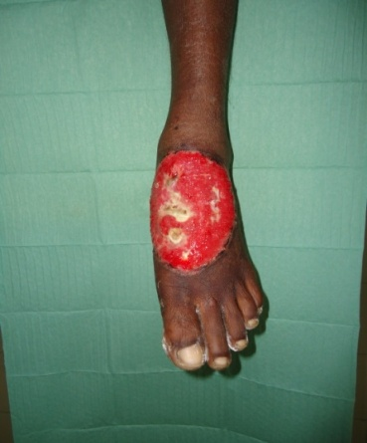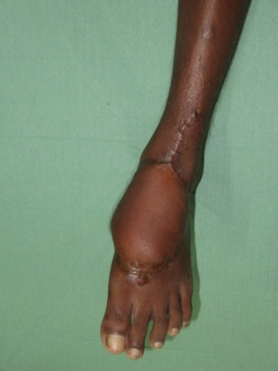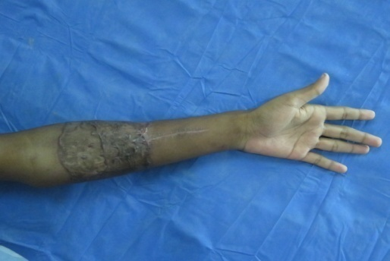
Figure 1 :Soft tissue losss (pre-operative) Figure 2: coverage of defect (post-operative) Figure 3 : Donar site

Professional Biography (100-150 words)

Dr. Mostafa Amin Khan has completed his Masters in Plastic and Reconstructive surgery in 2016 from the University of Dhaka,at the age of 37. He is currently working as the Unit Chief, in the Burn and Plastic Surgery Unit of Dhaka National Medical Institute Hosptal, Dhaka. He has advanced training in home and abroad on Microsurgery. He is a Life Member of the Society of Plastic Sugeons of Bangladesh. He has published papers in reputed journals,including the Bangladesh Journal of Plastic Surgery.

 Email Id:mostafasaki@gmail.com

