Abstract

Abstract Title: Vaginal Reconstruction Using Pudendal thigh Flap
Humayra Z U, Kalam M A, Awwal R

¹ Zaman Ummay Humayra, Assistant Professor (East West Medical College & Hospital, Bangladesh)
² Md. Abul Kalam , Professor (Dhaka Medical College Hospital, Bangladesh)
³Rayhana Awwal, Professor (Dhaka Medical College Hospital, Bangladesh)

Abstract
Aim & objectives: The surgical management of the vaginal agenesis is a complex problem and constitutes a significant technical challenge. The aim is to create a neo-vagina that is satisfactory both functionally and aesthetically using a technique that is simple, reliable, and applicable to most patients. Materials & methods: Twenty vaginal agenesis patients were opted for this prospective observational study conducted in the Department of Plastic Surgery, Dhaka Medical College and Hospital (DMCH), Bangladesh over a period of one year from September 2014 to August 2015. Neovagina was created using bilateral pudendal thigh flaps that is based on post labial artery which itself is the continuation of the internal pudendal artery. Results: The mean age of the patients was 17.9 (±3.39) years. The average length and breadth of the designed flap were 11.5 and 5.1 cm respectively. During the post operative follow up 16 (80%) patients presented with neovaginal length ≥7 cm. The diameter of the vaginal canal was 3 cm in 16(80%) patients. Most patients could appreciate touch and pain sensation at their neovagina. The reconstructed vagina was expansible and post operative stenting or dilatation was not required. Conclusion: Pudendal thigh flap is a useful technique to reconstruct the vagina which can provide satisfactory anatomical and functional outcome with negligible post operative problems.

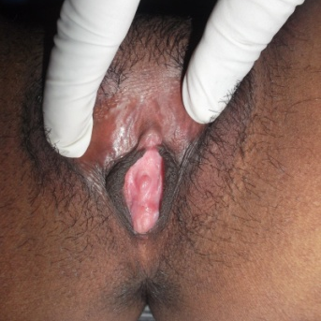
Figure 1 : Vaginal agenesis (pre-operative)
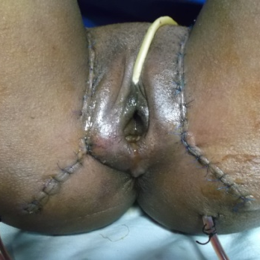
Figure 2: Neo-vagina by pudendal thigh flap(3rd post-operative day )

Keywords—Vaginal Agenesis, Neo-vagina, Pudendal thigh Flap.

Professional Biography

Zaman Ummay Humayra has completed her fellowship on Plastic and Reconstructive surgery from Tokyo Women Medical University, Japan at the age of 34 years and later she completed fellowship on same subject from Bangladesh College of Physicians and Surgeons. She is working as Assistant Professor in East West Medical College Hospital in Plastic Surgery Unit of Department of Surgery, Dhaka, Bangladesh. She has published 2 papers in reputed journals and has been serving as an editorial board member of a national journal.

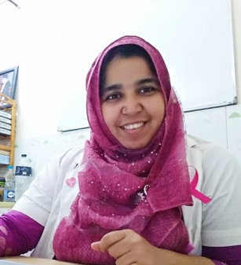

Email Id: drhumayra1996@gmail.com

Any Comments:
Note: To submit your abstract go through the following link: https://goo.gl/N3ZDtY

