Abstract Title: Non-surgical alternative for prominent ear positioning
Assis, Marcelo S. Author; Assis, Leila S. M.; Miranda, Silvio

Author Affiliation (Otyma Tech Brazil)

Abstract

Introduction: We present a magnetic device created to position the ears closer to the head, indicated in the cases of people who have prominent ears and are bothered by this familiar characteristic. Innovative product used as a non-surgical alternative on a temporary basis. The device consists of 2 pieces on each side, a half moon piece placed in the middle portion of the ears and another posterior piece, which is fixed with a special hypoallergic glue attached to the mastoid. The magnetic force of the two pieces positions the ears more aesthetically and without the stigma of bullying ears.
Method: In the period from 2016 to 2017, 60 cases of patients who did not want to undergo otoplasty surgery were studied, due to factors such as: surgery phobia (80%), risk of unsightly scarring or keloids (10%), coagulation (5%) and financial question (5%). The patients were 60% female and 40% male, with the mean age being 23.5 years. The magnetic device was offered as a non-aesthetic alternative for positioning the ears closer to the head, for use for 15 days, according to the user manual.
Results: All patients were interested in the non-surgical alternative and the initial main questioning was whether the device corrected the ears open permanently or temporarily. It was explained to all patients that the device only positioned the prominent ears closer to the head. The mean time of use was 12.5 days. Ten patients did not approve the device, and the main complaints were: aesthetic in 15 patients, with reports that it appeared to be a hearing aid and pain after 2 hours of use in 5 patients. The rest approved the magnetic device and requested more days of use.
Conclusion: The magnetic device has been shown to be an effective alternative for placing prominent ears closer to the head in patients who are uncomfortable or bullying and who do not wish to perform otoplasty at that time.

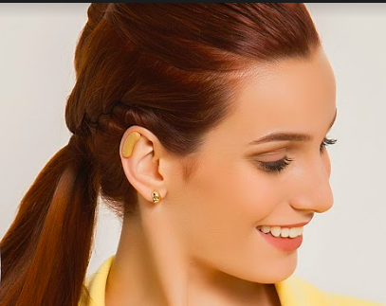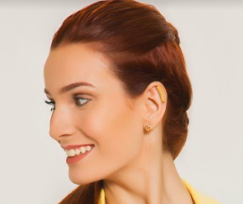

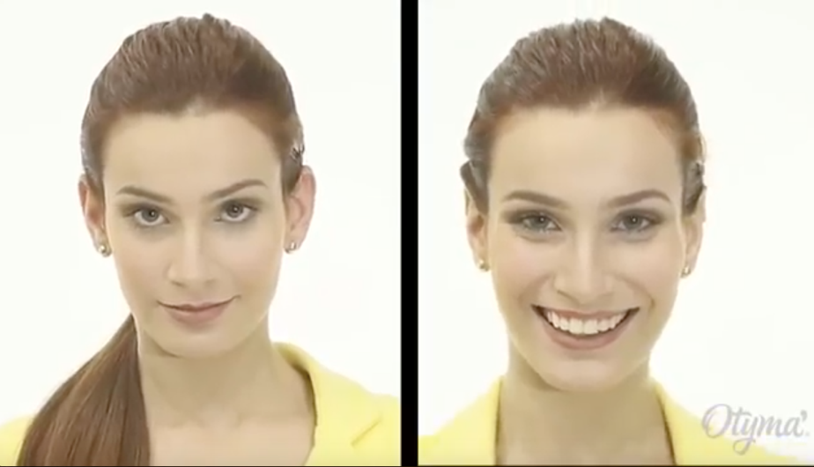

Keywords—Otoplasty, Prominent Ears, New technique, Hi performance

Professional Biography

Marcelo S. Assis is a brazilian plastic surgeon with extensive experience in aesthetic surgeries, mainly in otoplasties. He founded the Global Otoplasty Group / Projeto Orelhinha, a service specialized in the repair of prominent ears, with operations in 18 cities in Brazil, with more than 20,000 surgeries performed by the group.



Email Id: dr.assis@gmail.com

