Abstract Title: HI PERFORMANCE TECNIQUE OF OTOPLASTY
Assis, Marcelo S. Author

Author Affiliation (Global Otoplasty Group / Projeto Orelhinha Brasil)

Abstract

Introduction: Bullying is an increasing problem in modern society with severe psychological and social damage to its victims. There is a special concern when it comes to anatomical disorders such as prominent ears that can be treated with Otoplasty. The average cost for this surgery in Brazil is between US$ 1.500,00 and US$ 4.500,00. Brazil, a developing country, has a large population with a low economic status that hinders access to plastic surgery, even for minor surgeries. In order to enhance the accessibility to Otoplasty we have created a High-Performance Protocol that includes: low cost, fast execution and low recurrence rate, that we named ‘’ medical lean’’.
Method: In 2010, a non-government organization was created specializing in Otoplasty for patients as young as 7 years old who have an aesthetical complaint or is a victim of bullying. Our technique corrects the 3 parts of the ear. The surgeries are performed in an outpatient setting with a minimal charge for material and medication. The procedure is done with local anesthesia and light sedation allowing maximum comfort for the patient and the surgeon. There is no hospitalization.
Results: From 2010 to 2017, we have performed 15.000 surgeries in 14 cities with 21 different surgeons, all following the High-Performance Protocol. Patients only payed U$690,00 for total cost. The High-Performance Protocol can be reproduced any time despite location, surgeon or anesthesia. The average cost for material and medication for these surgeries is US$ 76,90. The average surgical time is 45 minutes. Of these 15.000 surgeries, we had a recurrence rate of 2%, and even a lower rate of complications such as hematomas, infections, skin/cartilage necrosis, allergic reaction, hypertrophic/keloid scar, cartilage irregularity and late sensitivity changes.
Conclusion: The High-Performance Protocol emerges as an option to increase accessibility for Otoplasty by lowering the average cost, surgical time and recurrence. This protocol will allow surgeons to increase the number of low income patients who need this surgery and help prevent bullying in this population.

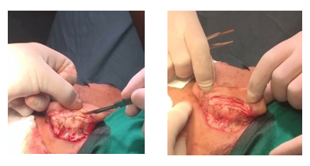

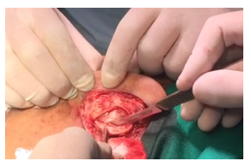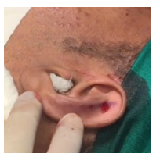

Keywords—Otoplasty, Prominent Ears, New technique, Hi performance

Professional Biography

Marcelo S. Assis is a brazilian plastic surgeon with extensive experience in aesthetic surgeries, mainly in otoplasties. He founded the Global Otoplasty Group / Projeto Orelhinha, a service specialized in the repair of prominent ears, with operations in 18 cities in Brazil, with more than 20,000 surgeries performed by the group.



Email Id: dr.assis@gmail.com

