A study of Selected Medicinal Plants from Azad Jammu and Kashmir and Their Nutritional, Biochemical and Medicinal Potential for Human Beings.
ASAD HUSSAIN SHAH PhD, Department of Biotechnology, University of Kotli Azad Jammu and Kashmir, Pakistan
SAMMIYA JANNAT, TAHIRA NAWAZ, SOBIA SHABBIR, SOBIA BATOOL, SUMMAN ZAHID Department of Biotechnology, University of Kotli Azad Jammu and Kashmir
FARHAT BATOOL PhD Department of Biochemistry, University of Karachi, Karachi Pakistan

Abstract (300-word limit)
Statement: Azad Jammu and Kashmir has been blessed with diversity of medicinal flora of immense value. Due to the disputed nature of State of Jammu and Kashmir, the area is unexplored and natural resources are being eroded at alarming rate. The area predominantly comprises of mountains and V shaped valleys. The steep slopes do not allow cultivation practices for conventional crops. The medicinal flora requires to be explored to utilize the raw plan material in pharmaceutical industry at one hand and conservation of eroding resource base is ensured (SHAH 2007).
Methodology and Theoretical Orientation:
The present study has been designed to explore multiple medicinal plants from Azad Jammu and Kashmir for their insecticidal, anti bacterial, anti diabetic, anti oxidant activities, anti coagulant potential and mosquito repellent activities. These plants included (Hippophar rhamnoides), (Eleagnus umbellate), (Zanthoxylum almatum), (Adhoca vasica), Dandiline, (Berbberis lyceum) and (Casaeria tomentosa). These plants were collected from different and distant locations of Azad Jammu and Kashmir. Anti oxidant activity was estimated using DPPH while organic solvents, ethanol, methanol, acetone, ether and chloroform for extracting the biochemical ingredients. Rotary evaporator was used to evaporate the solvent. Human fresh blood samples were used to study anti diabetic effects of plant parts. .
The mineral estimation was performed according to the protocol given by (Shah et al., 2007) by acid digestion followed by using spectrophotometer
Findings:
Sea buckhorn has exhibited significant results for biochemical constituents. The antioxidants activities of plants under this study showed promising results. Cassaera tomentosa has exhibited excellent anti insecticidal properties which can lead towards biopesticide development. Zanthxylum almatum fruit extract has been found mosquito repellent. Eleaguns umbelleta and berbberis lycium have shown anti diabetic and anti coagulant effects.
Conclusion and Significance:
Sea buckthorn (Hippophae rhamnoides L) is an important multipurpose plant in Pakistan and should be utilized to develop pharmaceutical, cosmetic, nutritional and industrial products to support the rural economy of mountain communities.
Berberis lycium and Autum olive have shown significant potential for anti diabetic and anti coagulant activities that will lead to clinical studies to be used in drug development in future. Casearia tomentosa has exhibited remarkable potential to be used as bio-pesticide in future. Zanthoxylum almatum fruit has been proved best to be used in developing mosquito repellent products.
Image:

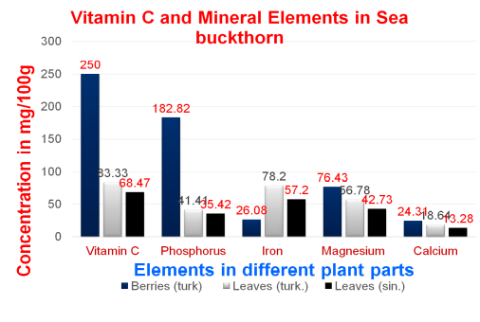
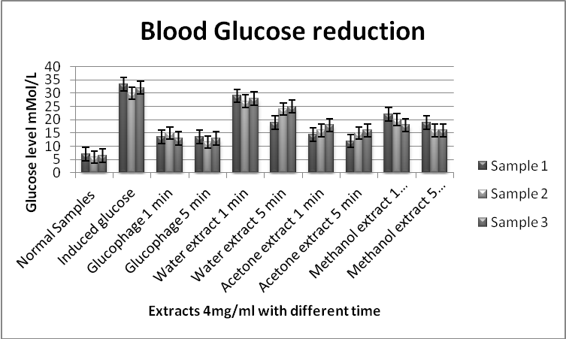

Recent Publications (minimum 5)

1- Avila DA García RJ Gustavo A Aguilar G Laura A (2017) Rosa DL The Antidiabetic Mechanisms of Polyphenols Related to Increased Glucagon-Like Peptide-1 (GLP1) and Insulin Signaling. Mole 6:903
2- Ahmed SD, MS Sabir, M. Juma, AH Shah, 2005, Morphological and biochemical variations in Elaeagnus umbellata Thunb. from mountains of Pakistan Acta Bot. Croat. 64 (1), 121–128
3- Farhat Batool, Mubasher Sabir, J.P.E Rocha, Asad Hussain Shah, Zafar Saied Saifi and Syed Dilnawaz Ahmad 2010. Evaluation of anti oxidant and free radical scavenging activities of fruit extract from Xanthoxylum alutum: A commonly used spice from Pakistan. Pak.J Bot, 42(6) 4299-4311.


Biography (150-word limit-mandatory)

Dr. Asad Hussain Shah has been working as chairman Department of Biotechnology, University of Kotli, Azad Jammu and Kashmir. His area of expertise is plant breeding and molecular genetics. He is working on medicinal flora of Himalayan region for genetic and phytochemical potentials. Dr. Shah has been working on Sea buckthorn in Pakistan from more than a decade and has evaluated the Pakistani germplasm of Sea buckthorn for its nutritional and biochemical properties along with its impact on human health. He has also been working on Sea buckthorn genetic improvement. In addition to that Dr. Shah is supervising research on drought and heat stress in wheat. Dr. Shah has vast experience of working on crop improvement
Email: syedasadhamdani@gmail.com

Notes/Comments:

Dear Organizers
It is requested to include my abstract for oral presentation.

