Potential yield of advanced soybean lines in tidal swamp land type C
Heru Kuswantoro, Indonesian Legume and Tuber Crops Research Institute, Indonesia

Abstract (300 word limit)
Statement of the Problem: Tidal swamp land is tergeted as a new area for soybean development due to the sifting of optimal land of agriculture. Tidal swamp land type C is the most prospective area, because there is no flooding effect. Methodology & Theoretical Orientation: Twelve advanced soybean lines derived from five crossings were grown in tidal swamp land type C. The design was randomized complete block design with three replicates. Findings: All of the observed agronomical characters were significantly different. The highest grain yield was shown by G15 followed by G16 and G20 with 1.89, 1.74 and 1.49 t.ha-1 respectively. These three genotypes were supported by the highest number of filled pod per plant. G16 was also supported by larger grain size reaching 13.85 g. The lowest grain yield was shown by G11 and G6 with 0.69 and 0.70 t.ha-1 respectively. Days to maturing of all tested genotypes were catagorized as late maturing. The earliest days to maturity was reached by five genotypes of G1, G2, G6, G12 and G19 with 87 days, while the latest days to maturing was reached by G14 and G5 with 92 and 90 days. Genotypes with the latest days to maturity also had the latest days to flowering. Corellation among the characters revealed that grain yield was significantly correlated with plant height, number of branches per plant, number of reproductive nodes per plant, and number of filled pods per plant. Conclusion & Significance: In tidal swamp land, soybean genotype having high grain yield can be select identify by its plant height, number of branches per plant, number of reproductive nodes per plant, and number of filled pods per plant.

Image
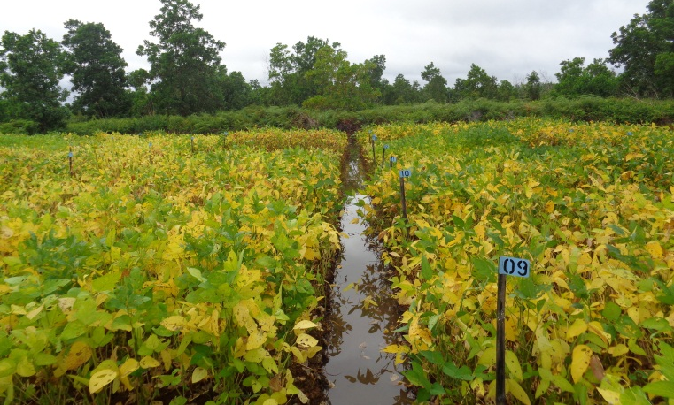
Recent Publications (minimum 5)
- Kuswantoro H, Hapsari RT, Sulistyo A, Supeno A. (2017) Potential yield of tidal swamp-adaptive soybean promising lines. Legume Research, 40(3): 514-519.
- Kuswantoro H. (2017) The role of heritability and genetic variability in estimated selection response of soybean lines on tidal swamp land. Pertanika J. Trop. Agric. Sci. 40 (2): 319-328.
- Kuswantoro H. (2017) Genetic variability and heritability of acid-adaptive soybean promising lines. Biodivseritas 18(1): 378-382.
- Kuswantoro H. (2016) Potential yield of acid-adaptive soybean promising lines in Ultisols of tanah laut regency, South Kalimantan Province, Indonesia. Biotropia 23(1): 52-57.
- Kuswantoro H. (2015) Agronomical characters of some soybean germplasm under waterlogging condition. Journal of Agronomy 14(2): 93-97

Biography (150 word limit)
Heru Kuswantoro is a plant breeder in Indonesian Legume and Tuber Crops Research Institute. His role as soybean breeder for tolerance to acid soils was done by participating as a research team or principle investigator in the development of six soybean superior varieties that tolerant to acid soils. Currently, he works in the development of soybean varieties for tidal swamp land. Besides,he also works in the development of soybean variety resistant to Cowpe Mild Mottle Virus (CpMMV) and soybean variety with high protein and methionine content. He uses conventional and molecular breeding methods for his research activities.
Email: herukusw@gmail.com

Notes/Comments:
This abstract is to replace the previous abstract I sent before with different format

