A comparative synteny analysis tool for target-gene SNP marker discovery: connecting genomics data to breeding in Solanaceae
Junkyoung Choe^{1,2}, Ji-Eun Kim¹, Bong-Woo Lee¹, Jeong-Hee Lee¹, Moon Nam¹, Youn-Il Park², and Sung-Hwan Jo¹
¹SEEDERS Inc. Daejeon 34015, Republic of Korea
²School of Medicine, Biological Sciences, Chungnam National University, Daejeon 34134, Republic of Korea

Abstract
It is necessary for molecular breeders to overcome the difficulties in applying abundant genomic information to crop breeding. Candidate orthologs would be discovered more efficiently in less-studied crops if the information gained from studies of related crops were used. We developed a comparative analysis tool and web-based genome viewer to identify orthologous genes based synteny as well as sequence similarity between tomato, pepper and potato. The tool has a step-by-step interface with multiple viewing levels to support the easy and accurate exploration of functional orthologs. Furthermore, it provides access to single nucleotide-polymorphism markers from the massive genetic resource pool in order to accelerate the development of molecular markers for candidate orthologs in the Solanaceae. This tool provides a bridge between genome data and breeding by supporting effective marker development, data utilization and communication.
Database URL: http://tgsol.seeders.co.kr/scomp/
Acknowledgement: This work was supported by a grant from the Next-Generation BioGreen 21 Program (No. PJ01100301, PJ01313203), Rural Development Administration, Republic of Korea.
Methodology and Theoretical Orientation:
Findings:
Conclusion and Significance:
Image:
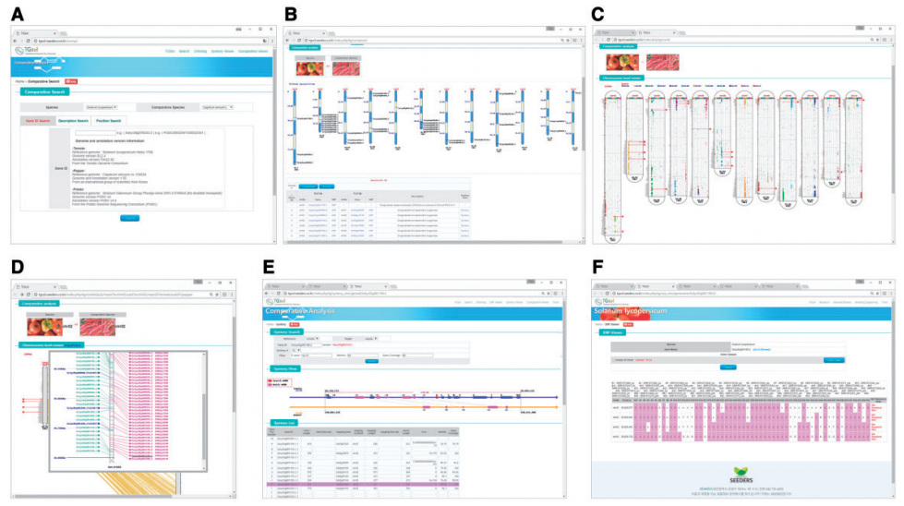
Recent Publications (minimum 5)
- A comparative synteny analysis tool for target-gene SNP marker discovery: connecting genomics data to breeding in Solanaceae. Database, 2018, 1–6
- De novo gene set assembly of the transcriptome of diploid, oilseed-crop species Perilla citriodora. J Plant Biotechnol. 43:293–301
- High-Throughput Sequencing and De Novo Assembly of Brassica oleracea var. Capitata L. for Transcriptome Analysis. PLOS ONE 9(3). e92087
- Genome-Wide SNP Calling Using Next Generation Sequencing Data in Tomato. Mol. Cells. 37:36-42
- Genome sequence of the hot pepper provides insights into the evolution of pungency in Capsicum species. Nature Genetics 46:270-278


Biography
Sung-Hwan Jo has Ph.D in plant genomics and he expertise in plant bioinfomatics. He has been contributed to complete reference genome of solanaseae plant such as tomato and pepper. He has established plant bio-informatics company, SEEDERS Inc in 2010. The vision of SEEDERS Inc. is to support crop breeding based on genome information in various species.
Email: shjo@seeders.co.kr

Notes/Comments

