Morpho-physiological and molecular Assessment for foliar disease and oleic acid content using gene based SSR markers in groundnut (Arachis hypogea L.)
Tiwari Sushma PhD, Scientist, Rajmata Vijayaraje Scindia Krishi Vishva Vidyalaya, Gwalior, Madhya Pradesh, India
Pramanik Anushree, PG,
Rajmata Vijayaraje Scindia Krishi Vishva Vidyalaya, Gwalior, Madhya Pradesh, India
Tripathi M K, PhD, Principal Scientist, Rajmata Vijayaraje Scindia Krishi Vishva Vidyalaya, Gwalior, Madhya Pradesh, India
Tomar R S, PhD
NRCPB, IARI, New Delhi, India

Abstract (300-word limit)
Cultivable groundnut (Arachis hypogea L.), is an important oilseed crop with an allotetraploid genome (AABB, 2n=4x=40), which is being cultivated and practiced widely. It is self-pollinated legume and excellent cash crop, cultivated in more than 100 countries for edible oil and food uses. Like other crops, several biotic and abiotic factors affect yield of groundnut including foliar fungal diseases. Rust (caused by Puccinia arachidis) and late leaf spot (LLS) (caused by Cerco sporidium personatum) are two major foliar fungal diseases of groundnut and can cause yield loss upto 70%. Developing advance varieties resistant to various stresses is the best and viable option to minimize economic losses for farmer and is Eco-friendly also. Integration of molecular breeding is the best option to improved variety with trait of interest. In current study, genetic diversity was studied in Forty two germplasm lines and four cultivars of diverse groundnut set using 7 morphological traits and Simple Sequence Repeat (SSR) markers. Morphological characters were taken for yield related traits were observed i.e., Days to Maturity, Number of Pods/ Plant, 100 Pod weight (gm), Karnel Yield (gm/plant), 100 Karnel Weight (gm), Shelling percentage and Sound Mature Karnel. In this study morphological analysis has been conducted with 7 parameters and genetic distance was measured by NTSYS2.0 to show diversity. Gene based markers were used for screening of oleic acid and foliar diseases. Total 5 germplasms were identified having foliar disease resistance and 16 germplasms have been identified having high oleic acid content using gene based markers. Molecular characterization along with morphological analysis show an authentic result and identified highly diversified lines of Groundnut along with some germplasms lines having foliar disease resistance and high oleic acid content. Molecular characterization along with morphological analysis identified several lines having resistance for late leaf spot and rust along with higher yield performance which can further be utilized in crop improvement programme.
Methodology and Theoretical Orientation:
Measurement of Morphological Traits
A set of 42 germplasms and four varieties were evaluated for 7 morphological traits. Days to Maturity, Number of Pods/ Plant, 100 Pod weight (gm), Karnel Yield (gm/plant), 100 Karnel Weight (gm), Sound Mature Karnel and Shelling % were observed for five plants and there mean value was considered for further analysis. The analysis of variance (ANOVA) of morphological traits for standard error (S.E.), critical difference (CD) and coefficient of variation (CV) was performed. The coefficient of correlation among all morphological traits at maturity was calculated using SPSS ver19.0 software. The similarity matrices were used to construct a dendrogram for all the germplasm lines and genotypes using NTSYS-pc 2.0

Genotyping with gene based molecular markers
For screening of foliar disease resistant germplasms four allele specific markers i.e., GMRQ517, GMRQ786, GMRQ843 for rust and GMRQ975 for LLS (Pandey et al., 2017) were used. For screening of oleic acid gene based markers were used (Chu et al., 2011, Chen et al., 2010).
Findings:
Identified 11 superior genotypes/ germplasms of groundnut with foliar disease resistance, high oleic acid content alongwith higher yield. These germplasms would be used in varietal improvement program.
Conclusion and Significance:
Marker assisted breeding approach is time saving and give reproducible result as environmental conditions do not affect the results. Application of molecular marker along-with conventional phenotyping is most applicable approach for crop improvement programme. In case of groundnut this approach is very much successful for screening of late leaf spot, rust and oleic acid content screening.
Image:

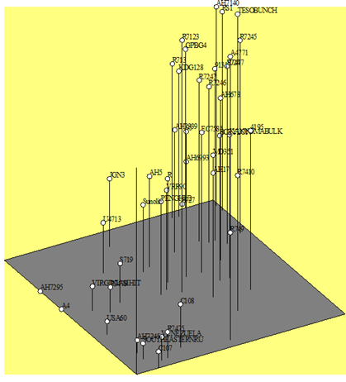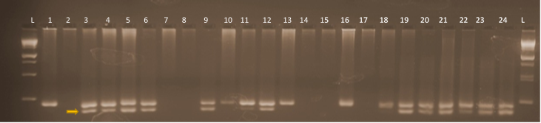
Recent Publications (minimum 5)
- Tiwari S, SL Krishnamurthy, Kumar V, Singh B, Rao A, Mithra SV A, Singh A K, Singh N K. (2016) Mapping QTLs for Salt Tolerance in Rice (Oryza sativa L.) by Bulked Segregant Analysis of Recombinant Inbred Lines Using 50K SNP Chip. PLoS ONE 11(4): e0153610. doi:10.1371/journal.pone.0153610.
- Tomar RS☯, Sushma Tiwari☯ (☯Equal contribution), Vinod, Bhojaraja K Naik, Suresh Chand, Rupesh Deshmukh, Niharika Mallick, Sanjay Singh, Nagendra Kumar Singh, S. M. S. Tomar (2016). Molecular and Morpho-Agronomical Characterization of Root Architecture at Seedling and Reproductive Stages for Drought Tolerance in Wheat. PLoS ONE 11(6): e0156528. doi:10.1371/journal.pone.0156528.
- Preeti Pachauri, R.S. Shikarvar, Sushma Tiwari, Chitralekha Shyam and Asha Kushwah (2018) Application of Next Generation Sequencing System in Groundnut Improvement. Int. J. Pure App. Biosci. 6 (3): 616-622
- Anushree Pramanik, Sushma Tiwari, M.K. Tripathi, R.S. Tomar and A. K. Singh. (2018) Molecular characterization of groundnut (Arachishypogaea L.) germplasm lines for yield attributed traits. Accepted Indian J. Genet ISSN 0019-5200
- Sushma Tiwari, Sanjeev Kumar Yadav, Vinod Kumar Sahu and M.K. Tripathi (2018). Current Status and Future Prospects of Marker Assisted Breeding for Genetic Improvement of Minor Millets. International Journal of Current Microbiology and Applied Sciences. ISSN: 2319-7706


Biography (150-word li mit-mandatory)
Dr. Sushma Tiwari, is presently working as Scientist in the discipline of Genetics & Plant Breeding/Biotechnology at Department of Plant Molecular Biology and Biotechnology, College of Agriculture, Rajmata Vijayeraje Scindia Krishi Vishwa Vidyalaya, Gwalior, Madhya Pradesh. She has received several awards i.e., Emerging Scientist Award, Distinguished Scientist Award, Scientist of the Year Award and Young Scientist Award from different scientific societies. She has good research experience of conventional and molecular breeding in several crops including rice, wheat, groundnut, minor millets, pearl millets, chickpea and soybean. She has worked on improvement of these crops under both biotic and abiotic stress. She has published more than 20 research papers in high impact National and International journals including PlosOne, Plant Breeding, Journal of Biochemistry and Biotechnology and Indian J. of Genetics and Plant Breeding etc. and participated in more than 25 National and International Conferences, Seminars, Workshops and Trainings.

Email: sushma2540@gmail.com

