Heterologous expression of a barley homologue Na⁺/K⁺ transporter from Leptochloa fusca showed ion permeability and salt tolerance
Khurram Shahzad¹, Muhammad Rauf², Zaheer Ahmed*³
¹Department of Agricultural Sciences, Faculty of Basic and Applied Sciences, University of Haripur, Haripur, Khyber Pakhtunkhwa, Pakistan
²Agriculture Biotechnology Division, National Institute for Biotechnology and Genetic Engineering, Faisalabad Pakistan
³Department of Plant Breeding and Genetics, University of Agriculture, Faisalabad, Pakistan
*presenting author
Abstract
The aminoglycoside antibiotic hygromycin (hyg), inhibits yeast growth by hyperpolarization of cell membrane. Wild type and trk1, trk2 yeast (Saccharomyces cervisceae) strains growing on solid yeast peptone dextrose (YPD) media showed growth sensitivity when supplemented with hyg. Growth of potassium uptake deficient yeast strain deprived of its two major K⁺ transporters; Trk1 and Trk2, was used to show the K⁺ uptake activities on expression of LfHKT2;1. Loss of growth activity of trk1, trk2 yeast was observed on expression of empty control vector in the presence of hyg while expression of LfHKT2;1 complemented the growth activity of trk1, trk2 yeast cells. Increased concentration of Na⁺ resulted in cellular Na⁺ toxicity which elevated on supplementing hyg in the media. Hypersensitivity of trk1, trk2 yeast cells to Na⁺ on expression of LfHKT2;1, clearly showed an additional Na⁺ uptake system operating on membrane as confirmed by transient GFP expression studies. Relative abundance of transcripts under low K⁺ concentration revealed the high affinity K⁺ uptake system on expression of LfHKT2;1. This study demonstrated the hyg sensitivity of yeast cells as the most powerful screen to functionally characterize membrane transporters and channels.

Material and Theoretical orientation:
Cloning of LfHKT2;1 gene
LfHKT2;1 was amplified by PCR, using a forward primer (5ʹ-CACCAAGCTTATGAGCTCGGTGAAAAGATTTTAC-3ʹ) and a reverse primer (5ʹ-AGATCTTCATACTTTCCAGGATTTACCCATGGTCA-3ʹ). PCR reactions were performed in a final volume of 25 μl containing 2.5 U of Takara Ex TaqTM (Hot start version).
Yeast expression vectors, strains and reagents
Yeast expression vectors pYES DEST-52 and pYES2/CT (Invitrogen, USA) were used for functional characterization of LfHKT2;1 and control respectively.
Transformation of yeast
Both wild type and K⁺ uptake deficient mutant yeast strains trk1, trk2 were grown overnight at 30˚C shaker incubator in rich media (YPD). Yeast cells were transformed with 2 µg plasmid DNA harboring LfHKT2;1 using EZ transformation kit (Bio101, La Jolla, CA, USA) and left overnight at room temperature.
Media and growth conditions for yeast growth assays
URA⁺ transformants were selected on uninduced minimal media (containing 2% glucose, 0.5% ammonium sulfate, 0.17 % yeast nitrogen base without amino acids and without ammonium sulfate; BIO 101, Inc) while for induction of galactose promoter, glucose was replaced in minimal media with 2 % galactose + 2 % raffinose. Growth assays on liquid cultures were performed by inoculating 10 ml of minimal medium with overnight grown cultures in selective SC medium (uninduced).
RNA extraction and cDNA synthesis for real-time RT-PCR
Transcript abundance was measured to quantitatively correlate the growth of trk1, trk2 yeast expressing LfHKT2;1 under induced/uninduced growth conditions and different K⁺ concentration in the media.
Protein localization in Nicotiana benthamiana
To detect functional proteins, Nicotiana benthamiana was used as a model system to transiently express GFP tagged LfHKT2;1 gene under the control of CaMV35S promoter.
DNA sequence and bioinformatic tools
ABI 3100 capillary array genetic analyzer was used for sequencing, using a BigDye terminator sequencing standard v3.1. DNA sequences were analyzed with Vector NTI Suite 10 (Informax), CLUSTAL W 1.8 and BLAST programs.

Findings:
Optimization of culture conditions for yeast growth assays
It was also observed that the growth of trk1, trk2 mutant depends on presence of K⁺ in the selective media. No growth was seen in selective media under K⁺ depletion conditions.
K⁺ concentration ameliorated cellular resistance to hygromycin
The growth activities of trk1, trk2 yeast strain expressing LfHKT2;1 were monitored under hyg growth limiting conditions and varying K⁺ concentrations in solid YPD media. Inhibitory effect of hyg on the growth of trk1, trk2 yeast strain expressing LfHKT2;1 was reduced on addition of K⁺ (applied as KCl salt) in hyg supplemented solid YPD media while trk1, trk2 yeast cells expressing EV could not enable to show the growth activity.
Increased cellular sensitivity to Na⁺ ion concentrations
Different concentrations of Na⁺ were used in hyg supplemented YPD media to check the sensitivity of the yeast cell expressing EV and LfHKT2;1. Expression of LfHKT2;1 resulted in an increased cellular sensitivity of trk1, trk2 yeast cells to addition of Na⁺ in solid YPD media without any added hyg.
Relative expression levels of LfHKT2;1
LfHKT2;1 transcripts were observed to increase with increasing K⁺ concentration from 0 to 10 mM under induced growth condition. Furthermore, higher transcript abundance was observed at 0 (minimal zero) and 10 mM under induced growth condition compared to uninduced conditions which indicate a strong induction of galactose promoter.
LfHKT2;1 localizes to the plasma membrane
The green fluorescence of CaMV35S::LfHKT2;1-GFP appeared in the location of the plasma membrane.

Conclusion and significance:
This work has allowed us to show the utility of growth sensitivity of yeast cells to hyg as a reliable assay system for studying ion movement across the membranes by expression of genes encoding transporters and/or channels and generalizing the method for functional characterization of ion transport processes by heterologous complementation.
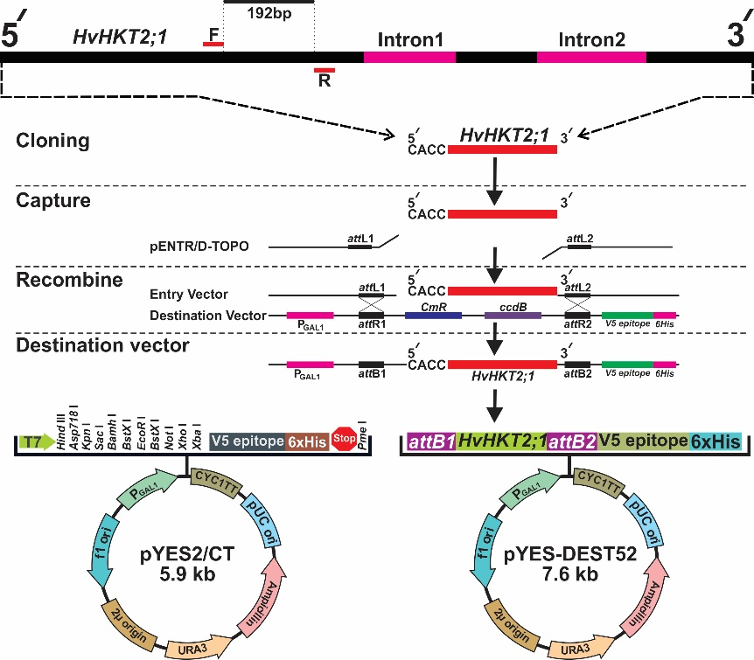
Images:

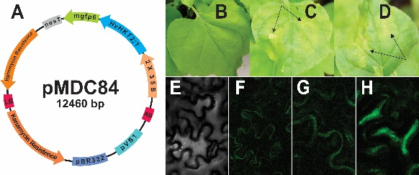

References
Ali R, Brett CL, Mukherjee S, Rao R (2004) Inhibition of sodium/proton exchange by a Rab-GTPase-activating protein regulates endosomal traffic in yeast. Journal Biological Chemistry 279(6): 4498-4506
Aranda-Sicilia MN, Cagnac O, Chanroj S, Sze H, Rodriguez-Rosales MP, Venema K (2012) Arabidopsis KEA2, a homolog of bacterial KefC, encodes a K⁺/H⁺ antiporter with a chloroplast transit peptide. Biochim Biophys Acta 1818(9): 2362-2371
Ardie SW, Xie L, Takahashi R, Liu S, Takano T (2009) Cloning of a high-affinity K⁺ transporter gene PutHKT2;1 from Puccinellia tenuiflora and its functional comparison with OsHKT2;1 from rice in yeast and Arabidopsis. Journal of Experimental Botany 60(12): 3491-3502
Bailleul PA, Newnam GP, Steenbergen JN, Chernoff YO (1999) Genetic study of interactions between the cytoskeletal assembly protein sla1 and prion-forming domain of the release factor Sup35 (eRF3) in Saccharomyces cerevisiae. Genetics 153(1): 81-94
Bakker EP (1992) Aminoglycoside and aminocyclitol antibiotics: hygromycin B is an atypical bactericidal compound that exerts effects on cells of Escherichia coli characteristics for bacteriostatic aminocyclitols. Journal of General Microbiol 138(3): 563-569

