Fine mapping and marker development of major quantitative trait loci that confers resistance against Hessian fly in Wheat
Nida Ghori, Kansas State University, USA
Guihua Bai, PhD, Kansas State University, USA

Abstract (300-word limit)
Hessian fly (HF) is a major invasive wheat pest in North Africa, southern Europe, North America, and northern Kazakhstan that cause massive economical damage and reduce the grain yield and quality every year. At least 35 different HF-R genes, from H1 to H34 and Hdic, have already been genetically identified. Most of them have been mapped within cluster of NB LLR encoding genes but no HF-R genes have yet been cloned. H34 is a Hessian fly resistance gene, confers high level of resistance against many Hessian fly biotypes. So, it is need of time to develop resistant wheat cultivars adapted to this region to minimize the losses caused by HF.
Methodology and Theoretical Orientation:
Previously, it was detected on distal end of short arm of chromosome 6BS using recombinant inbred lines (RILs) from a cross between Ning7840 x Clark. After that, another RIL F₅ population was developed from a cross between two of the RILs (RIL118 and RIL 115) to fine map H34. The RIL 118 carries H34 from Clark whereas RIL115 carries the susceptibility allele. Initially, two flanking SNPs were identified at the H34 region using the new RIL population and heterozygous RILs were identified to generate a new F₂ population. After screening >3000 F₂ plants using the flanking markers, >100 F₂ recombinants were selected. Their F₃ families were phenotyped to further narrowing the flanking region of H34 to the minimum.
Findings and Conclusion:
This study resulted in development of diagnostic markers linked to H34 gene for marker-assisted selection that will lead to the cloning of H34.

Recent Publications (minimum 5)
- Ali, Z., Rana, R.M., Cheema, H.M.N., Ahmed, Z., Maqbool, R., Ma, X., Ali, A. and Ghori, N. 2018.Genomics Based Plant Breeding, Plant Breeding Book Chapter. 209-224. http://onlinebooks.uaf.edu.pk/ChapterView.aspx?ChapId=370
- Xu Xincheng, Zulfiqar Ali*, Song Weiyi, Nida Ghori, Shao Hongbo and Ding Jinping. 2016. Alterations of DNA methylation in diverse grafted hybrid tomatoes (Lycopersicon esculentum mill.). Pak. J. Agri. Sci. 53: 1.
- Ashraf, S., Khaliq, A., Maloq, S., Amin, W., Ghori, N., Naseem, I. and Ashraf, S. 2015. Combining ability analysis breeding approach to develop wheat genotypes: A review. Acad. J. Entomol.
- Ali, Z., A.S. Khan, I. Karim, M. Uzair, T. Mahmood, T. Saeed, S. Sarwar, N. Ghori, Z. Nisar, S.S. Sarwat, A. Qayyum and A.A. Khan. 2014. Generation mean effects, heterosis and heritabilities for seedling, adult and physiological salinity tolerance in spring wheat (Triticum aestivum L.). Int. J. Agric. Biol. 16: 1059-1066.
- Hussain, Z., Zafar, M.B., Ghori, N., Mustafa, H.S.B., Ejaz-ul-Hassan, Mahmood, T. and Muddasir, M. 2016. Acclimatization of Mustard (Brassica juncea L.) Genotypes under Different Agro-Climatic Zones of Punjab Province, Pakistan. Researcher. 8(4):43-47.

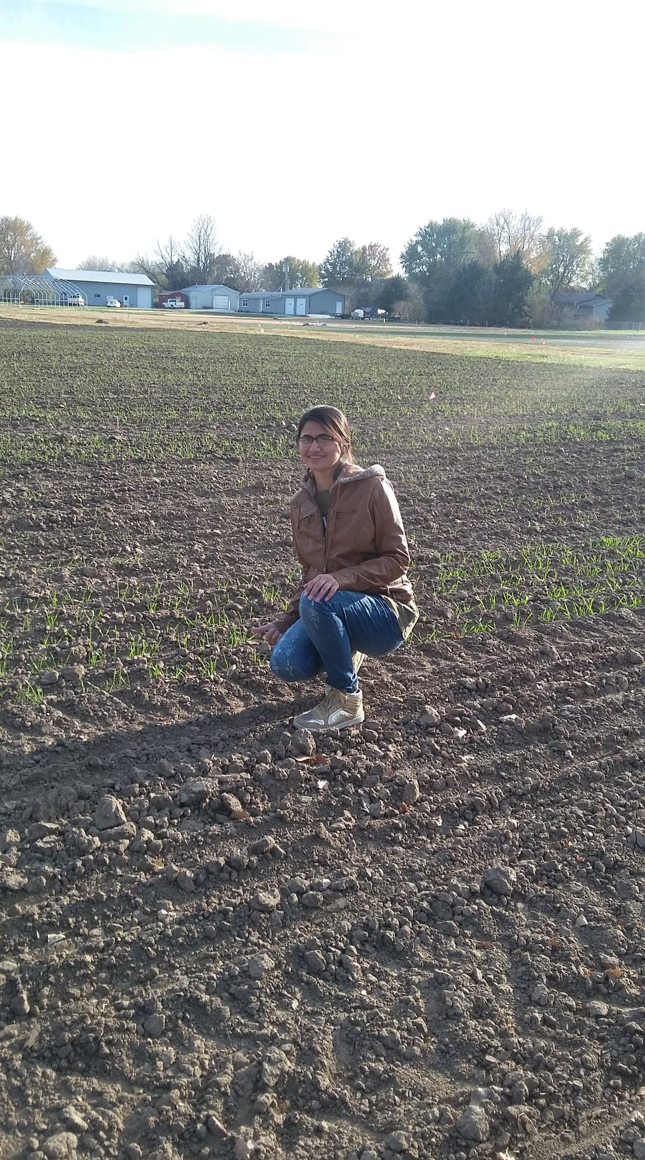
Biography (150-word limit-mandatory)
I am Nida Ghori, Fulbright PhD candidate in department of Agronomy, working under the supervision of Dr. Guihua Bai and
Dr. Allan Fritz at the Kansas State University (KSU), USA. In my Masters, my research project was to determine the genetic polymorphism of TaZnF gene family and its association with drought and yield related traits in wheat. After completing degree, I joined the Department of Plant Breeding and Genetics in the same university as lecturer and worked on different research projects with wheat research group of the department. In 2016, I won world’s most prestigious Fulbright scholarship to pursue my PhD studies in USA. My PhD research is aimed at development of markers for Hessian fly screening and map-based cloning of HF34 resistant gene in wheat. I am highly passionate to devote my life in improving the wheat yield by fighting against insects and pathogens.
Email: nghori@ksu.edu

Notes/Comments:
Previously, I have submitted an abstract with the same title but mistakenly I have submitted the wrong file. So please consider this latest one.

Thanks
Nida

