TaZnF gene family confers drought tolerance in Wheat (Triticum aestivum L.)
Nida Ghori, Kansas State University, USA
Zulfiqar Ali, PhD, University of Agriculture Faisalabad, Pakistan

Abstract (300-word limit)
Drought is the major a-biotic stress that limit crop production especially of wheat. So, it is necessary to identify drought responsive wheat germplasm having drought responsive genes using different conventional and modern techniques. Many genes have been reported that respond to these stresses at transcriptional level. Among all these gene families, Zinc finger protein (ZFP) is one of biggest family of transcriptional factors in eukaryotes including plants and animals. There are 1940 transcription factors present in wheat which is classified into 56 families.
Methodology and Theoretical Orientation:
In the present study, the plant material was comprised of six wheat F₂ populations, their parents, three elite lines and two check varieties (Chakwal-50 and Kohistan-97). The plant material was grown in the field under normal and water deficit condition. Morphometric traits were noted at appropriate time. Sequences of TaZnF genes were downloaded from various genomic databases and analyzed bioinformatically to construct phylogeny.
Findings:
The results suggested that traits like leaf area, tillers per plant, 100 grain weight, and yield per plant can be used as selection criteria for identification of drought tolerance accessions. Phylogenetic tree of TaZnF family includes some members showing maximum sequence similarity and distributed into two clear groups (C2H2 and DOF) (Fig 1). The same sequences of TaZnF proteins were subjected to MEME server for analysis of conserved domain and 12 and 25 domains have been identified for Dof and C2H2 zinc finger family respectively (Fig 2). TaZnF homologs of drought responsive ZnFs were analyzed for their polymorphism in the wheat plant material and only ZFP-2 and DOF-8 were annealed and amplified.
Conclusion and Significance:
The AtZFP2 gene involved in alteration of floral morphology and induced by onset of abiotic stresses (Drought and salinity) in Arabidopsis thaliana (Chen et al., 2011), as it has homology with TaZFP2 so, it may have the same function in Triticum aestivum.
Image:
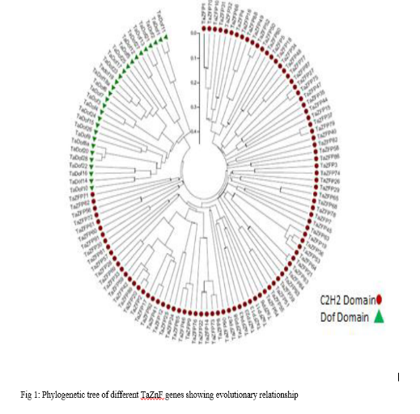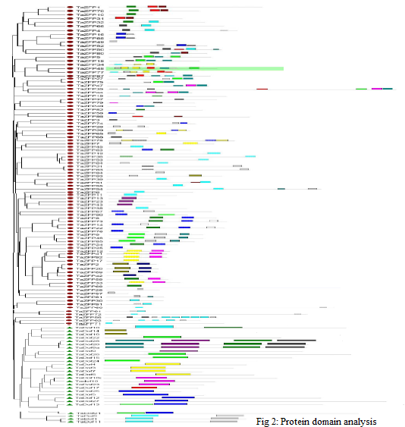
Recent Publications (minimum 5)
- Ali, Z., Rana, R.M., Cheema, H.M.N., Ahmed, Z., Maqbool, R., Ma, X., Ali, A. and Ghori, N. 2018.Genomics Based Plant Breeding, Plant Breeding Book Chapter. 209-224. http://onlinebooks.uaf.edu.pk/ChapterView.aspx?ChapId=370
- Xu Xincheng, Zulfiqar Ali*, Song Weiyi, Nida Ghori, Shao Hongbo and Ding Jinping. 2016. Alterations of DNA methylation in diverse grafted hybrid tomatoes (Lycopersicon esculentum mill.). Pak. J. Agri. Sci. 53: 1.
- Ashraf, S., Khaliq, A., Maloq, S., Amin, W., Ghori, N., Naseem, I. and Ashraf, S. 2015. Combining ability analysis breeding approach to develop wheat genotypes: A review. Acad. J. Entomol.
- Ali, Z., A.S. Khan, I. Karim, M. Uzair, T. Mahmood, T. Saeed, S. Sarwar, N. Ghori, Z. Nisar, S.S. Sarwat, A. Qayyum and A.A. Khan. 2014. Generation mean effects, heterosis and heritabilities for seedling, adult and physiological salinity tolerance in spring wheat (Triticum aestivum L.). Int. J. Agric. Biol. 16: 1059-1066.
- Hussain, Z., Zafar, M.B., Ghori, N., Mustafa, H.S.B., Ejaz-ul-Hassan, Mahmood, T. and Muddasir, M. 2016. Acclimatization of Mustard (Brassica juncea L.) Genotypes under Different Agro-Climatic Zones of Punjab Province, Pakistan. Researcher. 8(4):43-47.

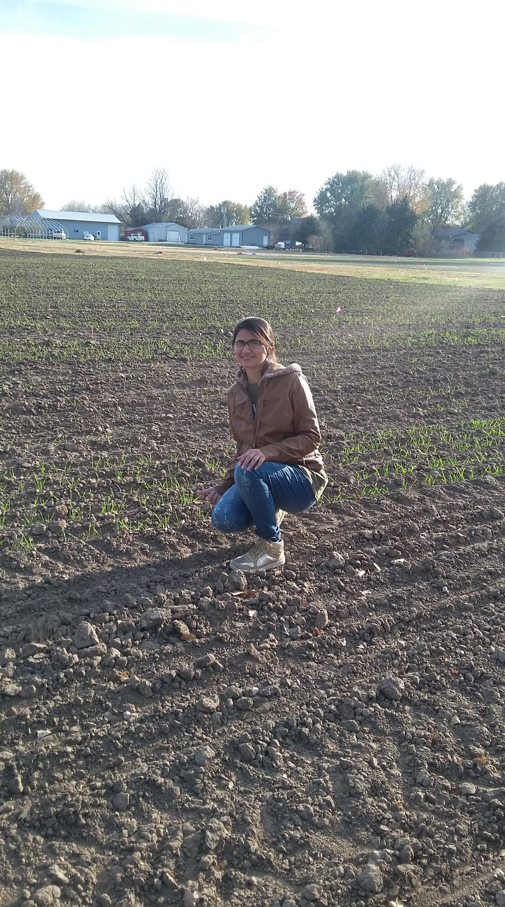
Biography (150-word limit-mandatory)
I am Nida Ghori, Fulbright PhD candidate in department of Agronomy, working under the supervision of Dr. Guihua Bai and
Dr. Allan Fritz at the Kansas State University (KSU), USA. In my Masters, my research project was to determine the genetic polymorphism of TaZnF gene family and its association with drought and yield related traits in wheat. After completing degree, I joined the Department of Plant Breeding and Genetics in the same university as lecturer and worked on different research projects with wheat research group of the department. In 2016, I won world’s most prestigious Fulbright scholarship to pursue my PhD studies in USA. My PhD research is aimed at development of markers for Hessian fly screening and map-based cloning of HF34 resistant gene in wheat. I am highly passionate to devote my life in improving the wheat yield by fighting against insects and pathogens.
Email: nghori@ksu.edu

Notes/Comments

