Meta QTL (mQTL) Analysis Using Three Connected Mapping Populations in Sorghum bicolor for Drought Tolerance Related Traits
¹Drs Techale Birhan (Ass proff), ²DR Kassahun Bantte (Professor), ³DR Andrew Paterson (Professor)
¹ ² Department of plant science and horticulture, Jimma University, Ethiopia
³Plant Genomic mapping laboratory head and professor, University of Georgia, USA
Abstract
Statement: Identifying quantitative trait loci (QTL) of considerable effects that are expressed in diverse genetic backgrounds across different drought stress regions can signiﬁcantly complement the conventional breeding efforts. The purpose of this study was therefore to map consistent QTL related to drought tolerance using three connected mapping populations of different genetic backgrounds.
Methodology and Theoretical Orientation: All QTL identified in the individual populations using CIM were projected on the consensus linkage maps using the chromosomal position, LOD score, confidence interval and proportion of phenotypic variance (R2) explained by each QTL. For each chromosome, meta-QTL analysis was used to estimate the numbers and positions of the mQTL. Meta QTL was declared only when it was common to all the three populations or when one region harbored an elevated number of QTL derived from a minimum of two populations.
Findings: A total of 106 QTL were identified from the three individual population QTL analysis for all traits studied. All the 106 QTLs identified in individual populations were projected on the combined consensus map for Meta QTL analysis. The meta-analysis then reduced the total number of QTLs from106 to 16 mQTLs. As a result, 4 mQTL for grain yield per plant, two for days to maturity, one for days to flowering, two for leaf senescence and three for plant height were detected.
Conclusion and Significance: The final consensus map developed would allow us to map a larger number of markers than possible in any individual map and to obtain a more complete coverage of the sorghum genome. Therefore, the consensus map can be used as a reference resource for genetic studies in different genetic backgrounds and the QTL identified in this study could be used for marker assisted breeding programs in sorghum.
Keywords: Sorghum, QTL mapping, Meta QTL, Drought Tolerance, Mapping Populations

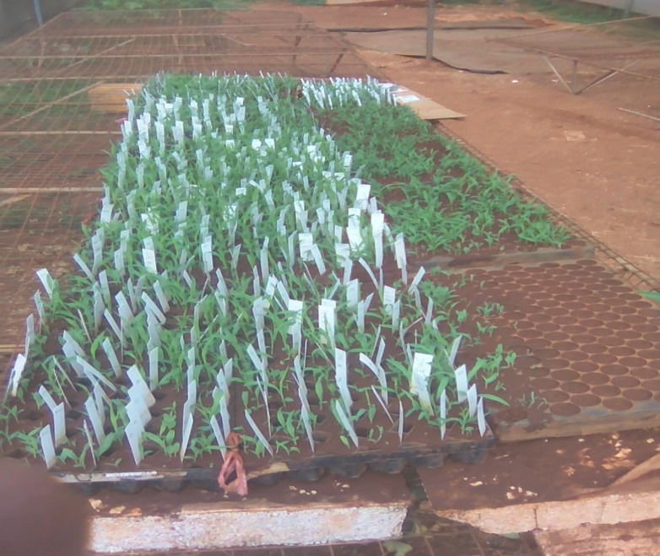
Image
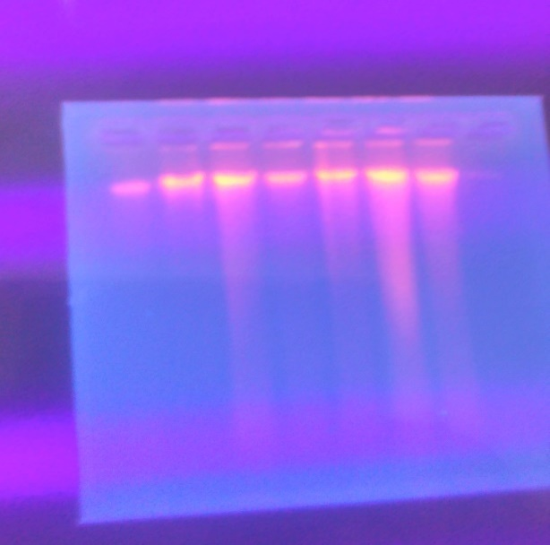
References
Tadesse Jilo, Leta Tulu, Techale Birhan and Lemi Beksisa, 2018. Genetic variability, heritability and genetic advance of maize (Zea mays L.) inbred lines for yield and yield related traits in southwestern Ethiopia. Journal of Plant Breeding and Crop Science, 10(10): 281-289
Nezif A., Ali M, Tilahun A, and Techale B. 2016. Effect of Soybean Varieties and Processing Methods on Nutritional and Sensory Properties of Soymilk. Journal of Food Processing and Preservation
Merkebe G., and Techale B., 2015. Growth and yield of rice as affected by time and ratio of nitrogen application at Jimma, south west Ethiopia. International journal of agricultural innovation and research, 4:2319-1473.

Techale B, Tamene Y and Ferede T.2014. Response of wild sorghum accessions to pre flowering drought stress. African Journal of agricultural science 9(41):3077-3081
Techale B., Musema A. and Kasahun M. 2013. Prevalence of Some Coffee Quality Problems in Gomma Woreda, Jimma Zone.World Applied Sciences Journal 29 (2): 202-207.
Techale Birhan, H. Zeleke, Ayana, A., Chemeda, A. and Tilahu A. 2013. Genetic Variability, Heritability and Genetic Advance in Early Maturing Pigeon Pea (Cajanus cajan L.) Genotypes. World Journal of Agricultural science 1(7), pp 241-247
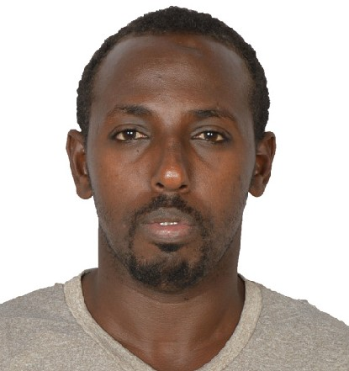

Biography:
Techale is serving as an Assistant Professor in the Department of Horticulture and Plant Science at Jimma University College of Agriculture and Veterinary Medicine, Jimma, Ethiopia. He did his B.Sc. in Horticulture at Jimma University and MSc in plant breeding at Haramaya University in Ethiopia working on genetic diversity in one of the very prominent pulse crop. He is attending his PhD in Plant Molecular Breeding at the University of Georgia in USA and Jimma University in Ethiopia. Currently he is advising and teaching different molecular breeding courses for postgraduate students at Jimma University. Techale has been a doctoral research fellow at the University of Georgia at Professor Andrew Paterson laboratory where he led the plant genomic mapping laboratory team. Techale’s current research is aiming on climate resilient sorghum breeding focusing on identifying genes responsible for drought tolerance in sorghum bicolor using nested mating designees and different mapping populations.
Email: eyulast1@gmail.com

