Genetic Variability, Heritability and Correlation Estimates of quantitative Traits in Early Rice under Rainfed Lowland Environments of Nepal

Dev N Tiwari

ABSTRACT
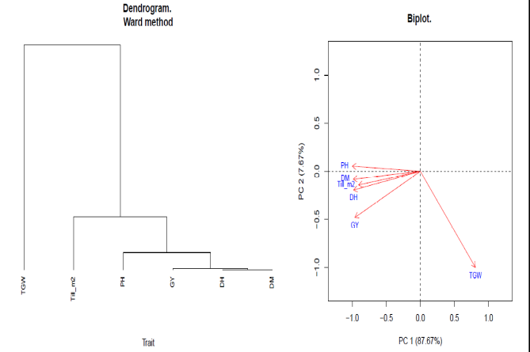
Genetic variability is the fundamental requirement of any crop breeding program to develop superior cultivars. The objective of this study was to estimate the genetic variability and find out the correlation among the different quantitative traits of early rice under rainfed lowland environments. The experiment was conducted during 2015 and 2016 wet season across the four locations namely Hardinath, Dhanusha, Khajura, Banke, Rampur, Chitwan and Bhairahawa, Rupendehi. Seven genotypes including Hardinath-1 as standard check variety were evaluated in the randomized complete block design with three replications. Several quantitative traits such as days to heading and maturity, plant height, 1000 grain weight, tillers per square meters and grain yield were measured to investigate the variability. Genotypic, phenotypic and environmental components of variance were computed to contrast the variability among the tested genotypes. All the genotypes and locations showed significant variability for all the traits studied. Similarly, genotype x environment interaction effects was also found highly significant except for the days to maturity. Genotypic coefficient of variation was lower than phenotypic coefficient of variation for all traits studied. The magnitudes of genotypic coefficient of variations were relatively higher for grain yield, 1000 grain weight and days to heading. The genotypic coefficient of variation was in the range of 0.7% to 12.86%. Heritability also ranges from 16% to 93.5% with high broad sense heritability of 93.5% was recorded from days to maturity and lowest heritability of 16% was observed in plant height which indicated the presence of additive gene effects. Positive and highest genetic correlations were found between days to heading and days to maturity (r=0.9999**), days to heading and grain yield (r=0.9999**), days to maturity and plant height (r=0.9999**). However, negative and highest correlation was observed between plant height and 1000 grain weight (r=0.9999**) followed by tillers and 1000 grain weight (0.3028**). Thus results indicated that days to heading, maturity, grain yield, and plant height are identified as selection criteria for obtaining stable and high yielding early rice genotypes under rainfed environments. Dendrogram and PCA clearly visualized the traits broadly into two clusters in which thousand grain weight into one and rest of the other traits come under separate cluster.

Image

Figure 1. Dendrogram cluster and PCA Biplot showing traits of rainfed early rice genotypes

Publications

- Tiwari, DN, " A Critical Review of Submergence Tolerance Breeding beyond Sub 1Gene to Mega Varieties in the Context of Climate Change", International Journal of Advances in Scientific Research and Engineering (ijasre), 2018, Vol. 4(3):140-148. DOI:http://dx.doi.org/10.7324/IJASRE.2018.32647
- Tiwari, DN, Bishwas Raj Bastola and Bikas Ghimire “Agro-morphological Variability of Upland Rice Hill Landraces Evaluated at Central Terai Region of Nepal”, International Journal of Advances in Scientific Research and Engineering (ijasre), 2018, Vol.4(4):45-51. DOI: http://dx.doi.org/10.7324/IJASRE.2018.32678
- Khadka, D., S. Lamichhane, D.N. Tiwari and K. Mishra. 2017. Assessment of soil fertility status of national rice research program, hardinath, dhanusha, Nepal. Int. J. Agri and Env. Res., 3(1): 86-105.
- Chapagain, Tika R., Dev N. Tiwari, Ram C. Adhikari and Man B. Shrestha. Physicochemical Properties and Yield of Tomato Varieties under Plastic House Condition. Nepal Journal of Science and Technology Vol. 15, No.2 (2014) 17-22.
- Basnet RK, Duwal A, Tiwari DN, Xiao D, Monakhos S, Bucher J, Visser RGF, Groot SPC, Bonnema G and Maliepaard C (2015). Quantitative Trait Locus Analysis of Seed Germination and Seedling Vigor in Brassica rapa Reveals QTL Hotspots and Epistatic Interactions. Front. Plant Sci. 6:1032. doi: 10.3389/fpls.2015.01032
- Tiwari, DN and RC Mishra. 2013. Evaluation of morphological traits of cucumber genotypes during off-season production. Nepal Agricultural Research Journal. Vol. 12. Tiwari, DN. 2012.
- Integrated Plant Nutrient Management for Onion Seed Production. Nepalese Horticulture: Vol. (8/9):24-28

Photograph


Biography
Mr Tiwari has been serving as Senior Scientist in Plant Breeding and Genetics under Nepal Agricultural Research Council. He is actively working in rice breeding for varietal improvement. His major focus on research is in abiotic stress tolerance in rice as well as contributed significantly to the breeding rice for upland and rainfed environments. He is also involved in the development of hybrid rice using heterosis breeding. He has adequate knowledge and skill in quantitative genetics and statistical plant breeding methods. He has been emphasizing on delivery of high yielding and stress tolerant cultivars for the flood prone and drought affected areas.
Email:dev.tiwari17@gmail.com

Notes/Comments:

