Chalcone synthase gene engineering affect flax metabolism.
Magdalena Zuk PhD, , Jan Szopa Prof. Wroclaw University, Faculty of Biotechnology

Abstract
Many biochemical pathways in plants show a tendency to be flexible and to be responsive to environmental changes. This is related to the fact that plants cannot avoid environmental stress. One of the best examples is the phenolics pathway.The chalcone synthase (CHS) gene controls the key step in the flavonoid biosynthesis. Gene down-regulation resulted in tannin accumulation and reduction in lignin synthesis, but flax growth was not affected. This suggests that lignin content and thus cell wall characteristics might be modulated through CHS activity. This study investigated the possibility that CHS affects cell wall sensing as well as polymer content and arrangement. CHS-suppressed and thus lignin-reduced plants showed significant changes in expression of genes involved in both synthesis of components and cell wall sensing. This was accompanied by increased levels of cellulose and hemicellulose. CHS-reduced flax also showed significant changes in morphology and arrangement of the cell wall. The stem tissue layers were enlarged averagely twofold compared to the control, and the number of fiber cells more than doubled. The stem morphology changes were accompanied by reduction of the crystallinity index of the cell wall. CHS silencing induces a signal transduction cascade that leads to modification of plant metabolism in a wide range and thus cell wall structure.
Since GM crops are rather scarcely accepted worldwide, several studies have proposed epigenetic modification, based on the plant treatment with short oligonucleotide sequences (OLIGO) that are homologues to the gene of interest. In most cases OLIGO silences the target gene by interference but in few cases target gene activation was reported. The recent data suggests that OLIGO technology is effective in the analysis of gene function as well as in the generating new types of plants. OLIGOs technology was also effective in CHS engineering in flax.

Image
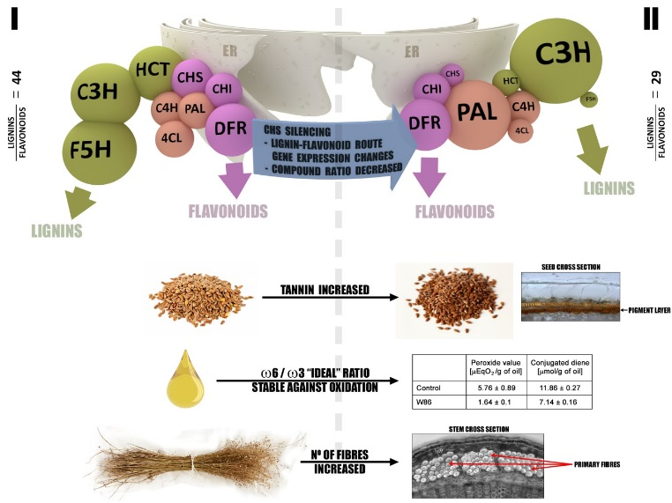
An efficient, approach for lignin/flavonoid route modification, seed and stem cell layers changes, ω6/ω3 fatty acids ratio in oil and its stability against oxidation improvement, increased number of elementary fibers in stem based on CHS gene silencing was successfully applied for potential of market valorization of linseed plant
Recent Publications (minimum 5)
- Kroliczewska B, Miśta D, Ziarnik A, Zuk M, Szopa J., Pecka-Kiełb E, Zawadzki W,Kroliczewski J.The effects of seed from Linum usitatissimum cultivar with increased phenylpropanoid compounds and hydrolysable tannin in a high cholesterol-fed rabbit Lipids in Health and Disease(2018) 17:76
- Dzialo M, Szopa J, Czuj T, Zuk M Oligodeoxynucleotides can transiently up- and downregulate CHS gene expression in flax by changing DNA methylation in a sequence-specific manner (2017) Frontiers in Plant Science 8:755
- Zuk M, Działo M, Richter D,Dyminska L, Matuła J, Kotecki A,Hanuza J and Szopa J (2016) Chalcone Synthase (CHS) GeneSuppression in Flax Leads to Changes in Wall Synthesis and Sensing Genes, Cell Wall Chemistry and Stem Morphology Prameters. Front. Plant Sci. 7:894
- Hasiewicz-Derkacz K, Kulma A, Czuj T,Prescha A, Zuk M, Grajzer M,ŁukaszewiczM,SzopaJ.Natural phenolics greatly increase flax (Linum usitatissimum) oil stability BMC Biotechnology (2015) 15(1):62
- Zuk M ; Richter D,Matula J ; Szopa J. Linseed, the multipurpose plant, Industrial Crops and Products (2015) 75,165-177

Biography
Magdalena Zuk has completed his PhD at 2003 in Wroclaw University and work on diversification of secondary metabolites in crop plants (flax, potato).She use techniques of molecular biology including gene isolation and expression analysis, protein expression and analysis, plant transformation and in vitro cultures, metabolite identification in particular focusing phenolic components by HPLC-MS analysis. She`s foxused on biomedical application of flax by-products. She published more than 35 papers in reputed journals. Member of a board of Linum Foundation, a non-profit organization promoting pro-health use of a flax products.
Email: mzuk@ibmb.uni.wroc.pl

