Allele Specific Expression Analysis on Moricandia Hybrids to identify factors governing CO₂ concentration Mechanisms
Meng-Ying Lin, Urte Schlüter, Andreas PM Weber
Institute of Plant Biochemistry, Heinrich-Heine-Universität Düsseldorf, Germany

Abstract (300-word limit)
Plants with C₃-C₄ photosynthesis display lower CO₂ compensation points than related C₃ species and Kranz-like anatomy. C₃-C₄ intermediates do not have the C₄ photosynthetic mechanism, but possess an efficient system for recycling of photorespiratory released CO₂ by transporting glycine into bundle sheath cells, where CO₂ released from mitochondria can be efficiently recaptured by numerous, adjacent chloroplasts. Within the project, we would like to investigate the importance of different biochemical and anatomical features for the function of this specific photorespiratory cycle as well as their manifestation in the genomes of the plants. In the genus Moricandia, species with C₃ and C₃-C₄ intermediate photosynthesis exist in close phylogenetic proximity and provide suitable materials to study early evolutionary steps of C₄ photosynthesis.
To explore allele specific expression (ASE) regarding this specific CO₂ concentration mechanism in Moricandia, six interspecific M. arvensis x M. moricandioides hybrids with diverse phenotypes as well as their parental species were selected for RNA-Seq analysis. In total, we obtained 54,97 Gb of RNA-Seq data, with an average of 4,58 Gb per sample. Parental species showed high aligning rate with an average of 92,33% to their own reference genome; on the other hand, reads from hybrids were about 75 to 85% mapped to each parental species. Approximately 120,000 SNP sites were examed by ASE analysis on every hybrid lines, 30% of the SNP sites were cis-regulatory variants, 7% of them were controlled by trans-acting regulators and others were with mixture of effects. Among hybrids, 3142 common cis-SNPs and 82 common trans-SNPs were found and mainly involving in cellular process (GO:0009987) and metabolic process (GO:0008152).
Methodology and Theoretical Orientation:
Findings:
Conclusion and Significance:
Image:
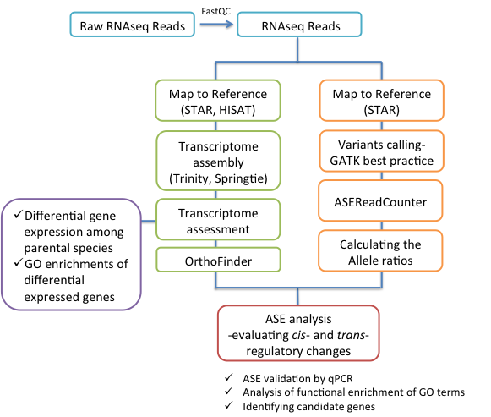
Recent Publications (minimum 5)
- Hsu YC, Tseng MC, Wu YP, Lin MY, Wei FJ, Hwu KK, Lin YR (2014) Genetic factors responsible for eating and cooking qualities of rice grains in a recombinant inbred population of an inter-subspecific cross. Mol Breed, 1-19.
- Lin MY (2013) The Effect of a Floury Gene Floury7 (FLO7) in Rice (Oryza sativa L.) on Grain Composition and Starch Synthesis Related Genes. National Taiwan University Master Thesis, Taipei, Taiwan, pp. 1-96

Biography (150-word limit)
Email:
Meng-Ying.Lin@hhu.de

