Exploitation of Genetic Variability of Gossypium hirsutum L. for Drought Tolerance
Rehman, A PhD, College of Agriculture, Bahauddin, Zakariya University, Bahadur sub campus, Layyah, Pakistan.
Hussain, M PhD, College of Agriculture, Bahauddin, Zakariya University, Multan, Pakistan.
Ijaz, M PhD, College of Agriculture, Bahauddin, Zakariya University, Bahadur sub campus, Layyah, Pakistan.

Abstract (300-word limit)
Drought is the most crucial threat to world food security. Due to world’s limiting water supply, future food demand increasing with the increase in population pressure. Keeping in view the present scenario, experiments were conducted to evaluate cotton germplasm under irrigated and drought regimes. The germplasm was evaluated for various physiological and morphological traits in greenhouse. Cotton seedling were subjected to 25, 50, 75 and 100% drought stress of pot capacity. Ten tolerant and six susceptible genotypes were selected based on root length, shoot length, fresh root weight, fresh shoot weight, dry root weight and dry shoot weight, root/shoot ratio. Selected genotypes were crossed in lines × tester mating fashion. The hybrids were evaluated at seedling and mature stage in greenhouse and field conditions respectively for collection of observation which were used for genetic analysis. A considerable reduction in most of parameters was observed under stress conditions. Lines × Tester analysis showed that plant height, GOT%, number of bolls per plant, boll weight, stomatal conductance and transpiration rate are governed by non-additive and dominant genetic effects under normal conditions and water stress conditions. All the lines and testers proved good general combiner for different characters under studied, so additive genes are involved in the inheritance. Most of traits showed high heterotic effects under both conditions. Cotton breeders may utilize these potential parents and combinations in breeding programs on drought tolerance.
Image:
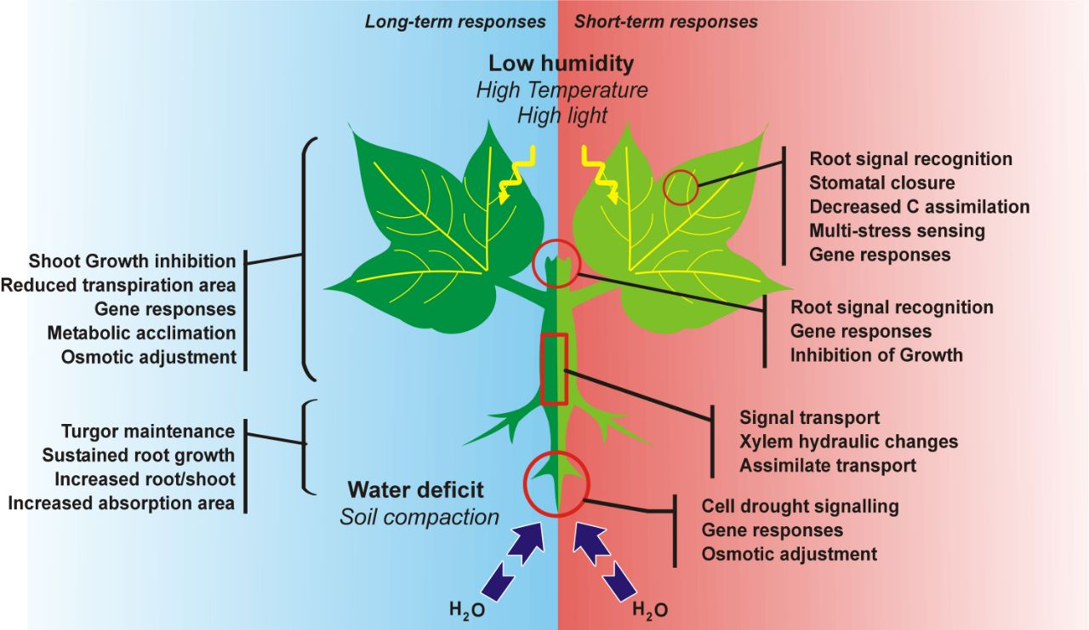
Recent Publications
- Rehman, A., M. T. Azhar, A. Shakeel, S. M. A. Basra. 2017. Breeding potential of upland cotton for water stress tolerance. Pak. J. Agri. Sci. 54: 619-626.
- Rehman, A., M. T. Azhar, A. Shakeel, S. M. A. Basra. 2017. Genetic analysis of some polygenic traits of Gossypium hirsutum L. for drought tolerance. J. Anim. Plant Sci. (In Review).
- Rehman, A., M. T. Azhar, A. Shakeel. 2017. Biplot and cluster analysis of some drought tolerance related traits in upland cotton. J. Envi. Agric. (In Review)
- Rehman, A., M. T. Azhar. 2017. Differential response of leaf pigments in cotton to water stress conditions. Czech J. Genet. Plant Breed. (In Review).

 Biography (150-word limit)
    - Abdul Rehman’s research interests are Molecular characterization of resistance genes analogues (RGAs) in cottons and identification of novel sources of resistance from wild relatives of Gossypium against viruses.
    - Identification and development of drought tolerant cotton lines by using various techniques including membrane chlorophyll contents, carotenoids, stomatal conductance, transpiration rate etc.
    - Working for the improvement of cotton germplasm for seed cotton yield and fiber parameters.

Email:
abdulpbg@gmail.com

