Anatomy Flipped Learning Project [A-FLP]: Technology for Flipped Learning in Anatomy Classes
Hany W. Abdel Malak

Abstract (300 word limit)
Problem: The flipped classroom represents an essential component in curricular reform. Technological advances enabling asynchronous and distributed learning are facilitating the movement to a competency-based paradigm in healthcare education. With digitization of information, a better interaction between professors and students at lectures occurs. Thus, the project could use media as videos or software like Anatomage for clarifying and explaining difficult terminology in Anatomy & Embryology due to limited time of lectures. The project reflects a new method of interactive teaching being adopted worldwide nowadays, facilitating the movement to a competency-based paradigm in medical education.
Context: 1st and 2nd year medical students at ASU
Intervention: 1. Preparing materials needed for flipped anatomy lectures.
2. Adopting flipped lectures as a method of anatomy teaching at ASU.
3. Training of staff members of Anatomy department at ASU on preparing flipped lectures and interactive quizzes.
4. Uploading flipped materials on ASU-MENA-FRI health professions education channel on YouTube & LMS (Moodle) at ASU.
5. Conducting interviews and questionnaires using survey monkey to measure & analyze student’s satisfaction about flipping of Anatomy & Embryology lectures.
Possible outcomes: 1. ≥ 50% of students are satisfied about the new teaching method.
2. Anatomy staff members at ASU are able to prepare flipped lectures and interactive quizzes.
3. Flipped anatomy / embryology lectures are uploaded.
4. Flipped learning extends to other specialties.
5. Improved students’ performance during assessments.
6. Improved HPE on long run.

Link to Anatomy FLP:

Image
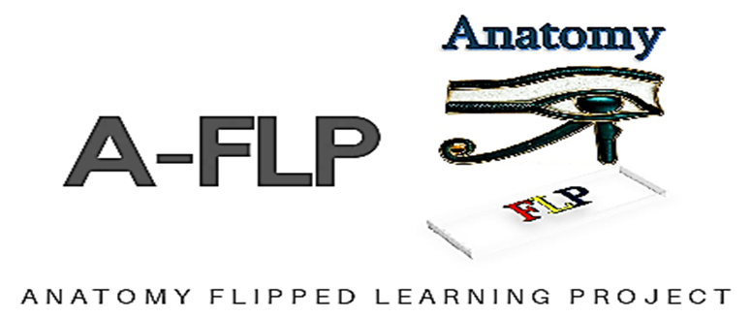
Recent Publications (minimum 5)
- Chen, F.; Lui, A. and Martinelli S. (2017): A systematic review of the effectiveness of flipped classrooms in medical education. Medical Education; 51: 585–597.
- Hanaa Ouda Khadri Ahmed (2016): Flipped Learning As A New Educational Paradigm: An Analytical Critical Study. European Scientific Journal April 2016 edition vol.12, No.10 ISSN: 1857 – 7881 (Print) e - ISSN 1857- 743. PP: 417 - 444.
- Dr. BADA, Steve Olusegun (2015): Constructivism Learning Theory: A Paradigm for Teaching and Learning. IOSR Journal of Research & Method in Education; (5), Issue 6 Ver. I: 66 – 70.
- Hurtubise, L.; Elissa Hall, E.; Sheridan, L. and Han, H. (2015): The Flipped Classroom in Medical Education: Engaging Students to Build Competency. Journal of Medical Education and Curricular Development; (2): 35–43.
- Williams, D. (2016): The Future of Medical Education: Flipping the Classroom and Education Technology. Ochsner J.; 16(1): 14–15.

Survey Monkey results: https://www.surveymonkey.com/results/SM-M6FQJ5CZV/
https://www.surveymonkey.com/results/SM-FYL5M5CZV/

Story on Yahki:


Biography (150 word limit)
Hany W. Abdel Malak is an assistant professor of Anatomy & Embryology at Faculty of Medicine - Ain Shams University. He has a -25- years’ experience in anatomy & embryology teaching. Currently he is involved in incorporation of Anatomage software and implementation of flipped classes with interactive quizzes in teaching anatomy and embryology at Ain Shams faculty of medicine. Hany is a coordinator of endocrine module at EMP/Ain Shams University. Hany gets an assessment and simulation program certified by Michigan State University, College of Osteopathic Medicine and the Institute for global health (2019). Hany W. Abdel Malak is an ASU-MENA-FRI Fellow, batch 2019
Email: : Hany_Waheeb@med.asu.edu.eg
hwabdelmalak@gmail.com

Notes/Comments:

