Brief view of Cardiovascular Hemodynamics Assessment In Children
Samah Alasrawi1
1 Pediatric Cardiologist, AlJalila Children Heart Center, Dubai UAE
*Corresponding author: Samah Alasrawi, Specialist Pediatric Cardiologist, AlJalila Children Heart center, Dubai, UAE, Email: samahisrawi@gmail.com
Tel :00971561387382
ORCID ID 0000-0003-3553-8807

Introduction:
Hemodynamics is the dynamics of blood flow and it is an important part of cardiovascular physiology dealing with the forces the pump (the heart) has to develop to circulate blood through the cardiovascular system.
Understanding of the cardiovascular hemodynamics is very important for diagnosis, treatment plan and follow up of the cardiac patients
Objective: to Know
What we measure: Intra cardiac pressures
What we calculate:
-Cardiac output
-Qp (pulmonary blood flow)
-Qs (systemic blood flow)
-PVR (Pulmonary vascular resistance)
-SVR (systemic vascular resistance)
-Ejection Fraction
-RVSP (Right ventricle systolic pressure)
-PAP (Pulmonary artery pressure)
Intra cardiac pressures measurement
We use fluid filled catheter (Figure 1, 2) which transmits pressure wave from the heart
To the pressure transducer which converts pressure to electrical impulse.1
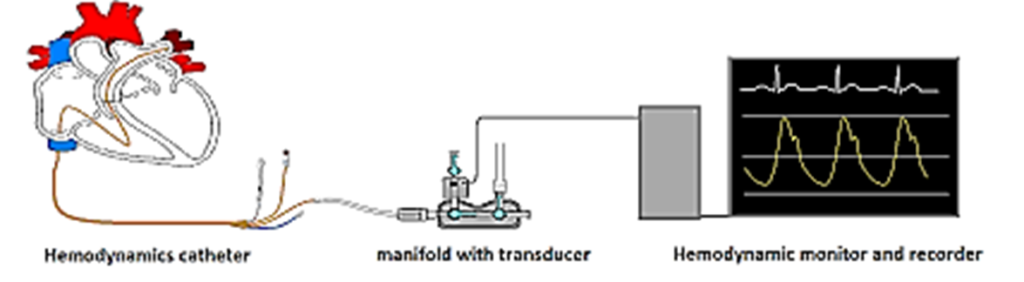
Figure 1: intra cardiac pressure measurement
Tubing should be non-compliant, fluid filled (NS)
Any disruption of continuity of fluid from catheter tip to transducer affects the quality of tracing
Bubbles, blood or contrast, clot, compliant tubing.1
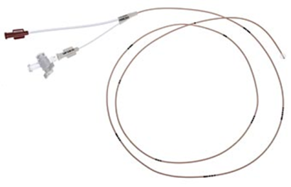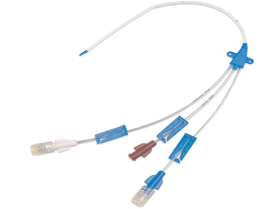
Figure 2: catheters
Examples for intra cardiac pressure
*Atrial tracings: Figure 3: it consist of
3 positive deflections: a, v, and c waves, and 2 negative deflections: x and y descent
A-wave: Atrial contraction
C-wave: Bulging of atrioventricular valve into atrium during isovolumic ventricular contraction
X-descent: Combination of atrial relaxation, downward displacement of atrioventricular valve during ventricular systole, ejection of blood from ventricle steeper than Y-descent
V-wave: Filling of atrium, Larger than ‘a’ wave in LA/smaller than ‘a’ wave in RA
Y-descent: Opening of atrioventricular valve, ventricular filling. 1
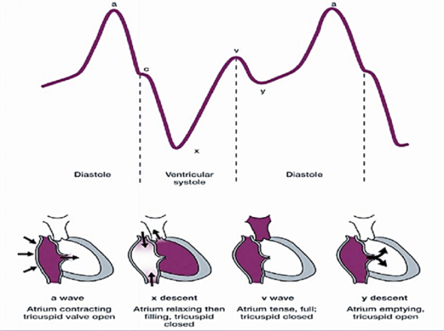
Figure 3 : Atrial tracing

Atrial pressures are a reflection of ventricular function, particularly diastolic function
Changes in ventricular compliance reflected in atrial pressures such as:
Hypertrophy, Myocardial diseases, pericardial constriction. 1
*Pulmonary vein wedge pressure: Figure 4
Measured by cath especially in patients with pulmonary hypertension
Can be used as surrogate for pulmonary artery pressure. 2
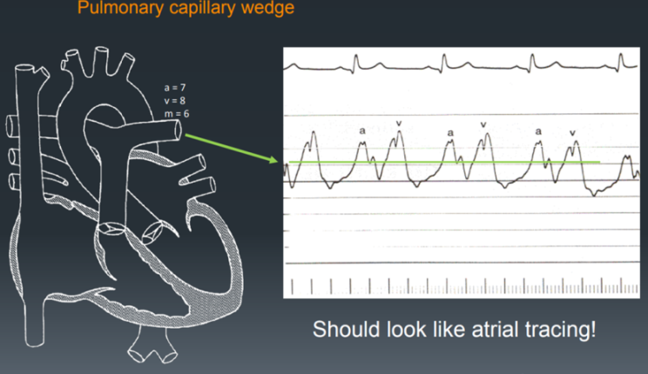
Figure 4: pulmonary wedge pressure
Cardiac output
The cardiac output is simply the amount of blood pumped by the heart per minute, CO = HR X SV.
The cardiac output is usually expressed in liters/minute.
Can be calculated by Fick calculation. Figure 5
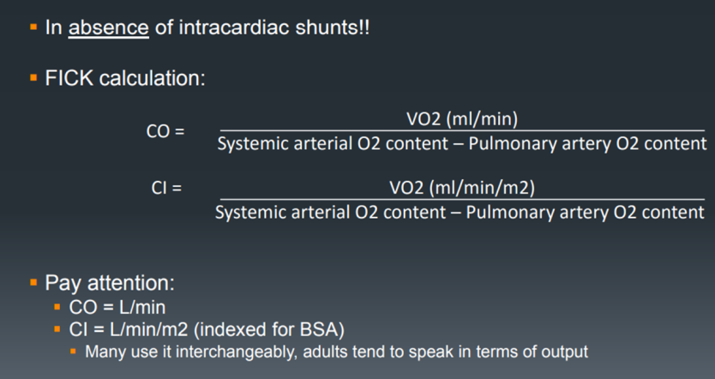
Figure 5 : Fick calculation
1 gm Hb carries 1.36 ml of O2
Coefficient of solubility for O2 in blood is 0.003 ml O2/100 ml plasma/mmHg
-At PO2 of 100 mmHg, 100 ml of plasma contains 0.03 mlO2/L/mmHg
Calculation of outputs dependent on accurate determination of oxygen saturations in the blood
Oxygen content (CaO2) = (SaO2 x Hb x 13.6) + (0.03 x PaO2)
Dissolved oxygen negligible at PaO2 < 100 mmHg. 3, 4
Sources of error for Fick calculation
1-Oxygen consumption:
Non-steady state condition, sedation, anxiety, disease state
2-Long time interval between saturation samples
3-Obtaining saturations in improper location
4-Neglecting dissolved oxygen in calculations. 4

Cardiac output by Echo 5
Stroke Volume = Outflow Tract Area * VTI. Figure 6
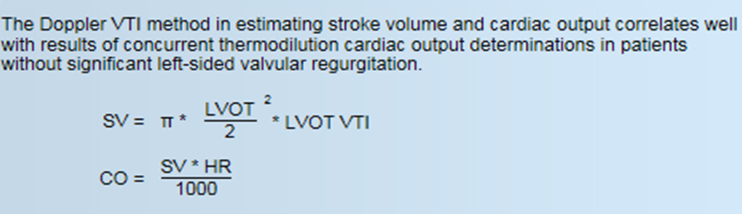
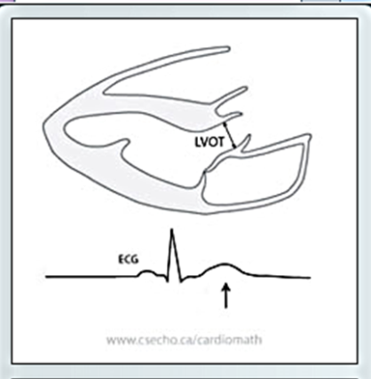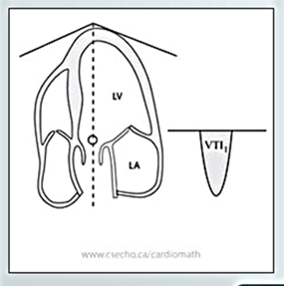
Figure 6: cardiac output by Echo
QP : Pulmonary Cardiac output
QP=Vo2/Cpv-Cpa
QP: Pulmonary Cardiac output, L/minute
Vo2: (oxygen Consumption), mL/minute.
Cpv (pulmonary venous oxygen content), mL/L.
Cpa (pulmonary arterial oxygen content) mL/L. 4
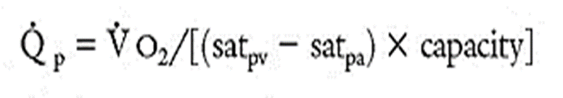
Qp:Qs Ratio:
In a normal heart, one without any septal defects, the output from the right and left ventricles are identical.
In this event, the systemic blood flow (Qs) is equal to the pulmonary blood flow (Qp). Therefore, the Qp:Qs ratio is 1:1
*By cath
QP/QS= (systemic arterial O2 content – systemic veins O2 content) / (pulmonary veins O2 content – pulmonary arterial O2 content)
*By echo
QP/QS= (RVOTd² * RVOT VTI) / (LVOTd² * LVOT VTI)
Qp:Qs describes the magnitude of a cardiovascular shunt
- Normally = 1:1
- Left to right shunts >1.0
- Right to left shunts <1.0
This is very helpful when quantifying shunts, studying associated complications and determine heart surgery indication. 3, 4
Systemic vascular resistance (SVR)
SVR= (MAP-CVP)/CO
SVR = Systemic Vascular Resistance (WU)
MAP = Mean Arterial Pressure (mmHg)
CVP = Central Venous Pressure (mmHg)
CO = Cardiac Output (L/min). 3
Pulmonary vascular resistance (PVR)
PVR= (MPAP - PCWP)/Qp
PVR = pulmonary vascular resistance (WU)
QP = pulmonary cardiac output
MPAP = mean pulmonary artery pressure
PCWP= pulmonary capillary wedge pressure
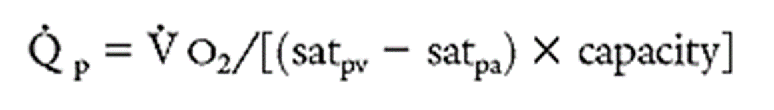
PVR=(MPAP- PCWP)/{Vo2/[(satpv-satpa)xcap]}. 3
PVR by ECHO
PVR = {(TR Jet velocity/ RVOT VTI) x 10} + 0.16
RVOT VTI (Right ventricular outflow Velocity time integral). 5
EF (ejection fraction)
The ejection fraction (EF) is an important measurement in determining how well the heart is pumping out blood and in diagnosing and tracking heart failure.

A normal heart's ejection fraction may be between 50% and 70%
If the LV end-diastolic volume (EDV) and end-systolic volume (ESV) are known,
LVEF can be determined using the following equation:
LVEF = stroke volume (EDV - ESV) ÷ EDV. Figure 7, 8
Ejection fraction can be measured with imaging techniques, including:
-Echocardiogram.
-Cardiac catheterization.
-Magnetic resonance imaging (MRI).
-Computerized tomography (CT).
-Nuclear medicine scan.
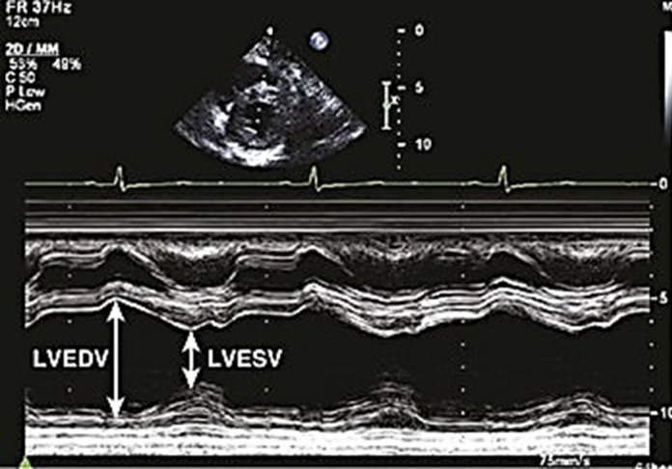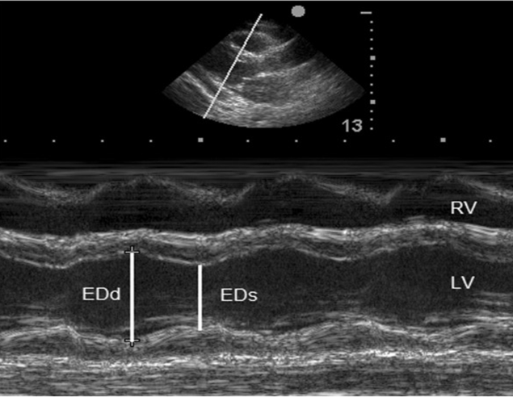
Figure 7: EF by Echo, M mode
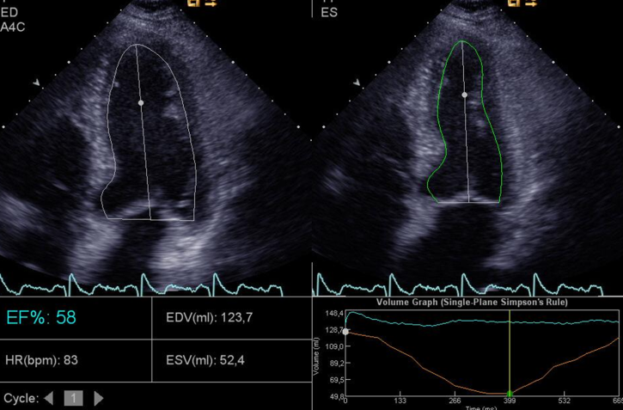
Figure 8: EF by Simpson`s method
RVSP (Right ventricle systolic pressure)
Can be carried out by measuring maximal tricuspid regurgitation velocity (V) and applying the modified Bernoulli equation 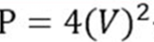 to convert this value into pressure values. Estimated right atrial pressure (RAP) must be added to this obtained value.
TR Max Jet Velocity (V). Figure 9
Right Atrial Pressure (RAP)
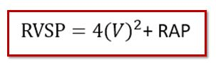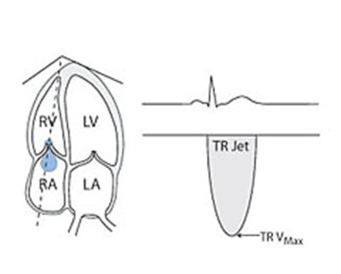
Figure 9: TR jet velocity
In case if there is a connection between the two ventricles (VSD)
The RVSP can be calculated by measure the gradient (PG) between the two ventricles then
RVSP= LVSP – PG
high PG means good prognosis, but low PG means bad prognosis. 5
Valve stenosis: figure 10
We measure the gradient in the stenotic area by continuous wave CW or pulse wave PW and we can assess the severity of the stenosis. So when the gradient is high this means there is sever stenosis
High PG means bad prognosis, but low PG means good prognosis. 5
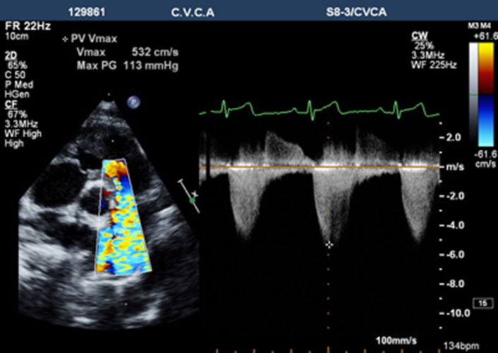
Figure 10: PG in pulmonary valve stenosis.
PAP (Pulmonary artery pressure)
*PASP
Assessment of pulmonary artery systolic pressure (PASP) can be carried out like RVSP (in absence of RVOT obstruction), So RVSP= PASP
*PAMP & PADP: figure 11
Mean (PAMP) and diastolic PA-pressures (PADP) can be estimated by assessment of the pulmonary regurgitation.
PAMP = pulmonary regurgitation gradient (M)
Normal values: rest up to 25 mmHg, during exercise up to 30 mmHg.
PADP = pulmonary regurgitation gradient (D) + RAP . 5
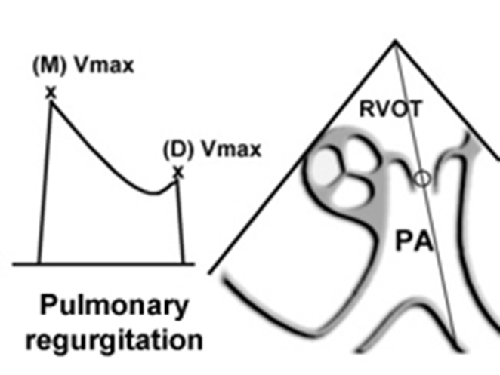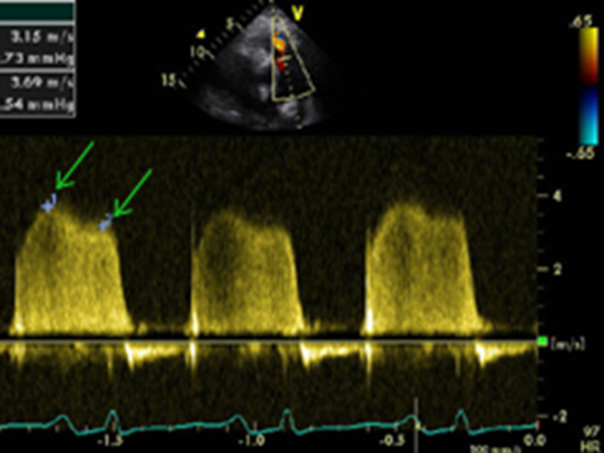
Figure 11: pulmonary regurgitation wave

After measurement of PAMP and PADP. We can calculate PASP by this equation:
PASP = 3 PAMP-2 PADA
Conclusion
-Obtaining accurate hemodynamics requires careful attention to detail
-Calculation of cardiac output has many potential sources of error
-Limit assumptions as much as possible
-Valuable information about disease states can be obtained with basic diagnostic catheterization and good Echo

References
- Kern MJ, Lim MJ, Goldstein JA (Eds), Wiley-Blackwell, Hoboken, Hemodynamic Rounds: Interpretation of Cardiac Pathophysiology from Pressure Waveform Analysis, 4th ed, 2012.
- Kern MJ (Ed) The Cardiac Catheterization Handbook, 7th ed, Elsevier, Philadelphia 2017.
- Kern MJ (Ed), Mosby, St. Louis, Interventional cardiac catheterization handbook, 4th ed, 2014.
- Moscucci M. Grossman and Baim’s Cardiac Catheterization, Angiography, and Intervention , 9th ed, Wolters Kluwer/Lippincott Williams & Wilkins, Philadelphia 2016. p.223.
- Caille V, Amiel JB, Charron C, et al. Echocardiography: a help in the weaning process. Crit Care. 2015;14(3):R120.

