Acute abdomen due to complicated midgut malrotation in undiagnosed adults

Constantinos Avgoustou, MD, G.H.N.I. 'Aghia Olga- Konstantopoulion', Athens, Greece

Statement: Midgut malrotation is a congenital anomaly of infancy associated with abnormal position of the bowel within the abdominal cavity. Adults are usually asymptomatic and incidentally diagnosed at surgery for other disease; rarely, they present acutely with bowel obstruction due to right colon volvulus (RCV), associated in few with ileocolonic intussusception (ICI). This study highlights the importance of understanding of rotation/fixation aberrations in adult right abdomen when these anomalies are presented acutely. Methology: In the last five years, three women (cases I: 46 yrs, II: 88, III: 49) and two men (cases IV: 42, V: 50) underwent urgent laparotomy for complete bowel obstruction (all cases) and peritonitis (II, III, IV/ sepsis in III). All presented with abdominal pain and distension, and complete constipation. Preoperative imaging (X-rays, CT) indicated RCV in all, ICI in II, III, abdominal abscess in IV, redundant colon and megasigmoid in V. Case I had a recent negative appendectomy, III was on chemotherapy for operated breast cancer, and V was insulin-dependent. Findings: At emergent surgery, RCV due to mobile caecocolon was found in all, associated with ICI in II and III, right-sided small intestine and Meckel's diverticulum abscess in IV, and volvulised megasigmoid in V. We performed resection/dissection of peritoneal bands when needed, right hemicolectomy/ ileotransversostomy in I-III (+excision of intussuscepted ileum in II, III), right colon fixation+enterectomy including Meckel’s diverticulum in IV, and right hemicolectomy/ileotransversostomy/Hartmann's sigmoidectomy in V. All had uneventful outcome except for III that remained intubated postoperatively and transferred to ICU; she was reoperated for perianastomotic abscess (ileostomy) on day 12, and discharged 14 days later. Histology revealed ischaemia in all segments excised, ICI in II, III, caecal adenocarcinoma in II, and inflammed Meckel's diverticulum in IV. Conclusion: Complicated with RCV and/or ICI adult bowel malrotation requires emergent surgery, preferably before peritoneal signs occur.

Images

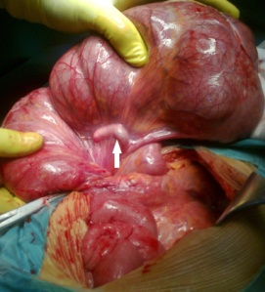 | 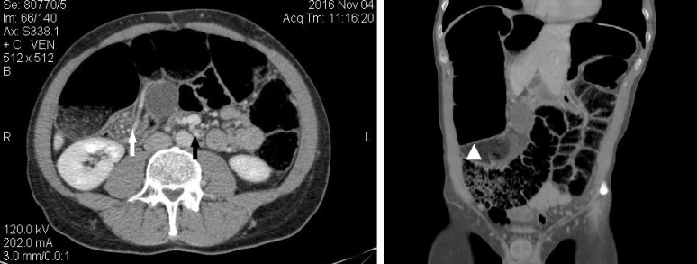
Fig. 1 Intraoperative: mobile caecocolon, RCV (arrow: appendix) | Fig. 2 CT scan: large bowel enlargement, RCV, incomplete sigmoid volvulus (axial: arrows are ''whirl signs'', coronal: arrowhead shows distended volvulised sigmoid)

Recent publications:
- Nehra D, Goldstein AM (2011) Intestinal malrotation: varied clinical presentation from infancy through adulthood. Surgery 149: 386-393.
- Avgoustou C, Papazoglou A, Apessou D, Papailiou I (2014) Synchronous acute ileocaecocolonic intussusception and right colon volvulus associated with caecal adenocarcinoma and malrotation in an elder. Chirurgia (Minerva) 27: 163-166
- Martin MJ, Steele SR (2010) Twists and turns: A practical approach to volvulus and intussusception. Scand J Surg 99: 93-102

