Complicated diaphragmatic hernias. A surgical emergency

Constantinos Avgoustou, MD, G.H.N.I. 'Aghia Olga- Konstantopoulion', Athens, Greece
Statement: Significant but untreated paraesophageal and posttraumatic hernias may present acutely when their herniated content has been incarcerated, obstructed/volvulised, or strangulated. Emergent surgery is then mandatory and life-saving. The purpose of this study is to describe difficulties, surprises and risks in case of urgent surgery and highlight the importance of their on-time elective repair. Methology: Three cases, I woman 78 yrs, II man 88 and III man 53, were urgently operated for strangulated (I) and volvulised (II) paraesophageal hernias and obstructed posttraumatic (III) hernia, promptly after their admission. Respiratory embarrassment in all, sepsis in I and inability to vomit in I, II, were encountered. Case I had a coexistent incisional abdominal wall hernia, and III a history of compressive injury of lower chest and abdomen 20 yrs ago. Radiographies and chest-abdomen CT helped diagnosis. Findings: In case I, gastric fundus and body with part of spleen were strangulated in mediastinum, and antrum was ischaemic; damage control surgery consisted of total gastrectomy/splenectomy with stapled closure of esophagus and duodenum. In case II, the whole stomach with a prepyloric obstructive lesion was volvulised in mediastinum, along with omentum and part of spleen. A distal gastrectomy/splenectomy, gastrojejunostomy, closure of hiatus and fundus fixation to diaphragm were performed. In case III, large segment of obstructed transverse colon, along with omentum and part of gastric fundus were herniated in left chest cavity through a posttraumatic diaphragmatic defect. Reduction of contents, excision of omentum, closure of defect and chest close-tube drainage were performed. Case I was transferred intubated in ICU, but never stabilized and died after 30 hours. Case II had prolonged hospitalization for pulmonary insufficiency and finally was discharged in good condition; histology revealed pT2 gastric adenocarcinoma. Case III had uneventful outcome. Conclusions: Complicated diaphragmatic hernias are life-threatening situations, and mandatory urgent surgery is challenging.

Figures
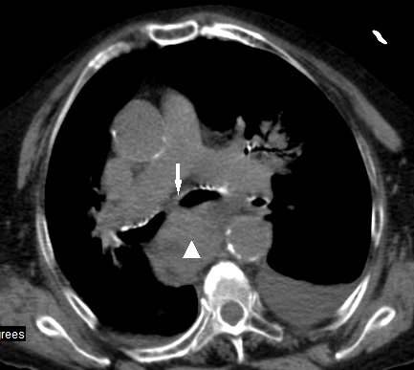 | 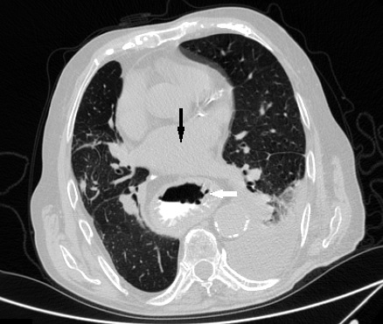
Fig.1 CT chest: Strangulated paraesophageal hernia (arrow: bronchi, arrowhead: stomach) | Fig. 2 CT chest: Volvulised paraesophageal hernia (arrows: white, pulmonary artery; black, intrathoracic stomach)
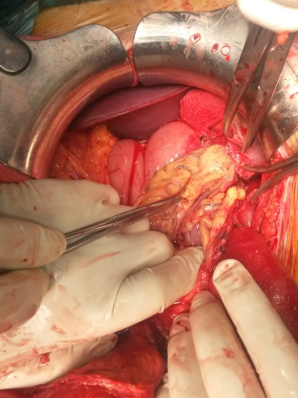 | 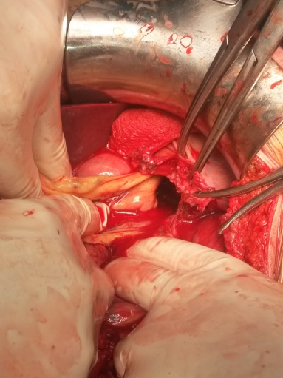
Fig. 3 Posttraumatic diaphragmatic defect before and after reduction

Recent publications:
- Siow SL, Wong CM, Hardin M, Sohail M (2016) Successful laparoscopic management of combined traumatic diaphragmatic rupture and abdominal wall hernia: a case report. J Med Case Rep 10: 11.
- Köhler G, Koch OO, Antoniou SA, Emmanuel K, Pointner R (2015) "Acute intrathoracic stomach!" How should we deal with complicated type IV paraesophageal hernias? Hernia 19: 627-633.
- Bhayani NH, Kurian AA, Sharata AM, Reavis KM, Dunst CM, Swanstrom LL (2013) Wait only to resuscitate: early surgery for acutely presenting paraesophageal hernias yields better outcomes. Surg Endosc 27: 267-271.

